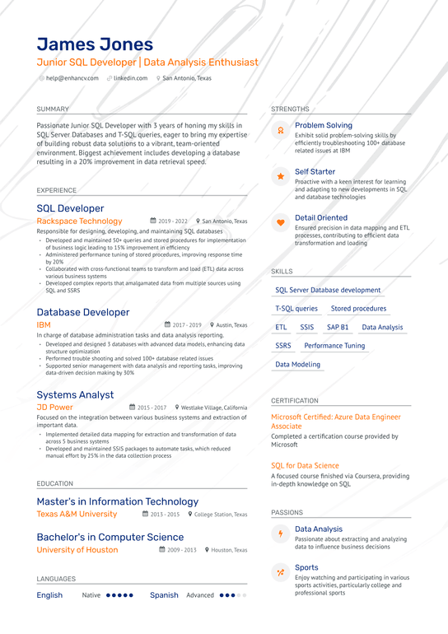

**James Jones**

Junior SQL Developer | Data Analysis Enthusiast help@enhancv.com linkedin.com San Antonio, Texas

SUMMARY

Passionate Junior SQL Developer with 3 years of honing my skills in SQL Server Databases and T-SQL queries, eager to bring my expertise of building robust data solutions to a vibrant, team-oriented environment. Biggest achievement includes developing a database resulting in a 20% improvement in data retrieval speed.

EXPERIENCE

SQL Developer

Rackspace Technology

2019-2022 San Antonio, Texas

**Responsible for designing, developing, and maintaining SQL databases**

**•Developed and maintained 50+ queries and stored procedures for implementation of business logic leading to 15% improvement in efficiency ⚫Administered performance tuning of stored procedures, improving response time by 20%**

**• Collaborated with cross-functional teams to transform and load (ETL) data across various business systems**

**•Developed complex reports that amalgamated data from multiple sources using SQL and SSRS**

Database Developer

IBM

STRENGTHS

SKILLS

Problem Solving

Exhibit solid problem-solving skills by efficiently troubleshooting 100+ database related issues at IBM

Self Starter

Proactive with a keen interest for learning and adapting to new developments in SQL and database technologies

Detail Oriented

**Ensured precision in data mapping and ETL processes, contributing to efficient data transformation and loading**

SQL Server Database development Stored procedures

T-SQL queries

**2017-2019 Austin, Texas**

ETL

SSIS SAP B1 Data Analysis

SSRS Performance Tuning

In charge of database administration tasks and data analysis reporting. •Developed and designed 3 databases with advanced data models, enhancing data structure optimization

•Performed trouble shooting and solved 100+ database related issues Supported senior management with data analysis and reporting tasks, improving data-driven decision making by 30%

Systems Analyst

JD Power

2015-2017

Westlake Village, California

**Focused on the integration between various business systems and extraction of important data.**

**• Implemented detailed data mapping for extraction and transformation of data across 5 business systems**

**•Developed and maintained SSIS packages to automate tasks, which reduced manual effort by 25% in the data collection process**

Data Modeling

CERTIFICATION

Microsoft Certified: Azure Data Engineer Associate

Completed a certification course provided by Microsoft

SQL for Data Science

A focused course finished via Coursera, providing in-depth knowledge on SQL

**EDUCATION**

Master's in Information Technology

Texas A&M University

**2013-2015 College Station, Texas**

Bachelor's in Computer Science

University of Houston

2009-2013 Houston, Texas

LANGUAGES

English Native ..... Spanish Advanced ...

PASSIONS

Data Analysis

Passionate about extracting and analyzing data to influence business decisions

Sports

Enjoy watching and participating in various sports activities, particularly college and professional sports