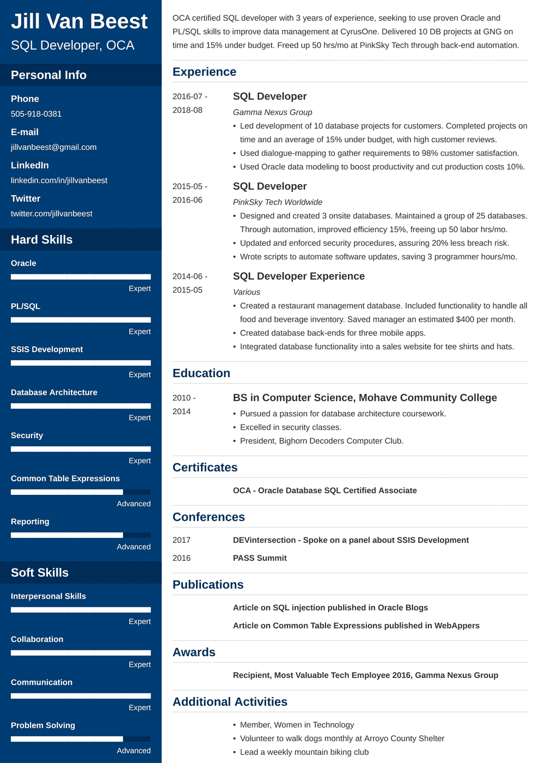

Jill Van Beest SQL Developer, OCA

**Personal Info**

OCA certified SQL developer with 3 years of experience, seeking to use proven Oracle and PL/SQL skills to improve data management at CyrusOne. Delivered 10 DB projects at GNG on time and 15% under budget. Freed up 50 hrs/mo at PinkSky Tech through back-end automation.

**Experience**

**Phone**

505-918-0381

**E-mail**

jillvanbeest@gmail.com

LinkedIn

linkedin.com/in/jillvanbeest

**Twitter**

twitter.com/jillvanbeest

Hard Skills

**Oracle**

**PL/SQL**

2016-07- 2018-08

**SQL Developer**

2015-05-

2016-06

2014-06-

Expert

2015-05

Expert

SSIS Development

**Education**

Expert

**Database Architecture**

2010-

2014

Expert

Security

*Gamma Nexus Group*

• Led development of 10 database projects for customers. Completed projects on time and an average of 15% under budget, with high customer reviews.

• Used dialogue-mapping to gather requirements to 98% customer satisfaction.

• Used Oracle data modeling to boost productivity and cut production costs 10%.

**SQL Developer**

*PinkSky Tech Worldwide*

• Designed and created 3 onsite databases. Maintained a group of 25 databases. Through automation, improved efficiency 15%, freeing up 50 labor hrs/mo.

• Updated and enforced security procedures, assuring 20% less breach risk.

• Wrote scripts to automate software updates, saving 3 programmer hours/mo. SQL Developer Experience

*Various*

• Created a restaurant management database. Included functionality to handle all food and beverage inventory. Saved manager an estimated $400 per month.

• Created database back-ends for three mobile apps.

• Integrated database functionality into a sales website for tee shirts and hats.

**BS in Computer Science, Mohave Community College**

• Pursued a passion for database architecture coursework.

• Excelled in security classes.

• President, Bighorn Decoders Computer Club.

Expert

**Certificates**

Common Table Expressions

OCA - Oracle Database SQL Certified Associate

Advanced

**Conferences**

**Reporting**

Advanced

2017 2016

**DEVintersection - Spoke on a panel about SSIS Development PASS Summit**

Soft Skills

**Publications**

**Interpersonal Skills**

Expert

**Collaboration**

**Awards**

Expert

**Communication**

**Article on SQL injection published in Oracle Blogs**

**Article on Common Table Expressions published in WebAppers**

**Recipient, Most Valuable Tech Employee 2016, Gamma Nexus Group**

**Additional Activities**

Expert

Problem Solving

Advanced

• Member, Women in Technology

• Volunteer to walk dogs monthly at Arroyo County Shelter

Lead a weekly mountain biking club