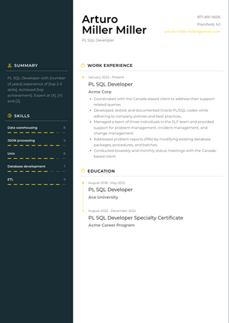

Arturo Miller Miller

PLSQL Developer

--506

N

& SUMMARY

PLSQL Developer with number of years experience of top 2-3 ski Achieved

**achievement Expert at [M**

and [2]

SKILLS

JSON processing

Unix

WORK EXPERIENCE

January 2003-Present

PL SQL Developer

**Acme Corp**

• Coordinated with the Canada-based client to address their support

•Developed, tested, and documented Oracle PL/SQL codes while adhering to company policies and best practi

Managed a team of three individuals in the SLF team and provided support for problem management, incident management, and change management

Addressed problem reports (P) by modifying existing database packages, procedures, and batches

•Conducted biweekly and monthly status meetings with the Canada based client

**EDUCATION**

**PL SQL Developer**

**Ace University**

PLSQL Developer Specialty Certificate Acme Career Program