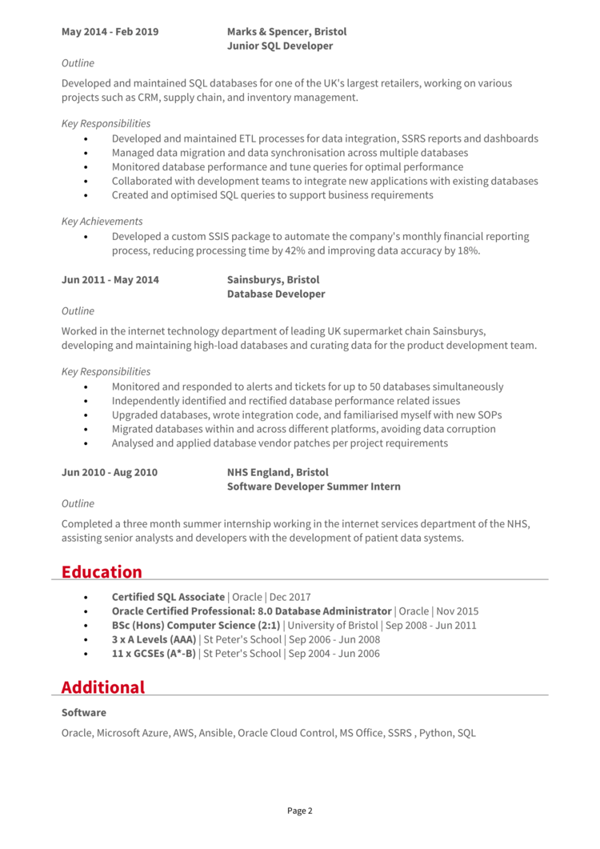

**May 2014 - Feb 2019**

**Marks & Spencer, Bristol Junior SQL Developer**

Outline

Developed and maintained SQL databases for one of the UK's largest retailers, working on various projects such as CRM, supply chain, and inventory management.

*Key Responsibilities*

Developed and maintained ETL processes for data integration, SSRS reports and dashboards Managed data migration and data synchronisation across multiple databases Monitored database performance and tune queries for optimal performance

Collaborated with development teams to integrate new applications with existing databases Created and optimised SQL queries to support business requirements

*Key Achievements*

Developed a custom SSIS package to automate the company's monthly financial reporting process, reducing processing time by 42% and improving data accuracy by 18%.

**Jun 2011 - May 2014**

*Outline*

**Sainsburys, Bristol Database Developer**

Worked in the internet technology department of leading UK supermarket chain Sainsburys, developing and maintaining high-load databases and curating data for the product development team.

*Key Responsibilities*

Monitored and responded to alerts and tickets for up to 50 databases simultaneously Independently identified and rectified database performance related issues Upgraded databases, wrote integration code, and familiarised myself with new SOPS Migrated databases within and across different platforms, avoiding data corruption Analysed and applied database vendor patches per project requirements

**Jun 2010-Aug 2010**

*Outline*

**NHS England, Bristol**

**Software Developer Summer Intern**

Completed a three month summer internship working in the internet services department of the NHS, assisting senior analysts and developers with the development of patient data systems.

**Education**

**Certified SQL Associate | Oracle | Dec 2017**

**Oracle Certified Professional: 8.0 Database Administrator | Oracle | Nov 2015 BSc (Hons) Computer Science (2:1) | University of Bristol | Sep 2008 - Jun 2011 3 x A Levels (AAA) | St Peter's School | Sep 2006 - Jun 2008**

11 x GCSEs (A*-B) | St Peter's School | Sep 2004 - Jun 2006

**Additional**

**Software**

Oracle, Microsoft Azure, AWS, Ansible, Oracle Cloud Control, MS Office, SSRS, Python, SQL

Page 2