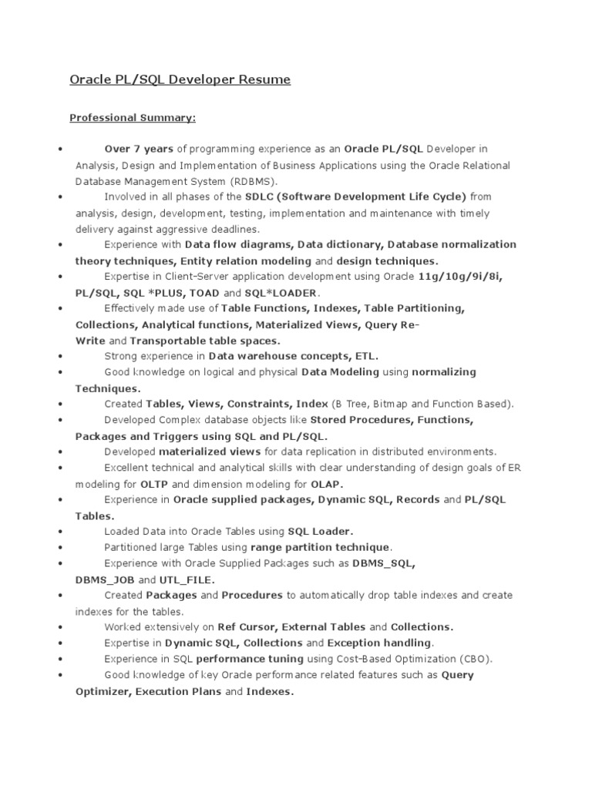

:

:

Oracle PL/SQL Developer Resume

Professional Summary:

Over 7 years of programming experience as an Oracle PL/SQL Developer in Analysis, Design and Implementation of Business Applications using the Oracle Relational Database Management System (RDBMS).

Involved in all phases of the SDLC (Software Development Life Cycle) from analysis, design, development, testing, implementation and maintenance with timely delivery against aggressive deadlines.

Experience with Data flow diagrams, Data dictionary, Database normalization theory techniques, Entity relation modeling and design techniques.

Expertise in Client-Server application development using Oracle 11g/10g/9i/8i,

PL/SQL, SQL*PLUS, TOAD and SQL*LOADER.

Effectively made use of Table Functions, Indexes, Table Partitioning, Collections, Analytical functions, Materialized Views, Query Re-

Write and Transportable table spaces.

Strong experience in Data warehouse concepts, ETL.

Good knowledge on logical and physical Data Modeling using normalizing Techniques.

Created Tables, Views, Constraints, Index (B Tree, Bitmap and Function Based). Developed Complex database objects like Stored Procedures, Functions,

Packages and Triggers using SQL and PL/SQL.

Developed materialized views for data replication in distributed environments. Excellent technical and analytical skills with clear understanding of design goals of ER modeling for OLTP and dimension modeling for OLAP.

Experience in Oracle supplied packages, Dynamic SQL, Records and PL/SQL

Tables.

Loaded Data into Orade Tables using SQL Loader.

Partitioned large Tables using range partition technique.

Experience with Oracle Supplied Packages such as DBMS_SQL,

DBMS_JOB and UTL_FILE.

Created Packages and Procedures to automatically drop table indexes and create indexes for the tables.

Worked extensively on Ref Cursor, External Tables and Collections.

Expertise in Dynamic SQL, Collections and Exception handling.

Experience in SQL performance tuning using Cost-Based Optimization (CBO).

Good knowledge of key Oracle performance related features such as Query Optimizer, Execution Plans and Indexes.