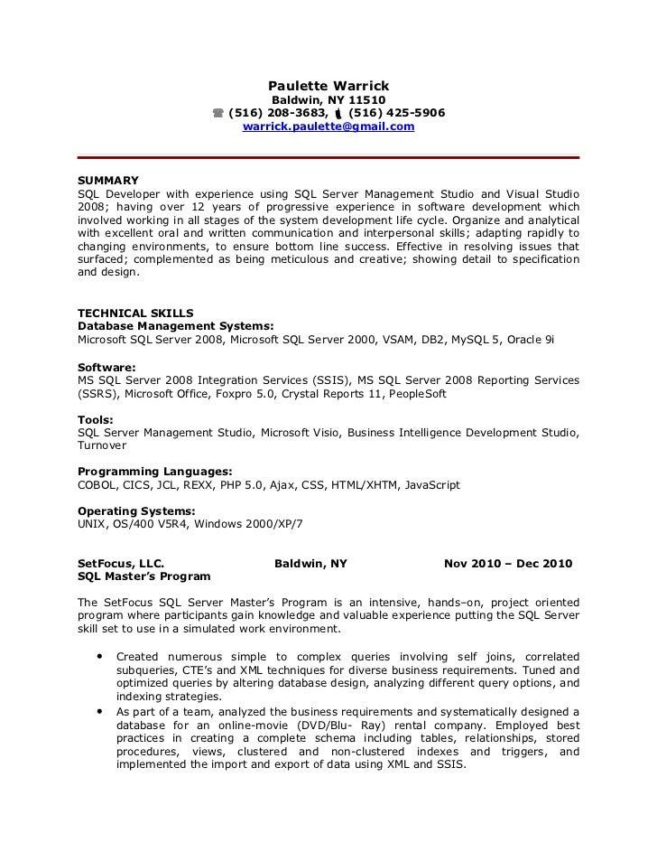

**Paulette Warrick**

**Baldwin, NY 11510**

**(516) 208-3683, (516) 425-5906**

**warrick.paulette@gmail.com**

SUMMARY

SQL Developer with experience using SQL Server Management Studio and Visual Studio 2008; having over 12 years of progressive experience in software development which involved working in all stages of the system development life cycle. Organize and analytical with excellent oral and written communication and interpersonal skills; adapting rapidly to changing environments, to ensure bottom line success. Effective in resolving issues that surfaced; complemented as being meticulous and creative; showing detail to specification and design.

**TECHNICAL SKILLS**

Database Management Systems:

Microsoft SQL Server 2008, Microsoft SQL Server 2000, VSAM, DB2, MySQL 5, Oracle 9i

**Software:**

MS SQL Server 2008 Integration Services (SSIS), MS SQL Server 2008 Reporting Services (SSRS), Microsoft Office, Foxpro 5.0, Crystal Reports 11, PeopleSoft

**Tools:**

SQL Server Management Studio, Microsoft Visio, Business Intelligence Development Studio, Turnover

**Programming Languages:**

COBOL, CICS, JCL, REXX, PHP 5.0, Ajax, CSS, HTML/XHTM, JavaScript

**Operating Systems:**

UNIX, OS/400 V5R4, Windows 2000/XP/7

**SetFocus, LLC.**

**SQL Master's Program**

**Baldwin, NY**

**Nov 2010 - Dec 2010**

The SetFocus SQL Server Master's Program is an intensive, hands-on, project oriented program where participants gain knowledge and valuable experience putting the SQL Server skill set to use in a simulated work environment.

• Created numerous simple to complex queries involving self joins, correlated subqueries, CTE's and XML techniques for diverse business requirements. Tuned and optimized queries by altering database design, analyzing different query options, and indexing strategies.

• As part of a team, analyzed the business requirements and systematically designed a database for an online-movie (DVD/Blu-Ray) rental company. Employed best practices in creating a complete schema including tables, relationships, stored procedures, views, clustered and non-clustered indexes and triggers, and implemented the import and export of data using XML and SSIS.