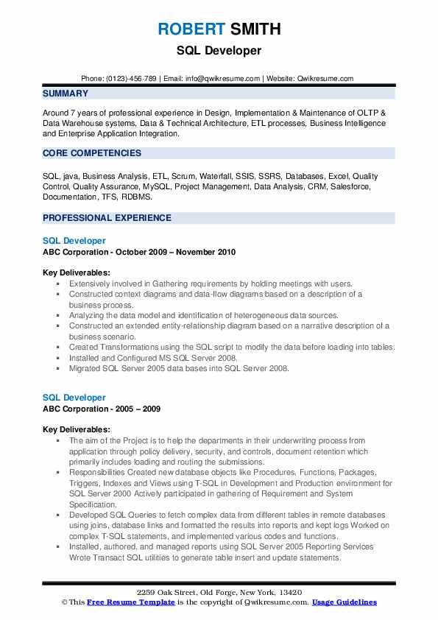

ROBERT SMITH SQL Developer

Phone: (0123)-456-789 | Email: info@qwikresume.com | Website: Qwikresume.com

SUMMARY

Around 7 years of professional experience in Design, Implementation & Maintenance of OLTP & Data Warehouse systems, Data & Technical Architecture, ETL processes, Business Intelligence and Enterprise Application Integration.

CORE COMPETENCIES

SQL, java, Business Analysis, ETL, Scrum, Waterfall, SSIS, SSRS, Databases, Excel, Quality Control, Quality Assurance, MySQL, Project Management, Data Analysis, CRM, Salesforce, Documentation, TFS, RDBMS.

PROFESSIONAL EXPERIENCE

SQL Developer

ABC Corporation - October 2009 November 2010

Key Deliverables:

•Extensively involved in Gathering requirements by holding meetings with users.

• Constructed context diagrams and data flow diagrams based on a description of a business process.

• Analyzing the data model and identification of heterogeneous data sources.

⚫ Constructed an extended entity relationship diagram based on a narrative description of a business scenario.

• Created Transformations using the SQL script to modify the data before loading into tables Installed and Configured MS SQL Server 2008,

⚫ Migrated SQL Server 2005 data bases into SQL Server 2008.

SQL Developer

ABC Corporation - 2005-2009

Key Deliverables:

The aim of the Project is to help the departments in their underwriting process from application through policy delivery, security, and controls, document retention which primarily includes loading and routing the submissions.

• Responsibilities Created new database objects like Procedures, Functions, Packages, Triggers, Indexes and Views using T-SQL in Development and Production environment for SOL Server 2000 Actively participated in gathering of Requirement and System Specification,

• Developed SQL Queries to fetch complex data from different tables in remote databases using joins, database links and formatted the results into reports and kept logs Worked on complex T-SQL statements, and implemented various codes and functions. Installed, authored, and managed reports using SQL Server 2005 Reporting Services Wrote Transact SQL utilities to generate table insert and update statements.

2259 Oak Street, Old Forge, New York, 13420

©This Free Resume Template is the copyright of Qwik resume.com. Usage Guidelines