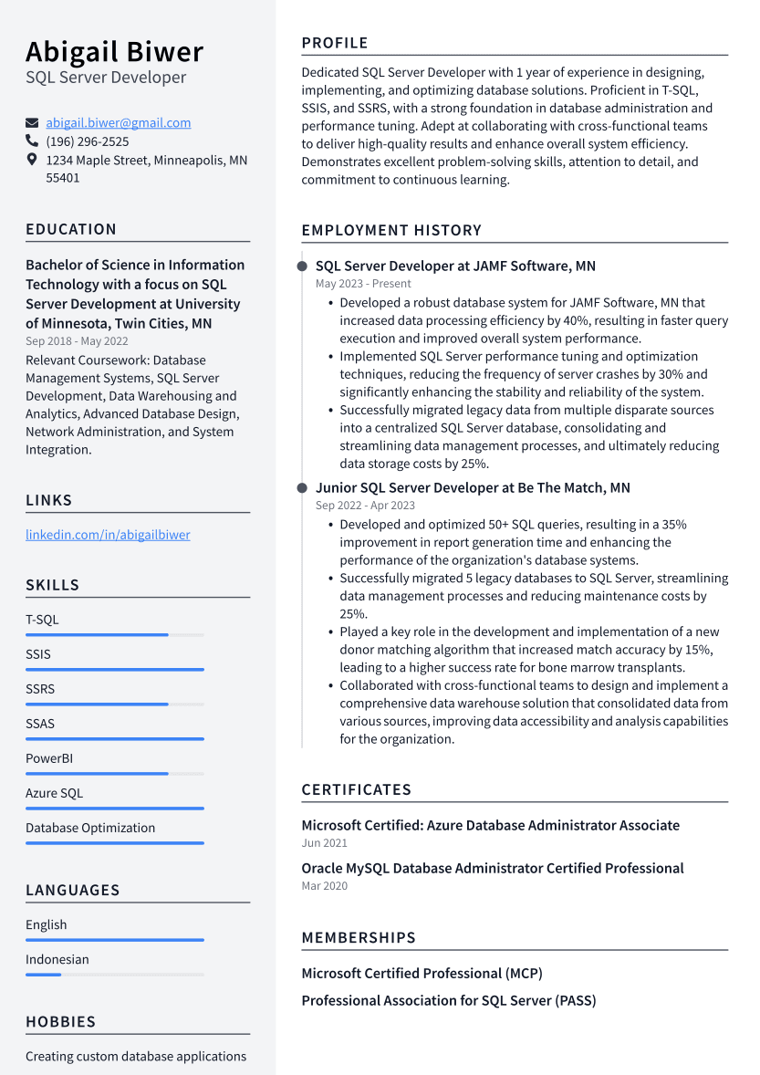

Abigail Biwer

SQL Server Developer

abigail.biwer@gmail.com (196) 296-2525

1234 Maple Street, Minneapolis, MN 55401

EDUCATION

Bachelor of Science in Information Technology with a focus on SQL Server Development at University of Minnesota, Twin Cities, MN Sep 2018 - May 2022

Relevant Coursework: Database Management Systems, SQL Server Development, Data Warehousing and Analytics, Advanced Database Design, Network Administration, and System Integration.

LINKS

linkedin.com/in/abigailbiwer

SKILLS

T-SQL

SSIS

SSRS

SSAS

PowerBI

Azure SQL

Database Optimization

PROFILE

Dedicated SQL Server Developer with 1 year of experience in designing, implementing, and optimizing database solutions. Proficient in T-SQL, SSIS, and SSRS, with a strong foundation in database administration and performance tuning. Adept at collaborating with cross-functional teams to deliver high-quality results and enhance overall system efficiency. Demonstrates excellent problem-solving skills, attention to detail, and commitment to continuous learning.

EMPLOYMENT HISTORY

SQL Server Developer at JAMF Software, MN May 2023 - Present

• Developed a robust database system for JAMF Software, MN that increased data processing efficiency by 40%, resulting in faster query execution and improved overall system performance.

• Implemented SQL Server performance tuning and optimization techniques, reducing the frequency of server crashes by 30% and significantly enhancing the stability and reliability of the system.

• Successfully migrated legacy data from multiple disparate sources into a centralized SQL Server database, consolidating and

streamlining data management processes, and ultimately reducing data storage costs by 25%.

Junior SQL Server Developer at Be The Match, MN Sep 2022-Apr 2023

• Developed and optimized 50+ SQL queries, resulting in a 35% improvement in report generation time and enhancing the performance of the organization's database systems.

• Successfully migrated 5 legacy databases to SQL Server, streamlining data management processes and reducing maintenance costs by 25%.

• Played a key role in the development and implementation of a new donor matching algorithm that increased match accuracy by 15%, leading to a higher success rate for bone marrow transplants.

• Collaborated with cross-functional teams to design and implement a comprehensive data warehouse solution that consolidated data from various sources, improving data accessibility and analysis capabilities for the organization.

CERTIFICATES

Microsoft Certified: Azure Database Administrator Associate Jun 2021

Oracle MySQL Database Administrator Certified Professional Mar 2020

LANGUAGES

English

Indonesian

HOBBIES

Creating custom database applications

MEMBERSHIPS

Microsoft Certified Professional (MCP)

Professional Association for SQL Server (PASS)