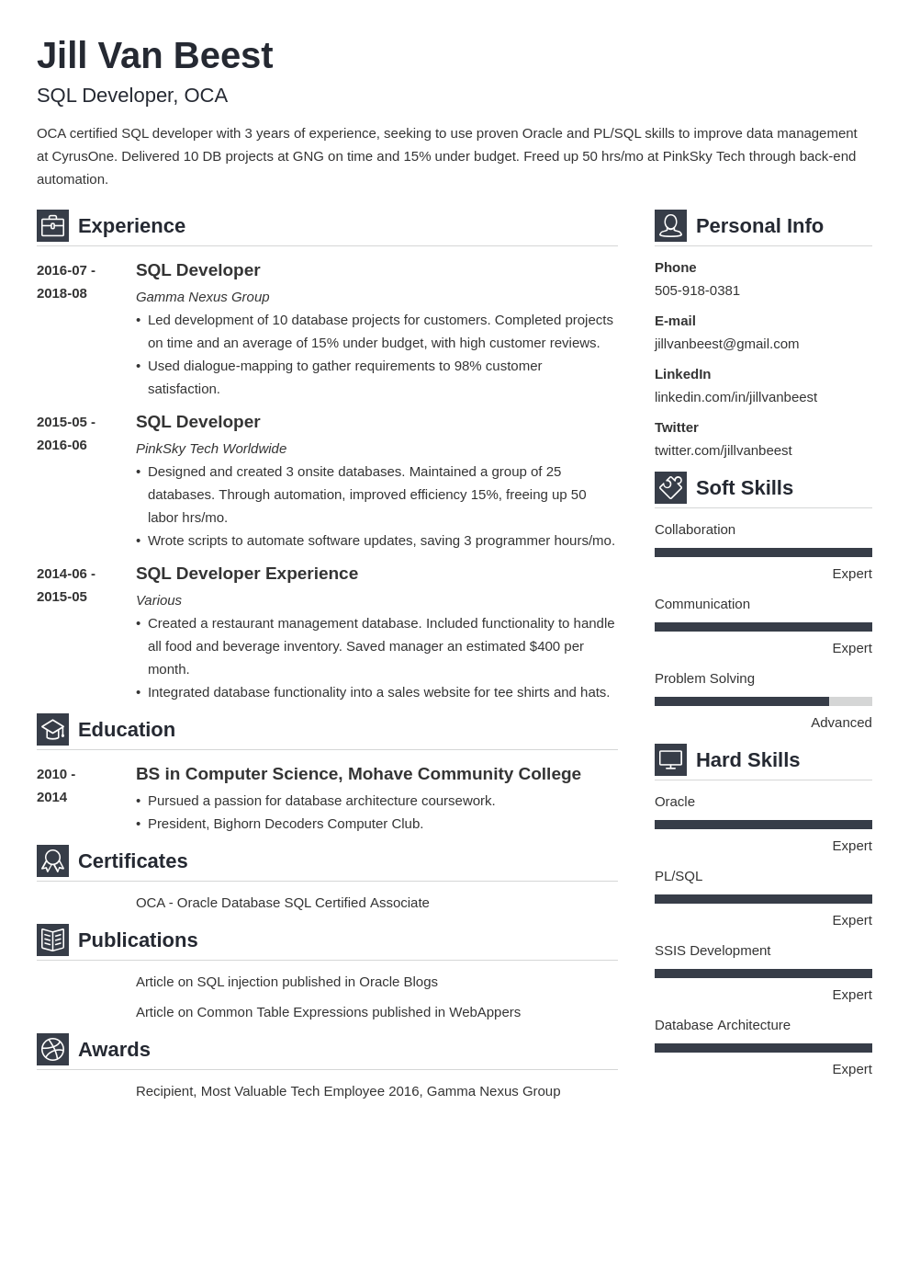

**Jill Van Beest**

SQL Developer, OCA

OCA certified SQL developer with 3 years of experience, seeking to use proven Oracle and PL/SQL skills to improve data management at CyrusOne. Delivered 10 DB projects at GNG on time and 15% under budget. Freed up 50 hrs/mo at PinkSky Tech through back-end automation.

**Experience**

2016-07-

SQL Developer

2018-08

*Gamma Nexus Group*

• Led development of 10 database projects for customers. Completed projects on time and an average of 15% under budget, with high customer reviews.

Phone

**Personal Info**

505-918-0381

E-mail

jillvanbeest@gmail.com

**LinkedIn**

2015-05-

**2016-06**

• Used dialogue-mapping to gather requirements to 98% customer satisfaction.

SQL Developer

*PinkSky Tech Worldwide*

• Designed and created 3 onsite databases. Maintained a group of 25 databases. Through automation, improved efficiency 15%, freeing up 50 labor hrs/mo.

• Wrote scripts to automate software updates, saving 3 programmer hours/mo.

linkedin.com/in/jillvanbeest

Twitter

twitter.com/jillvanbeest

**Soft Skills**

Collaboration

**2014-06- 2015-05**

**SQL Developer Experience**

*Various*

Expert

Communication

• Created a restaurant management database. Included functionality to handle all food and beverage inventory. Saved manager an estimated $400 per month.

• Integrated database functionality into a sales website for tee shirts and hats.

Expert

Problem Solving

**Education**

Advanced

**Hard Skills**

2010 -

**2014**

**BS in Computer Science, Mohave Community College • Pursued a passion for database architecture coursework.**

Oracle

• President, Bighorn Decoders Computer Club.

**Certificates**

OCA - Oracle Database SQL Certified Associate

**Publications**

Article on SQL injection published in Oracle Blogs

Article on Common Table Expressions published in WebAppers

**Awards**

Recipient, Most Valuable Tech Employee 2016, Gamma Nexus Group

Expert

PL/SQL

Expert

SSIS Development

Expert

Database Architecture

Expert