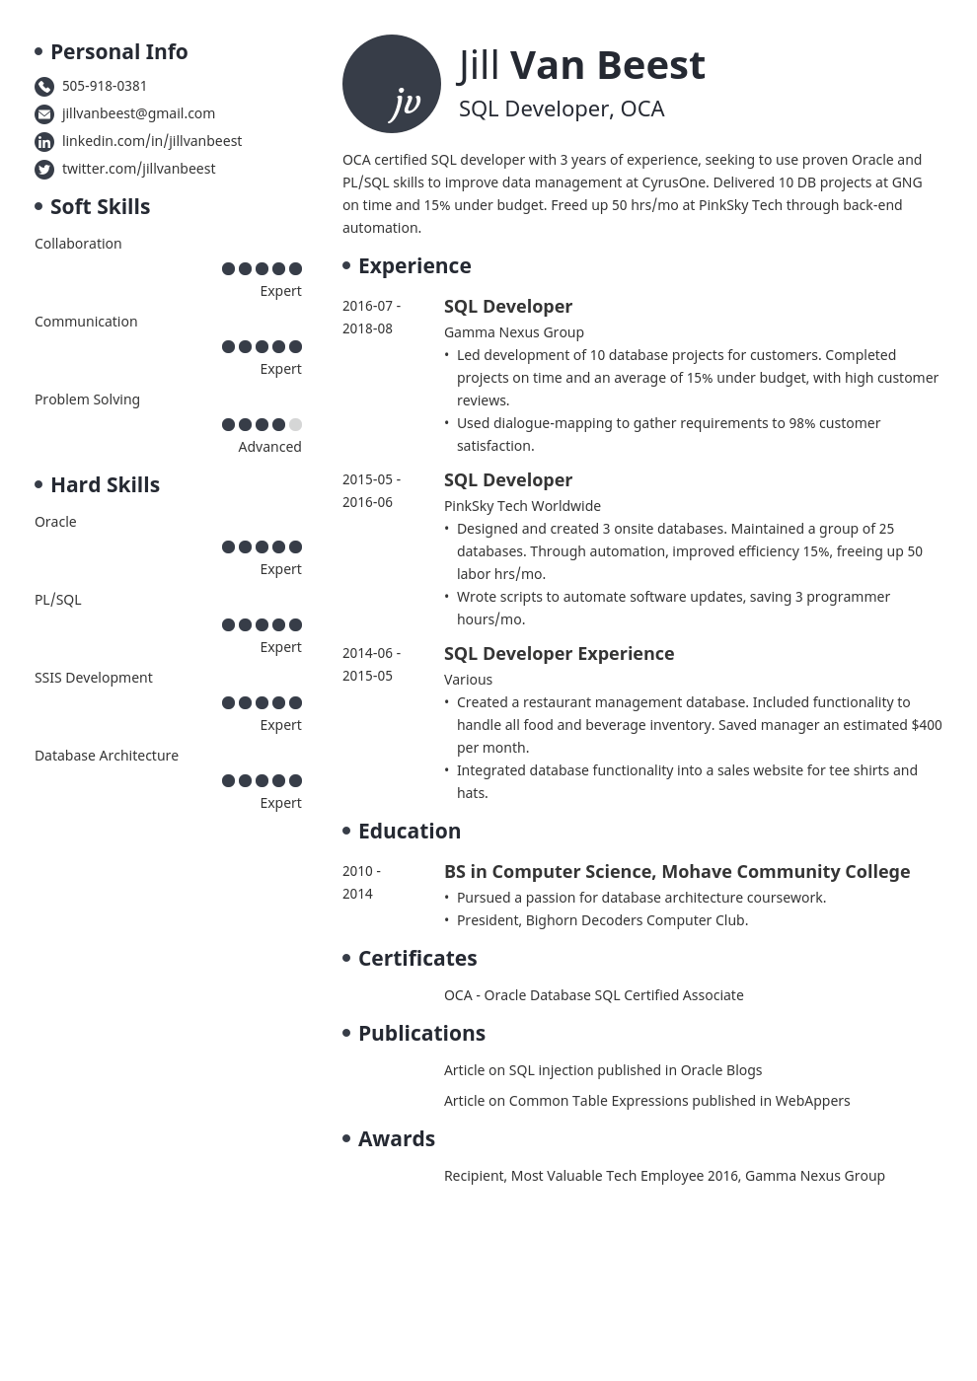

**• Personal Info**

505-918-0381

jillvanbeest@gmail.com

in linkedin.com/in/jillvanbeest twitter.com/jillvanbeest

**• Soft Skills**

Collaboration

Jill Van Beest ju SQL Developer, OCA

OCA certified SQL developer with 3 years of experience, seeking to use proven Oracle and PL/SQL skills to improve data management at CyrusOne. Delivered 10 DB projects at GNG on time and 15% under budget. Freed up 50 hrs/mo at PinkSky Tech through back-end

automation.

**Experience**

Expert

Communication

2016-07- 2018-08

Expert

Problem Solving

Advanced

**• Hard Skills**

2015-05- 2016-06

Oracle

PL/SQL

Expert

Expert

SSIS Development

2014-06- 2015-05

Expert

Database Architecture

Expert

**SQL Developer**

Gamma Nexus Group

• Led development of 10 database projects for customers. Completed projects on time and an average of 15% under budget, with high customer

reviews.

• Used dialogue-mapping to gather requirements to 98% customer satisfaction.

**SQL Developer**

PinkSky Tech Worldwide

• Designed and created 3 onsite databases. Maintained a group of 25 databases. Through automation, improved efficiency 15%, freeing up 50 labor hrs/mo.

• Wrote scripts to automate software updates, saving 3 programmer hours/mo.

**SQL Developer Experience**

Various

• Created a restaurant management database. Included functionality to handle all food and beverage inventory. Saved manager an estimated $400 per month.

• Integrated database functionality into a sales website for tee shirts and hats.

**• Education**

2010-

2014

**BS in Computer Science, Mohave Community College • Pursued a passion for database architecture coursework.**

• President, Bighorn Decoders Computer Club.

**• Certificates**

OCA - Oracle Database SQL Certified Associate

**• Publications**

**• Awards**

Article on SQL injection published in Oracle Blogs

Article on Common Table Expressions published in WebAppers

Recipient, Most Valuable Tech Employee 2016, Gamma Nexus Group