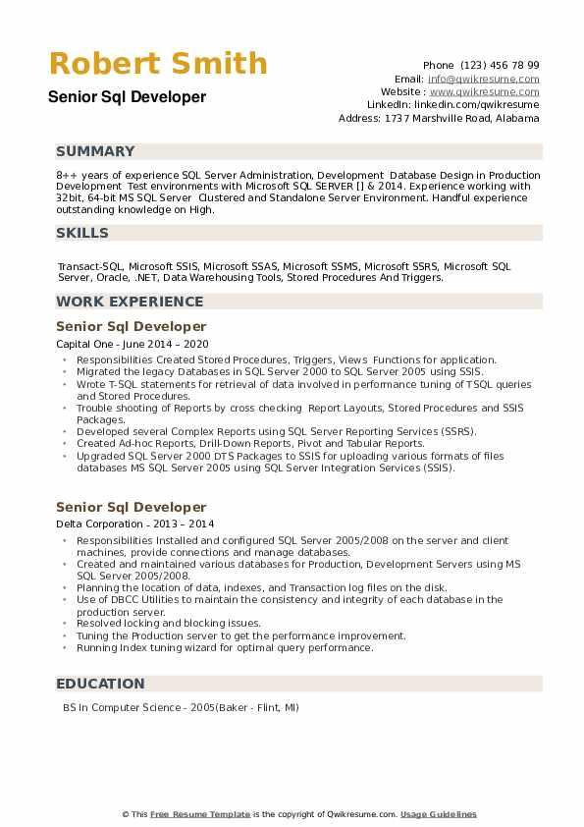

Robert Smith Senior Sql Developer

Phone (123) 456 78 99

Email: info@qwikresume.com

Website: www.qwikresume.com Linkedin: linkedin.com/qwikresume Address: 1737 Marshville Road, Alabama

**SUMMARY**

8++ years of experience SQL Server Administration, Development Database Design in Production Development Test environments with Microsoft SQL SERVER [] & 2014. Experience working with 32 bit, 64-bit MS SQL Server Clustered and Standalone Server Environment. Handful experience outstanding knowledge on High.

**SKILLS**

Transact-SQL, Microsoft SSIS, Microsoft SSAS, Microsoft SSMS, Microsoft SSRS, Microsoft SQL Server, Oracle, .NET, Data Warehousing Tools, Stored Procedures And Triggers.

**WORK EXPERIENCE**

Senior Sql Developer

Capital One - June 2014-2020

• Responsibilities Created Stored Procedures, Triggers, Views Functions for application.

⚫ Migrated the legacy Databases in SQL Server 2000 to SQL Server 2005 using SSIS.

⚫ Wrote T-SQL statements for retrieval of data involved in performance tuning of TSQL queries and Stored Procedures.

⚫ Trouble shooting of Reports by cross checking Report Layouts, Stored Procedures and SSIS Packages.

• Developed several Complex Reports using SQL Server Reporting Services (SSRS).

• Created Ad-hoc Reports, Drill-Down Reports, Pivot and Tabular Reports.

⚫ Upgraded SQL Server 2000 DTS Packages to SSIS for uploading various formats of files databases MS SQL Server 2005 using SQL Server Integration Services (SSIS).

Senior Sql Developer

Delta Corporation 2013-2014

• Responsibilities Installed and configured SQL Server 2005/2008 on the server and client machines, provide connections and manage databases.

• Created and maintained various databases for Production, Development Servers using MS SQL Server 2005/2008.

⚫ Planning the location of data, indexes, and Transaction log files on the disk.

Use of DBCC Utilities to maintain the consistency and integrity of each database in the production server.

Resolved locking and blocking issues.

Tuning the Production server to get the performance improvement.

⚫Running Index tuning wizard for optimal query performance.

**EDUCATION**

BS in Computer Science-2005 (Baker - Flint, MI)

This Free Resume Template is the copyright of Qwikresume.com. Usage Guidelines