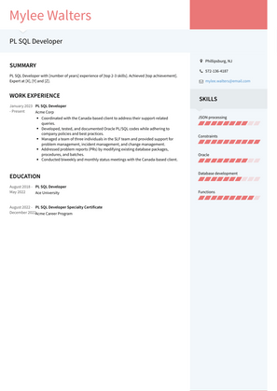

Mylee Walters

**PL SQL Developer**

SUMMARY

PLSQL with me of year experience of pop 3-3 skill, Achieved op achie

WORK EXPERIENCE

Condit with the Canadiens their support related

blackly and monthly Rates meetings with the Canada and client

EDUCATION

SKILLS