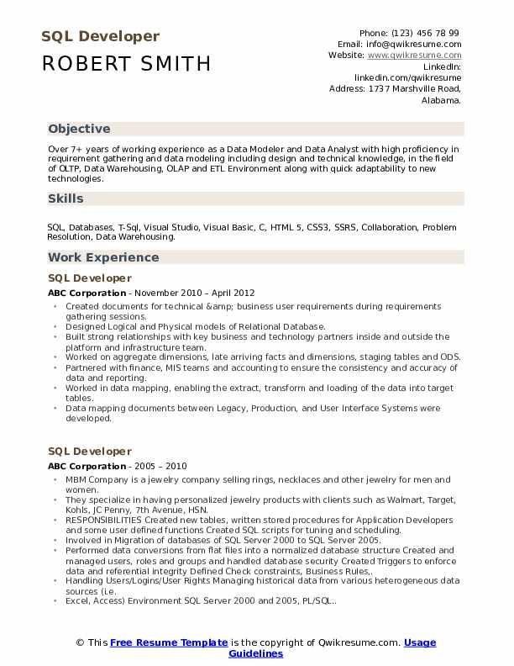

SQL Developer ROBERT SMITH

Phone: (123) 456 78 99 Email: info@qwikresume.com Website: www.qwikresume.com

Linkedin:

linkedin.com/qwikresume

Address: 1737 Marshville Road, Alabama.

**Objective**

Over 7+ years of working experience as a Data Modeler and Data Analyst with high proficiency in requirement gathering and data modeling including design and technical knowledge, in the field of OLTP, Data Warehousing, OLAP and ETL Environment along with quick adaptability to new technologies.

Skills

SQL Databases, T-Sql, Visual Studio, Visual Basic, C, HTML 5, CSS3, SSRS, Collaboration, Problem Resolution, Data Warehousing.

**Work Experience**

SQL Developer

ABC Corporation - November 2010 April 2012

• Created documents for technical &amp; business user requirements during requirements gathering sessions.

⚫ Designed Logical and Physical models of Relational Database.

⚫Built strong relationships with key business and technology partners inside and outside the platform and infrastructure team.

• Worked on aggregate dimensions, late arriving facts and dimensions, staging tables and ODS. Partnered with finance, MIS teams and accounting to ensure the consistency and accuracy of data and reporting.

• Worked in data mapping, enabling the extract, transform and loading of the data into target tables.

⚫Data mapping documents between Legacy, Production, and User Interface Systems were developed,

SQL Developer

ABC Corporation - 2005 - 2010

• MBM Company is a jewelry company selling rings, necklaces and other jewelry for men and women.

⚫ They specialize in having personalized jewelry products with clients such as Walmart, Target, Kohls, JC Penny, 7th Avenue, HSN.

⚫ RESPONSIBILITIES Created new tables, written stored procedures for Application Developers and some user defined functions Created SQL scripts for tuning and scheduling.

"

Involved in Migration of databases of SQL Server 2000 to SQL Server 2005.

Performed data conversions from flat files into a normalized database structure Created and

managed users, roles and groups and handled database security Created Triggers to enforce data and referential integrity Defined Check constraints, Business Rules..

Handling Users/Logins/User Rights Managing historical data from various heterogeneous data sources (Le..

• Excel, Access) Environment SQL Server 2000 and 2005, PL/SQL..

© This Free Resume Template is the copyright of Qwikresume.com. Usage

Guidelines