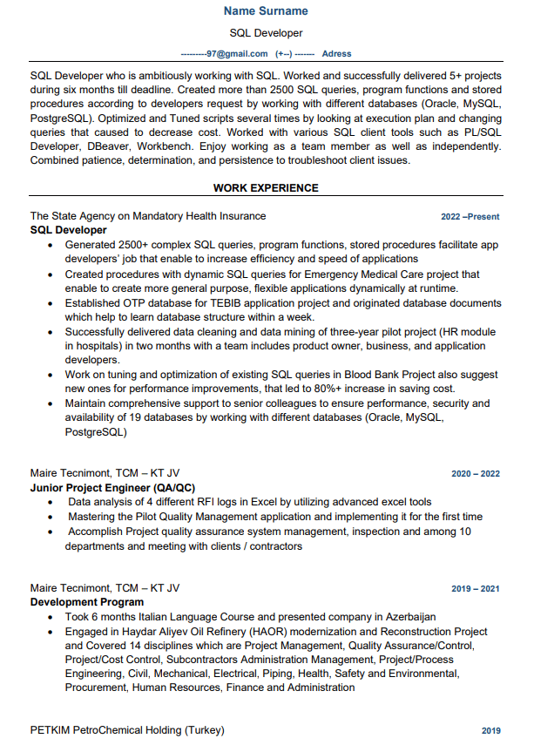

**Name Surname**

SQL Developer

---97@gmail.com (+-)---- Adress

SQL Developer who is ambitiously working with SQL. Worked and successfully delivered 5+ projects during six months till deadline. Created more than 2500 SQL queries, program functions and stored procedures according to developers request by working with different databases (Oracle, MySQL, PostgreSQL). Optimized and Tuned scripts several times by looking at execution plan and changing queries that caused to decrease cost. Worked with various SQL client tools such as PL/SQL Developer, DBeaver, Workbench. Enjoy working as a team member as well as independently. Combined patience, determination, and persistence to troubleshoot client issues.

**WORK EXPERIENCE**

The State Agency on Mandatory Health Insurance

SQL Developer

2022-Present

• Generated 2500+ complex SQL queries, program functions, stored procedures facilitate app developers' job that enable to increase efficiency and speed of applications

• Created procedures with dynamic SQL queries for Emergency Medical Care project that enable to create more general purpose, flexible applications dynamically at runtime.

• Established OTP database for TEBIB application project and originated database documents which help to learn database structure within a week.

• Successfully delivered data cleaning and data mining of three-year pilot project (HR module in hospitals) in two months with a team includes product owner, business, and application developers.

• Work on tuning and optimization of existing SQL queries in Blood Bank Project also suggest new ones for performance improvements, that led to 80%+ increase in saving cost.

• Maintain comprehensive support to senior colleagues to ensure performance, security and availability of 19 databases by working with different databases (Oracle, MySQL, PostgreSQL)

Maire Tecnimont, TCM -KT JV

**Junior Project Engineer (QA/QC)**

•

2020-2022

Data analysis of 4 different RFI logs in Excel by utilizing advanced excel tools Mastering the Pilot Quality Management application and implementing it for the first time

• Accomplish Project quality assurance system management, inspection and among 10 departments and meeting with clients/contractors

Maire Tecnimont, TCM -KT JV

Development Program

⚫ Took 6 months Italian Language Course and presented company in Azerbaijan

**2019-2021**

• Engaged in Haydar Aliyev Oil Refinery (HAOR) modernization and Reconstruction Project and Covered 14 disciplines which are Project Management, Quality Assurance/Control, Project/Cost Control, Subcontractors Administration Management, Project/Process Engineering, Civil, Mechanical, Electrical, Piping, Health, Safety and Environmental, Procurement, Human Resources, Finance and Administration

PETKIM PetroChemical Holding (Turkey)

2019