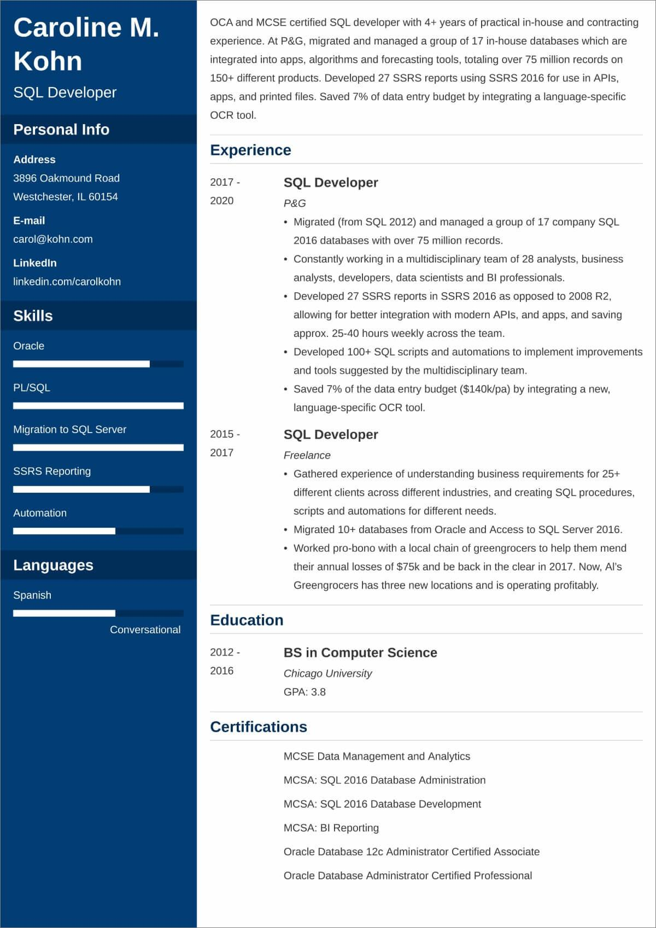

**Caroline M. Kohn**

SQL Developer

**Personal Info**

**Address**

3896 Oakmound Road

Westchester, IL 60154

OCA and MCSE certified SQL developer with 4+ years of practical in-house and contracting experience. At P&G, migrated and managed a group of 17 in-house databases which are integrated into apps, algorithms and forecasting tools, totaling over 75 million records on 150+ different products. Developed 27 SSRS reports using SSRS 2016 for use in APIs, apps, and printed files. Saved 7% of data entry budget by integrating a language-specific OCR tool.

2017-

2020

**E-mail**

carol@kohn.com

**LinkedIn**

linkedin.com/carolkohn

**Skills**

Oracle

PL/SQL

**Experience**

**SQL Developer**

P&G

.

Migrated (from SQL 2012) and managed a group of 17 company SQL 2016 databases with over 75 million records.

• Constantly working in a multidisciplinary team of 28 analysts, business

·

·

analysts, developers, data scientists and BI professionals.

Developed 27 SSRS reports in SSRS 2016 as opposed to 2008 R2,

allowing for better integration with modern APIs, and apps, and saving

approx. 25-40 hours weekly across the team.

Developed 100+ SQL scripts and automations to implement improvements and tools suggested by the multidisciplinary team.

⚫ Saved 7% of the data entry budget ($140k/pa) by integrating a new, language-specific OCR tool.

SQL Developer

*Freelance*

• Gathered experience of understanding business requirements for 25+ different clients across different industries, and creating SQL procedures, scripts and automations for different needs.

• Migrated 10+ databases from Oracle and Access to SQL Server 2016.

• Worked pro-bono with a local chain of greengrocers to help them mend their annual losses of $75k and be back in the clear in 2017. Now, Al's Greengrocers has three new locations and is operating profitably.

Migration to SQL Server

2015-

2017

SSRS Reporting

Automation

**Languages**

Spanish

Conversational

2012-

**Education**

2016

BS in Computer Science

*Chicago University*

GPA: 3.8

**Certifications**

MCSE Data Management and Analytics

MCSA: SQL 2016 Database Administration

MCSA: SQL 2016 Database Development

MCSA: BI Reporting

Oracle Database 12c Administrator Certified Associate

Oracle Database Administrator Certified Professional