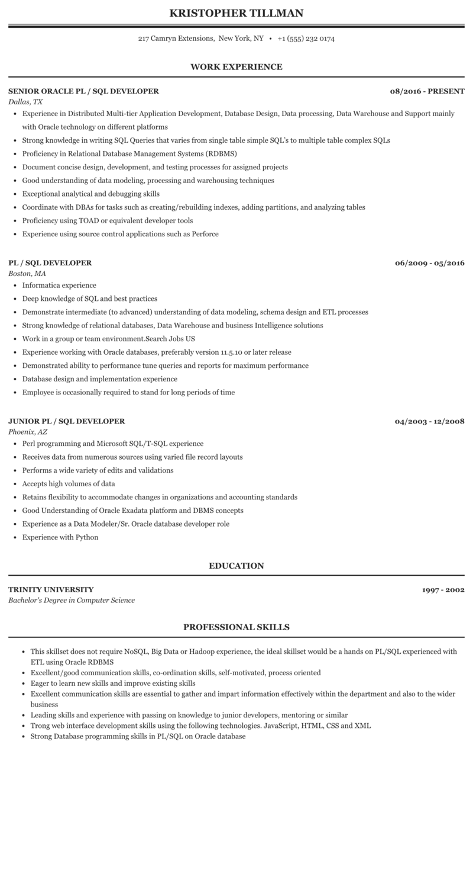

**KRISTOPHER TILLMAN**

217 Camryn Extensions, New York, NY⚫ +1 (555) 232 0174

**WORK EXPERIENCE**

**SENIOR ORACLE PL/SQL DEVELOPER**

*Dallas, TX*

**08/2016 - PRESENT**

• Experience in Distributed Multi-tier Application Development, Database Design, Data processing, Data Warehouse and Support mainly with Oracle technology on different platforms

• Strong knowledge in writing SQL Queries that varies from single table simple SQL's to multiple table complex SQLS

• Proficiency in Relational Database Management Systems (RDBMS)

• Document concise design, development, and testing processes for assigned projects

• Good understanding of data modeling, processing and warehousing techniques

• Exceptional analytical and debugging skills

• Coordinate with DBAs for tasks such as creating/rebuilding indexes, adding partitions, and analyzing tables

• Proficiency using TOAD or equivalent developer tools

• Experience using source control applications such as Perforce

**PL/SQL DEVELOPER**

Boston, MA

• Informatica experience

• Deep knowledge of SQL and best practices

• Demonstrate intermediate (to advanced) understanding of data modeling, schema design and ETL processes

• Strong knowledge of relational databases, Data Warehouse and business Intelligence solutions

• Work in a group or team environment.Search Jobs US

• Experience working with Oracle databases, preferably version 11.5.10 or later release

• Demonstrated ability to performance tune queries and reports for maximum performance

⚫ Database design and implementation experience

• Employee is occasionally required to stand for long periods of time

**JUNIOR PL/SQL DEVELOPER**

*Phoenix, AZ*

• Perl programming and Microsoft SQL/T-SQL experience

• Receives data from numerous sources using varied file record layouts

• Performs a wide variety of edits and validations

• Accepts high volumes of data

• Retains flexibility to accommodate changes in organizations and accounting standards

• Good Understanding of Oracle Exadata platform and DBMS concepts

• Experience as a Data Modeler/Sr. Oracle database developer role

• Experience with Python

**06/2009 - 05/2016**

**04/2003 - 12/2008**

**TRINITY UNIVERSITY**

*Bachelor's Degree in Computer Science*

**EDUCATION**

**PROFESSIONAL SKILLS**

**1997-2002**

This skillset does not require NoSQL, Big Data or Hadoop experience, the ideal skillset would be a hands on PL/SQL experienced with ETL using Oracle RDBMS

• Excellent/good communication skills, co-ordination skills, self-motivated, process oriented

⚫ Eager to learn new skills and improve existing skills

• Excellent communication skills are essential to gather and impart information effectively within the department and also to the wider business

• Leading skills and experience with passing on knowledge to junior developers, mentoring or similar

⚫ Trong web interface development skills using the following technologies. JavaScript, HTML, CSS and XML

• Strong Database programming skills in PL/SQL on Oracle database