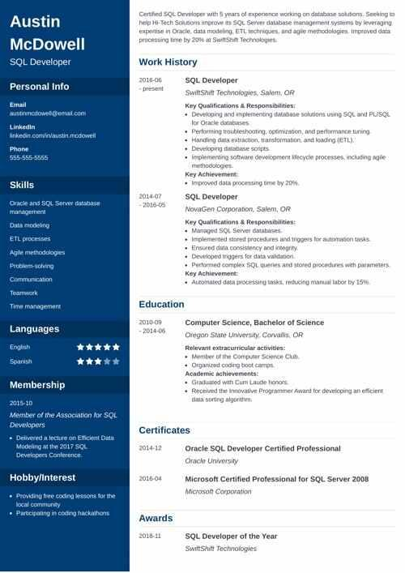

**Austin McDowell**

SQL Developer

Certified SQL Developer with 5 years of experience working on database solutions. Seeking help Hi-Tech Solutions improve its SQL Server database management systems by leveraging expertise in Oracle, data modeling, ETL techniques, and agile methodologies improved data processing time by 20% at SwiftShit Technologies

Work History

Personal Info

2016-06 -present

Email

austinmotoweb@email.com

Linkedin

**inkedin.com/in/austin.mcdowell**

Phone

555-555-5555

Skills

Oracle and SQL Server database

**management**

**Duta modeling**

**ETL processes**

**Agile methodologies**

Problem-solving

Communication

Teamwork

Time management

Languages

English

Spanish

Membership

2015-10

2014-07

2016-05

Education

2010-09 -2014-06

SQL Developer

Swift Shift Technologies, Salem, OR

Key Qualifications & Responsibilities:

Developing and implementing database solutions using SQL and PL/SQL for Oracle databases

Performing troubleshooting, optimization, and performance tuning

Handling data extraction, transformation and loading (ETL).

• Developing database scripts

⚫implementing software development Mecycle processes, including agile methodologies.

Key Achievement

**• Improved data processing time by 20%.**

SQL Developer

NovaGen Corporation, Salem, OR

Key Qualifications & Responsibilities:

Managed SQL Server databases.

**Implemented storest procedures and triggers for automation tasks •Ensured data consistency and incognity**

**•Developed triggers for data validation**

Performed complex SQL queries and stored procedures with parameters Key Achievement:

• Automated data processing tasks, reducing manual labor by 1596.

Computer Science, Bachelor of Science

Oregon State University, Corvallis, OR

**Relevant extracurricular activities:**

Member of the Computer Science Clu

• Organized coding boot camps.

Academic achievements:

Graduated with Cum Laude honors

• Received the innovative Programmer Award for developing an efficient dala sorting algorithm

Member of the Association for SQL Developers

• Delivered a lecture on Efficient Data

Modeling at the 2017 SQL

2014-12

Developers Conference

Hobby/Interest

• Providing free coding lessons for the local community

• Participating in coding hackathons

Certificates

Oracle SQL Developer Certified Professional Oracle University

2016-04

Microsoft Certified Professional for SQL Server 2008 Microsoft Corporation

Awards

2018-11

SQL Developer of the Year SwitShift Technologies