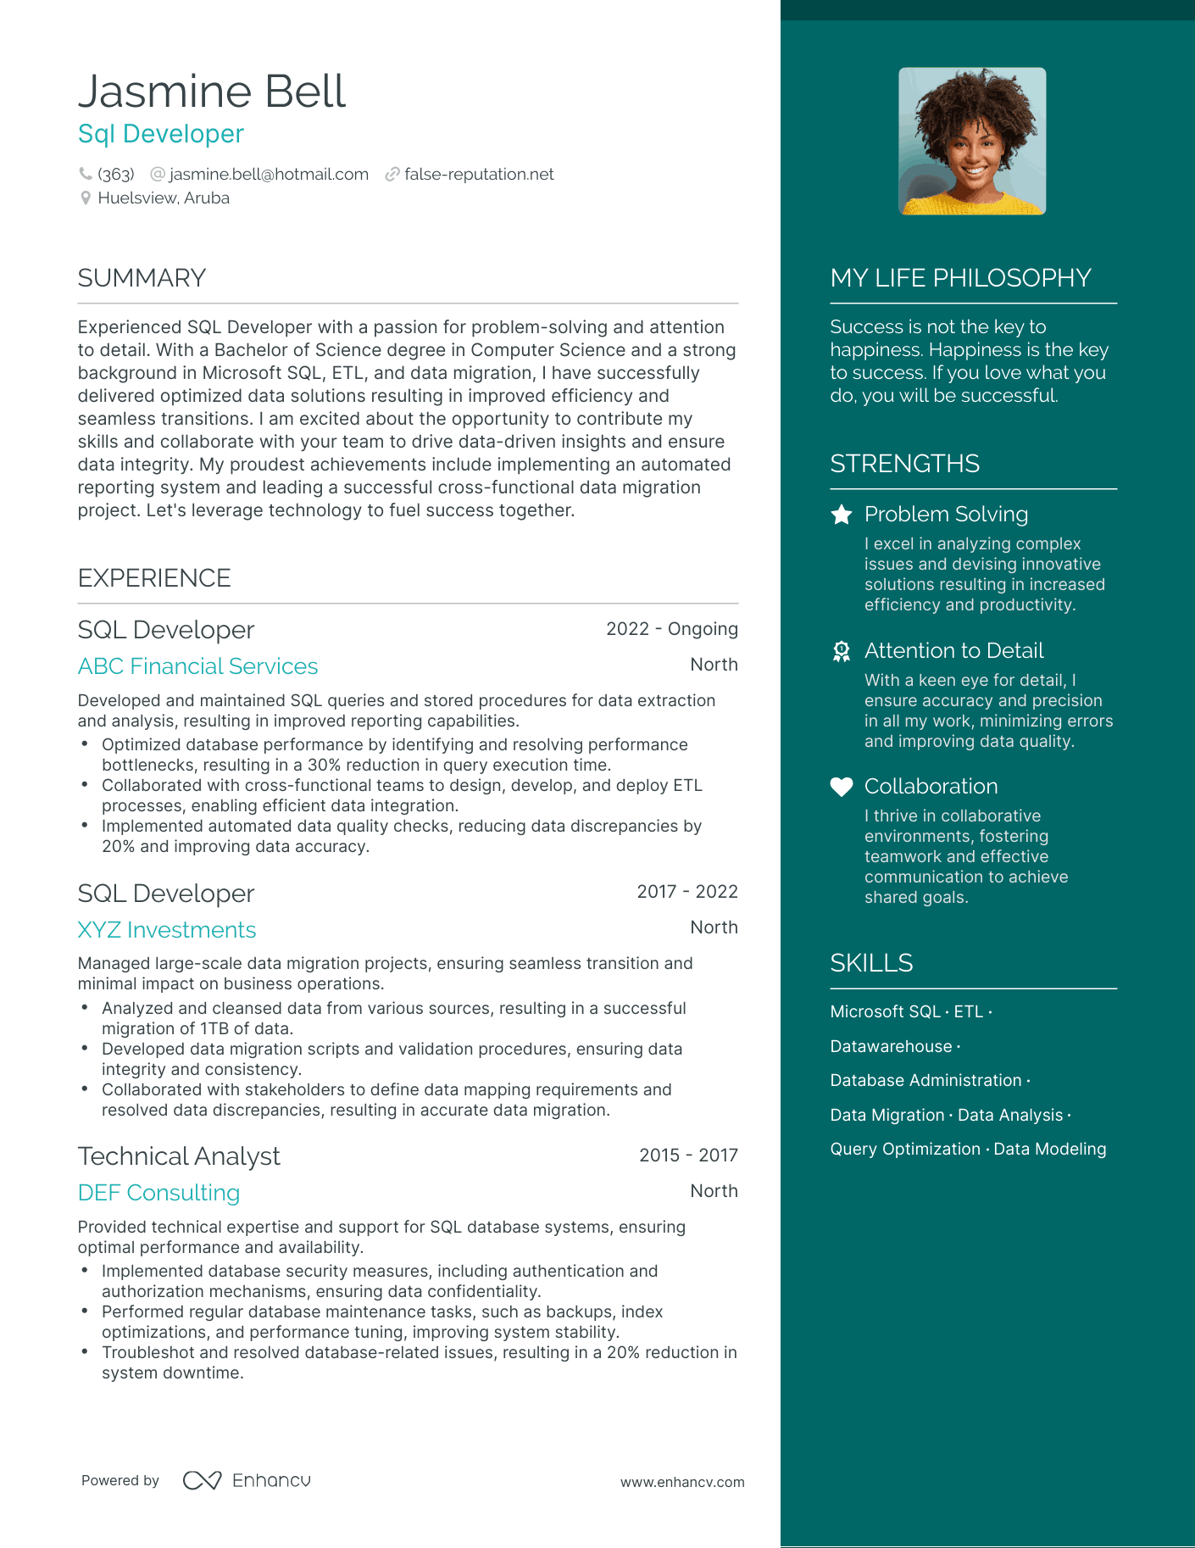

Jasmine Bell

Sql Developer

(363) @jasmine.bell@hotmail.com false-reputation.net Huelsview, Aruba

SUMMARY

Experienced SQL Developer with a passion for problem-solving and attention to detail. With a Bachelor of Science degree in Computer Science and a strong background in Microsoft SQL, ETL, and data migration, I have successfully delivered optimized data solutions resulting in improved efficiency and seamless transitions. I am excited about the opportunity to contribute my skills and collaborate with your team to drive data-driven insights and ensure data integrity. My proudest achievements include implementing an automated reporting system and leading a successful cross-functional data migration project. Let's leverage technology to fuel success together.

EXPERIENCE

SQL Developer

ABC Financial Services

2022 - Ongoing

North

Developed and maintained SQL queries and stored procedures for data extraction and analysis, resulting in improved reporting capabilities.

•

Optimized database performance by identifying and resolving performance bottlenecks, resulting in a 30% reduction in query execution time.

•

•

Collaborated with cross-functional teams to design, develop, and deploy ETL processes, enabling efficient data integration.

Implemented automated data quality checks, reducing data discrepancies by 20% and improving data accuracy.

SQL Developer

XYZ Investments

2017-2022

North

Managed large-scale data migration projects, ensuring seamless transition and minimal impact on business operations.

• Analyzed and cleansed data from various sources, resulting in a successful migration of 1TB of data.

• Developed data migration scripts and validation procedures, ensuring data integrity and consistency.

• Collaborated with stakeholders to define data mapping requirements and resolved data discrepancies, resulting in accurate data migration.

MY LIFE PHILOSOPHY

Success is not the key to happiness. Happiness is the key to success. If you love what you do, you will be successful.

STRENGTHS

Problem Solving

I excel in analyzing complex issues and devising innovative solutions resulting in increased efficiency and productivity.

Attention to Detail

With a keen eye for detail, I ensure accuracy and precision in all my work, minimizing errors and improving data quality.

Collaboration

I thrive in collaborative environments, fostering teamwork and effective communication to achieve shared goals.

SKILLS

Microsoft SQL. ETL .

Datawarehouse.

Database Administration.

Data Migration · Data Analysis.

Query Optimization · Data Modeling

Technical Analyst

DEF Consulting

2015-2017

North

Provided technical expertise and support for SQL database systems, ensuring optimal performance and availability.

• Implemented database security measures, including authentication and authorization mechanisms, ensuring data confidentiality.

• Performed regular database maintenance tasks, such as backups, index

optimizations, and performance tuning, improving system stability.

• Troubleshot and resolved database-related issues, resulting in a 20% reduction in system downtime.

Powered by ∞ Enhancu

www.enhancv.com