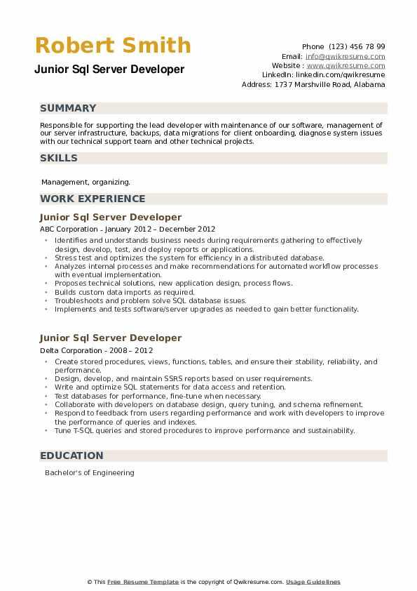

**Robert Smith**

Junior Sql Server Developer

Phone (123) 456 78 99

Email: info@qwikresume.com

Website: www.qwikresume.com Linkedin: linkedin.com/qwikresume Address: 1737 Marshville Road, Alabama

**SUMMARY**

Responsible for supporting the lead developer with maintenance of our software, management of our server infrastructure, backups, data migrations for client onboarding, diagnose system issues with our technical support team and other technical projects.

SKILLS

Management, organizing.

**WORK EXPERIENCE**

Junior Sql Server Developer

ABC Corporation - January 2012 December 2012

•

Identifies and understands business needs during requirements gathering to effectively design, develop, test, and deploy reports or applications

Stress test and optimizes the system for efficiency in a distributed database.

⚫ Analyzes internal processes and make recommendations for automated workflow processes with eventual implementation.

⚫Proposes technical solutions, new application design, process flows.

⚫ Builds custom data imports as required.

⚫ Troubleshoots and problem solve SQL database issues.

Implements and tests software/server upgrades as needed to gain better functionality.

Junior Sql Server Developer

Delta Corporation - 2008-2012

• Create stored procedures, views, functions, tables, and ensure their stability, reliability, and performance.

⚫ Design, develop, and maintain SSRS reports based on user requirements.

Write and optimize SQL statements for data access and retention.

Test databases for performance, fine-tune when necessary.

• Collaborate with developers on database design, query tuning, and schema refinement.

• Respond to feedback from users regarding performance and work with developers to improve the performance of queries and indexes.

⚫ Tune T-SQL queries and stored procedures to improve performance and sustainability.

**EDUCATION**

Bachelor's of Engineering

This Free Resume Template is the copyright of Qwikresume.com. Usage Guidelines