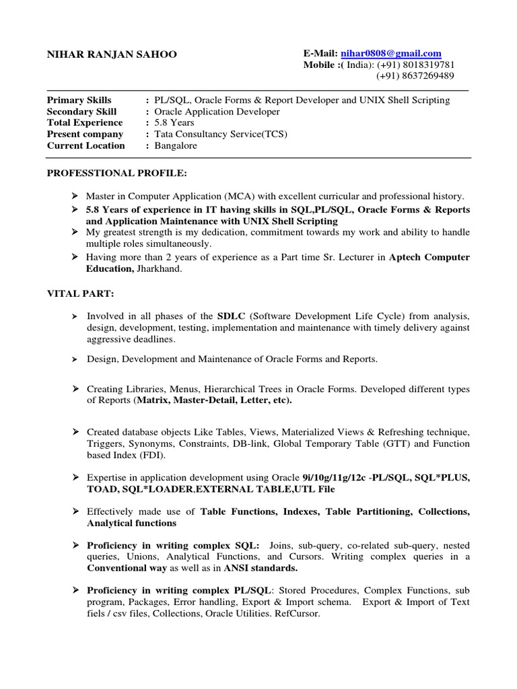

**NIHAR RANJAN SAHOO**

**Primary Skills Secondary Skill Total Experience Present company Current Location**

E-Mail: nihar0808@gmail.com Mobile :(India): (+91) 8018319781 (+91) 8637269489

: PL/SQL, Oracle Forms & Report Developer and UNIX Shell Scripting : Oracle Application Developer

:

5.8 Years

: Tata Consultancy Service(TCS)

: Bangalore

**PROFESSTIONAL PROFILE:**

➤ Master in Computer Application (MCA) with excellent curricular and professional history. 5.8 Years of experience in IT having skills in SQL,PL/SQL, Oracle Forms & Reports and Application Maintenance with UNIX Shell Scripting

➤ My greatest strength is my dedication, commitment towards my work and ability to handle multiple roles simultaneously.

➤ Having more than 2 years of experience as a Part time Sr. Lecturer in Aptech Computer Education, Jharkhand.

**VITAL PART:**

> Involved in all phases of the SDLC (Software Development Life Cycle) from analysis, design, development, testing, implementation and maintenance with timely delivery against aggressive deadlines.

➤ Design, Development and Maintenance of Oracle Forms and Reports.

➤ Creating Libraries, Menus, Hierarchical Trees in Oracle Forms. Developed different types of Reports (Matrix, Master-Detail, Letter, etc).

> Created database objects Like Tables, Views, Materialized Views & Refreshing technique, Triggers, Synonyms, Constraints, DB-link, Global Temporary Table (GTT) and Function based Index (FDI).

> Expertise in application development using Oracle 9i/10g/11g/12c -PL/SQL, SQL*PLUS, TOAD, SQL* LOADER,EXTERNAL TABLE,UTL File

**➤ Effectively made use of Table Functions, Indexes, Table Partitioning, Collections, Analytical functions**

**> Proficiency in writing complex SQL: Joins, sub-query, co-related sub-query, nested queries, Unions, Analytical Functions, and Cursors. Writing complex queries in a Conventional way as well as in ANSI standards.**

> Proficiency in writing complex PL/SQL: Stored Procedures, Complex Functions, sub program, Packages, Error handling, Export & Import schema. Export & Import of Text fiels/csv files, Collections, Oracle Utilities. RefCursor.