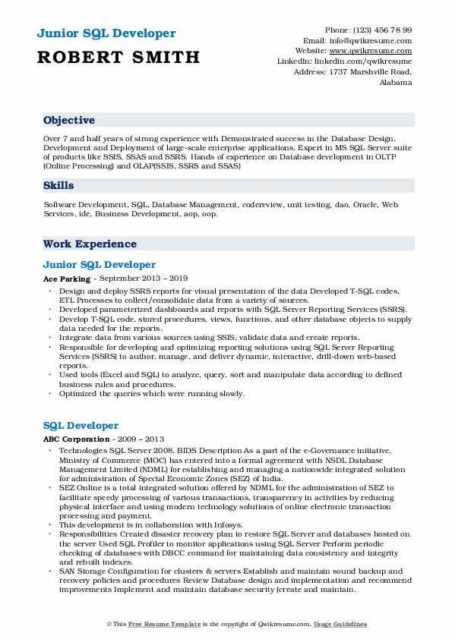

**Junior SQL Developer ROBERT SMITH**

Phone: (123) 456 78 99 Email: info@qwikresume.com Website: www.qwikresume.com Linkedin: linkedin.com/qwikresume Address: 1737 Marshville Road, Alabama

**Objective**

Over 7 and half years of strong experience with Demonstrated success in the Database Design, Development and Deployment of large-scale enterprise applications. Expert in MS SQL Server suite of products like SSIS, SSAS and SSRS. Hands of experience on Database development in OLTP (Online Processing) and OLAPISSIS, SSRS and SSAS)

Skills

Software Development, SQL, Database Management, codereview, unit testing, dao, Oracle, Web Services, ide. Business Development, aop, oop.

**Work Experience**

Junior SQL Developer

Ace Parking - September 2013 - 2019

⚫Design and deploy SSRS reports for visual presentation of the data Developed T-SQL codes. ETL Processes to collect/consolidate data from a variety of sources.

• Developed parameterized dashboards and reports with SQL Server Reporting Services (SSRS). ⚫ Develop T-SQL code, stored procedures, views, functions, and other database objects to supply data needed for the reports.

⚫Integrate data from various sources using SSIS, validate data and create reports.

.

Responsible for developing and optimizing reporting solutions using SQL Server Reporting Services (SSRS) to author, manage, and deliver dynamic, interactive, drill-down web-based reports.

⚫ Used tools (Excel and SQL) to analyze, query, sort and manipulate data according to defined business rules and procedures.

• Optimized the queries which were running slowly.

SQL Developer

**ABC Corporation - 2009 - 2013**

Technologies SQL Server 2008, BIDS Description As a part of the e-Governance initiative, Ministry of Commerce (MOC) has entered into a formal agreement with NSDL Database Management Limited (NDML) for establishing and managing a nationwide integrated solution for administration of Special Economic Zones (SEZ) of India.

⚫ SEZ Online is a total integrated solution offered by NDML for the administration of SEZ to facilitate speedy processing of various transactions, transparency in activities by reducing physical interface and using modern technology solutions of online electronic transaction processing and payment.

⚫This development is in collaboration with Infosys.

• Responsibilities Created disaster recovery plan to restore SQL Server and databases hosted on the server Used SQL Profiler to monitor applications using SQL Server Perform periodie checking of databases with DBCC command for maintaining data consistency and integrity and rebuilt indexes.

⚫SAN Storage Configuration for clusters & servers Establish and maintain sound backup and recovery policies and procedures Review Database design and implementation and recommend improvements Implement and maintain database security (create and maintain.

©This Free Resume Template is the copyright of Qwikresume.com. Usage Guidelines