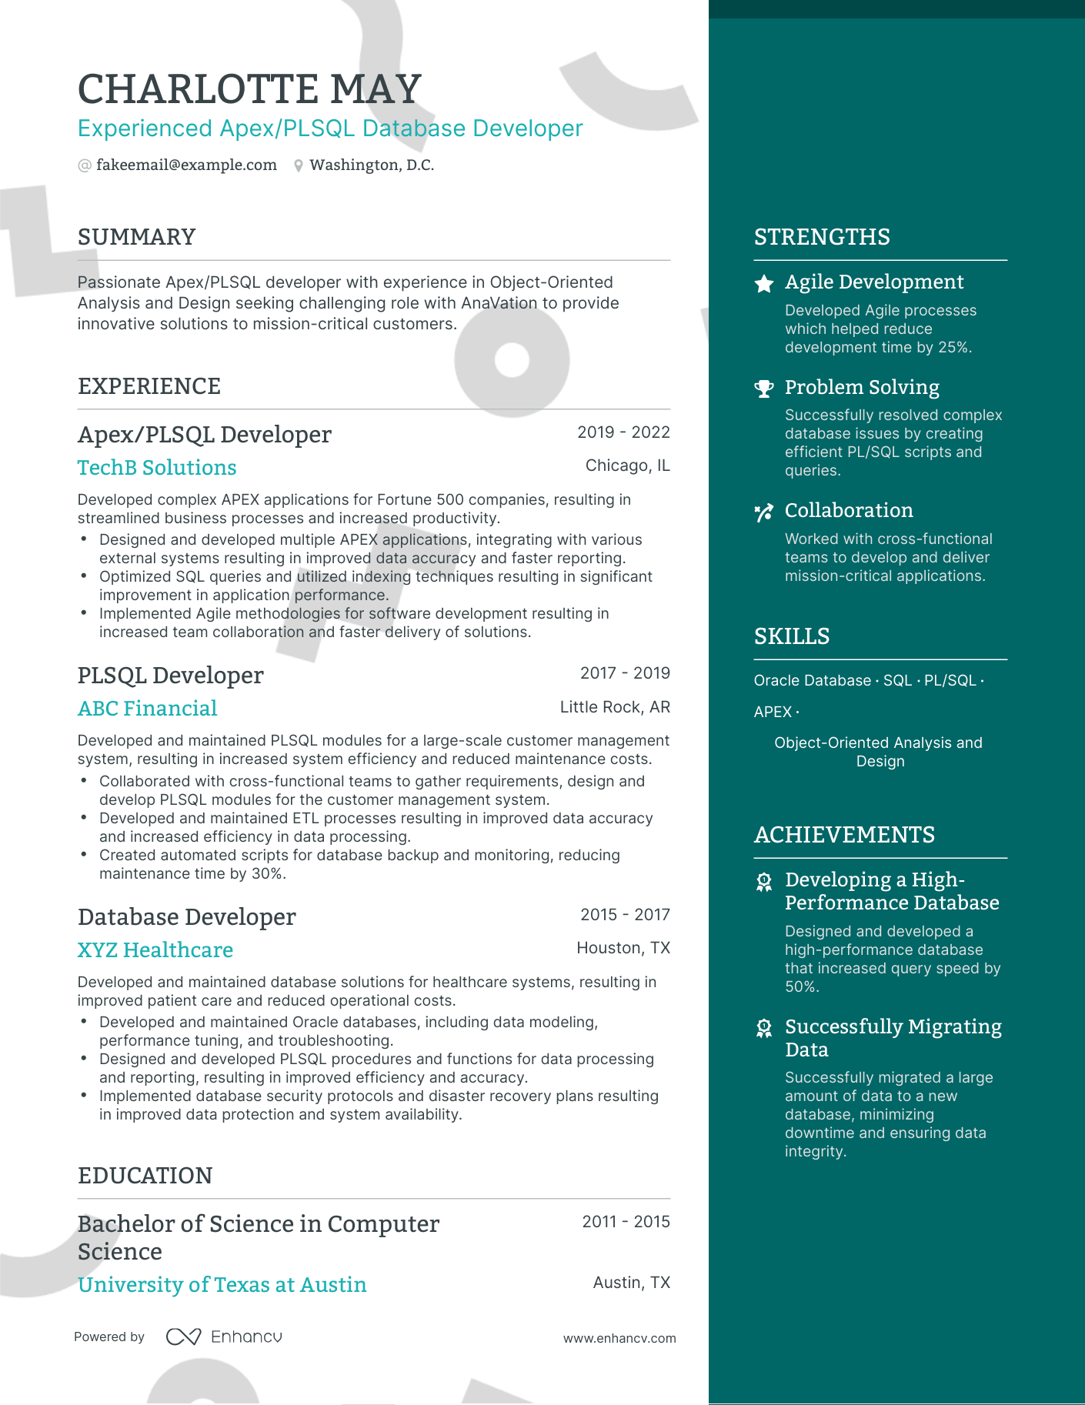

CHARLOTTE MAY

Experienced Apex/PLSQL Database Developer @fakeemail@example.com Washington, D.C.

SUMMARY

Passionate Apex/PLSQL developer with experience in Object-Oriented Analysis and Design seeking challenging role with AnaVation to provide innovative solutions to mission-critical customers.

EXPERIENCE

Apex/PLSQL Developer

TechB Solutions

•

2019-2022

Chicago, IL

STRENGTHS

Agile Development Developed Agile processes which helped reduce development time by 25%.

Problem Solving

Successfully resolved complex

database issues by creating efficient PL/SQL scripts and queries.

\* Collaboration

Worked with cross-functional teams to develop and deliver mission-critical applications.

Developed complex APEX applications for Fortune 500 companies, resulting in streamlined business processes and increased productivity.

• Designed and developed multiple APEX applications, integrating with various external systems resulting in improved data accuracy and faster reporting. Optimized SQL queries and utilized indexing techniques resulting in significant improvement in application performance.

·

Implemented Agile methodologies for software development resulting in increased team collaboration and faster delivery of solutions.

PLSQL Developer

ABC Financial

SKILLS

2017-2019

Oracle Database SQL PL/SQL.

Little Rock, AR

APEX.

Developed and maintained PLSQL modules for a large-scale customer management system, resulting in increased system efficiency and reduced maintenance costs. • Collaborated with cross-functional teams to gather requirements, design and develop PLSQL modules for the customer management system.

• Developed and maintained ETL processes resulting in improved data accuracy and increased efficiency in data processing.

• Created automated scripts for database backup and monitoring, reducing maintenance time by 30%.

Database Developer

XYZ Healthcare

2015-2017

Houston, TX

Developed and maintained database solutions for healthcare systems, resulting in improved patient care and reduced operational costs.

·

Developed and maintained Oracle databases, including data modeling, performance tuning, and troubleshooting.

Designed and developed PLSQL procedures and functions for data processing and reporting, resulting in improved efficiency and accuracy.

• Implemented database security protocols and disaster recovery plans resulting in improved data protection and system availability.

EDUCATION

Bachelor of Science in Computer Science

2011-2015

Object-Oriented Analysis and

Design

ACHIEVEMENTS

Developing a High- Performance Database

Designed and developed a high-performance database that increased query speed by 50%.

Successfully Migrating Data

Successfully migrated a large amount of data to a new database, minimizing downtime and ensuring data integrity.

University of Texas at Austin

Powered by Enhancu

Austin, TX

www.enhancv.com