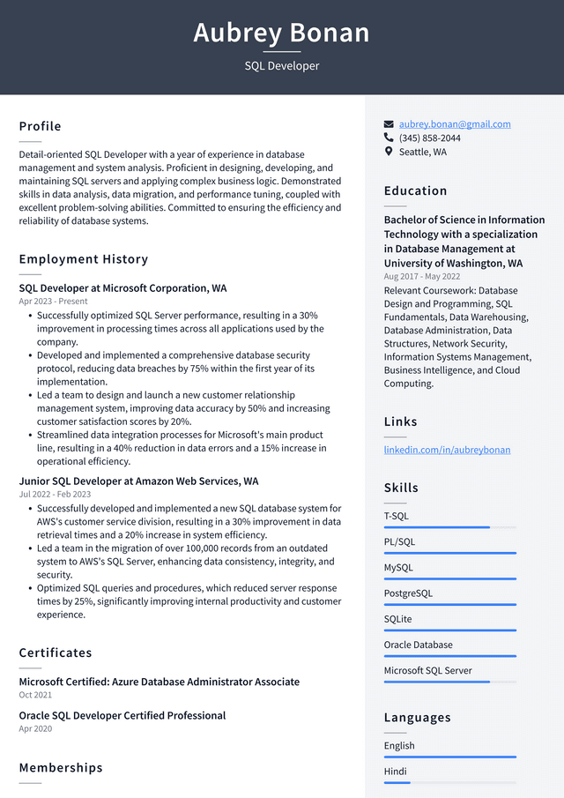

Aubrey Bonan

SQL Developer

Profile

Detail-oriented SQL Developer with a year of experience in database management and system analysis. Proficient in designing, developing, and maintaining SQL servers and applying complex business logic. Demonstrated skills in data analysis, data migration, and performance tuning, coupled with excellent problem-solving abilities. Committed to ensuring the efficiency and reliability of database systems.

Employment History

SQL Developer at Microsoft Corporation, WA Apr 2023-Present

• Successfully optimized SQL Server performance, resulting in a 30% improvement in processing times across all applications used by the company.

• Developed and implemented a comprehensive database security protocol, reducing data breaches by 75% within the first year of its implementation.

• Led a team to design and launch a new customer relationship management system, improving data accuracy by 50% and increasing customer satisfaction scores by 20%.

• Streamlined data integration processes for Microsoft's main product line, resulting in a 40% reduction in data errors and a 15% increase in operational efficiency.

Junior SQL Developer at Amazon Web Services, WA Jul 2022 - Feb 2023

• Successfully developed and implemented a new SQL database system for AWS's customer service division, resulting in a 30% improvement in data retrieval times and a 20% increase in system efficiency.

• Led a team in the migration of over 100,000 records from an outdated system to AWS's SQL Server, enhancing data consistency, integrity, and security.

• Optimized SQL queries and procedures, which reduced server response times by 25%, significantly improving internal productivity and customer experience.

Certificates

Microsoft Certified: Azure Database Administrator Associate Oct 2021

Oracle SQL Developer Certified Professional Apr 2020

Memberships

aubrey.bonan@gmail.com (345) 858-2044 Seattle, WA

Education

Bachelor of Science in Information Technology with a specialization in Database Management at University of Washington, WA Aug 2017 - May 2022

Relevant Coursework: Database Design and Programming, SQL Fundamentals, Data Warehousing, Database Administration, Data Structures, Network Security, Information Systems Management, Business Intelligence, and Cloud Computing.

Links

linkedin.com/in/aubreybonan

Skills

T-SQL

PL/SQL

MySQL

PostgreSQL

SQLite

Oracle Database

Microsoft SQL Server

Languages

English

Hindi