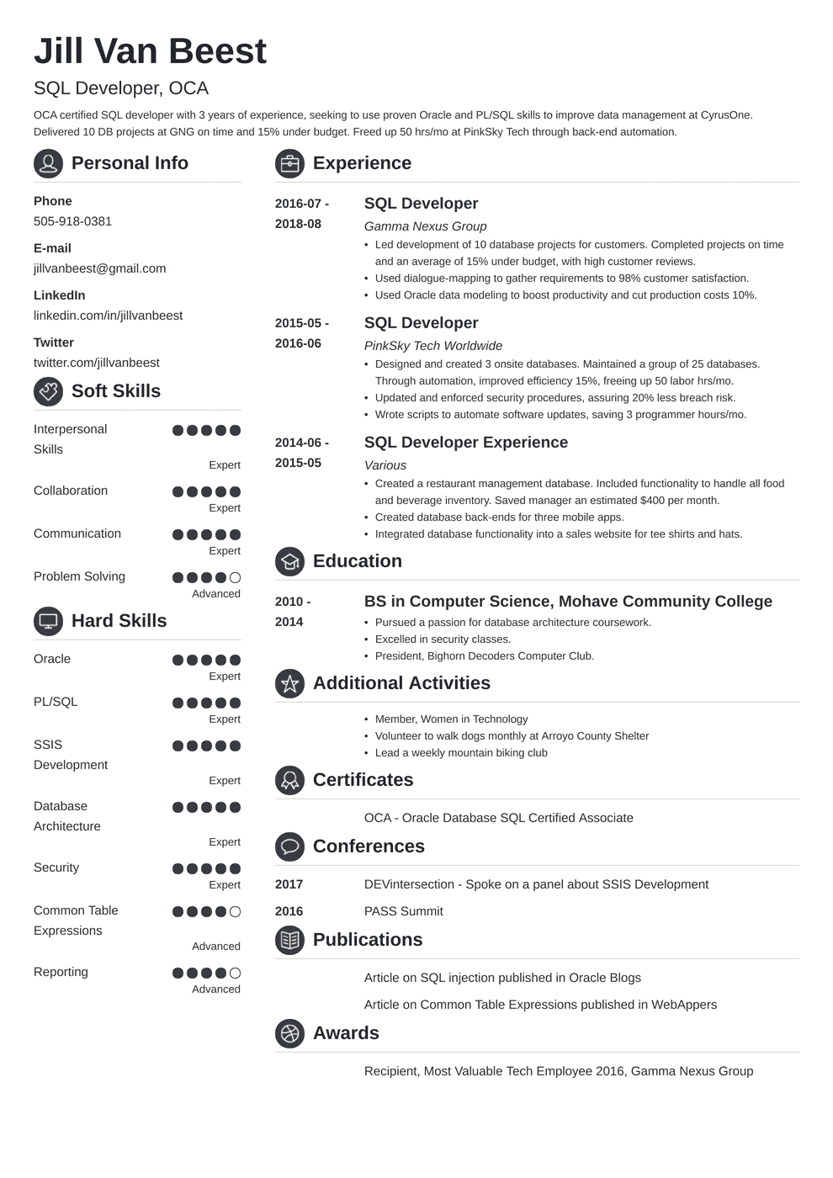

**Jill Van Beest**

SQL Developer, OCA

OCA certified SQL developer with 3 years of experience, seeking to use proven Oracle and PL/SQL skills to improve data management at CyrusOne. Delivered 10 DB projects at GNG on time and 15% under budget. Freed up 50 hrs/mo at PinkSky Tech through back-end automation.

**QPersonal Info**

Phone

505-918-0381

**Experience**

**2016-07-**

SQL Developer

E-mail

jillvanbeest@gmail.com

LinkedIn

linkedin.com/in/jillvanbeest

Twitter

twitter.com/jillvanbeest

**Soft Skills**

Interpersonal

Skills

**2018-08**

2015-05- 2016-06

*Gamma Nexus Group*

• Led development of 10 database projects for customers. Completed projects on time and an average of 15% under budget, with high customer reviews.

• Used dialogue-mapping to gather requirements to 98% customer satisfaction.

• Used Oracle data modeling to boost productivity and cut production costs 10%.

**SQL Developer**

*PinkSky Tech Worldwide*

• Designed and created 3 onsite databases. Maintained a group of 25 databases. Through automation, improved efficiency 15%, freeing up 50 labor hrs/mo. Updated and enforced security procedures, assuring 20% less breach risk.

• Wrote scripts to automate software updates, saving 3 programmer hours/mo. SQL Developer Experience

*Various*

• Created a restaurant management database. Included functionality to handle all food and beverage inventory. Saved manager an estimated $400 per month.

• Created database back-ends for three mobile apps.

• Integrated database functionality into a sales website for tee shirts and hats.

**Education**

**BS in Computer Science, Mohave Community College**

• Pursued a passion for database architecture coursework.

• Excelled in security classes.

• President, Bighorn Decoders Computer Club.

**Additional Activities**

⚫ Member, Women in Technology

• Volunteer to walk dogs monthly at Arroyo County Shelter

• Lead a weekly mountain biking club

2014-06-

Expert

2015-05

Collaboration

Expert

Communication

Expert

Problem Solving

Advanced

2010-

**Hard Skills**

2014

Oracle

Expert

PL/SQL

Expert

SSIS

Development

Expert

**Certificates**

Database

Architecture

Expert

Security

Expert

2017

OCA - Oracle Database SQL Certified Associate

**Conferences**

DEVintersection - Spoke on a panel about SSIS Development

Common Table

**2016**

PASS Summit

Expressions

Advanced

**Publications**

Reporting

Advanced

Article on SQL injection published in Oracle Blogs

Article on Common Table Expressions published in WebAppers

**Awards**

Recipient, Most Valuable Tech Employee 2016, Gamma Nexus Group