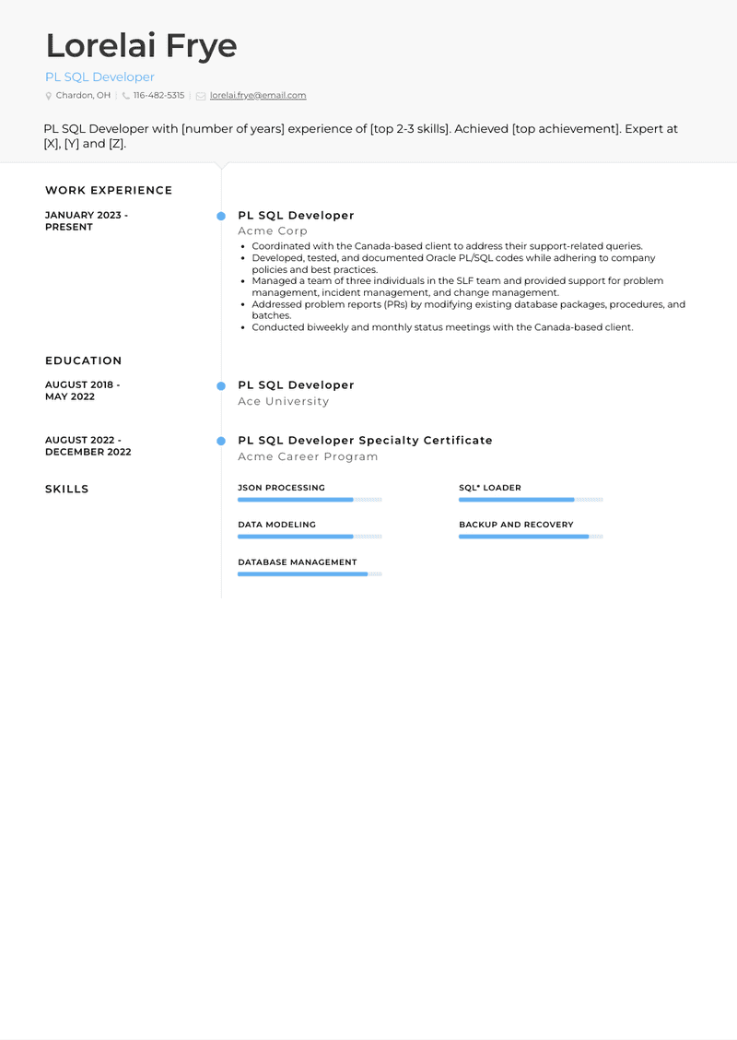

**Lorelai Frye**

PL SQL Developer

Chardon, OH 116-482-5315 Lorelai.frye@email.com

PL SQL Developer with [number of years] experience of [top 2-3 skills]. Achieved [top achievement]. Expert at [X], [Y] and [Z].

WORK EXPERIENCE

JANUARY 2023 - PRESENT

PL SQL Developer Acme Corp

• Coordinated with the Canada-based client to address their support-related queries.

• Developed, tested, and documented Oracle PL/SQL codes while adhering to company policies and best practices.

• Managed a team of three individuals in the SLF team and provided support for problem management, incident management, and change management.

. • Addressed problem reports (PRS) by modifying existing database packages, procedures, and batches.

• Conducted biweekly and monthly status meetings with the Canada-based client.

EDUCATION

AUGUST 2018. MAY 2022

AUGUST 2022. DECEMBER 2022

SKILLS

PL SQL Developer

Ace University

PL SQL Developer Specialty Certificate Acme Career Program

JSON PROCESSING

DATA MODELING

SQL* LOADER

BACKUP AND RECOVERY

DATABASE MANAGEMENT