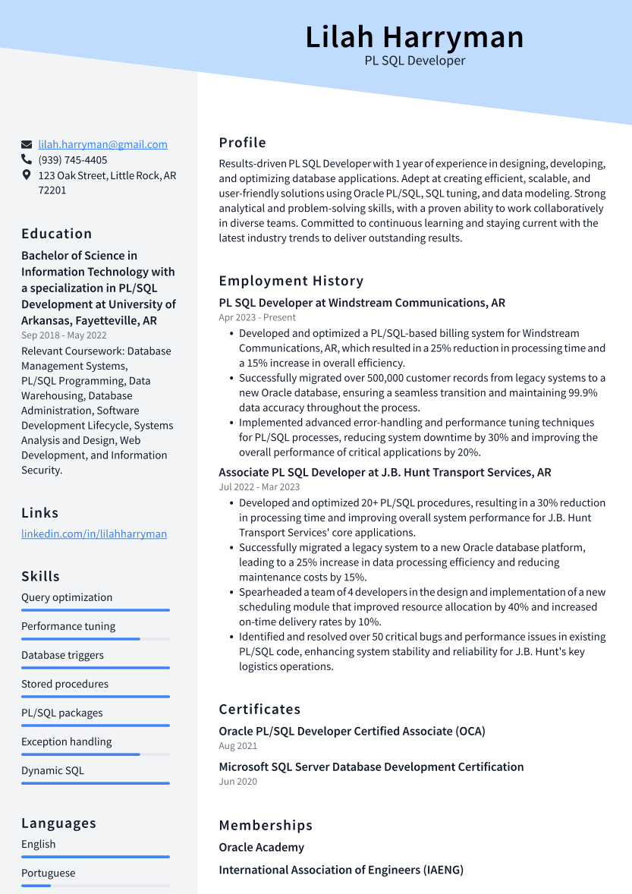

Lilah Harryman

PL SQL Developer

lilah.harryman@gmail.com (939) 745-4405

123 Oak Street, Little Rock, AR 72201

Education

Bachelor of Science in Information Technology with a specialization in PL/SQL Development at University of Arkansas, Fayetteville, AR Sep 2018 - May 2022

Relevant Coursework: Database Management Systems, PL/SQL Programming, Data Warehousing, Database Administration, Software Development Lifecycle, Systems Analysis and Design, Web Development, and Information

Security.

Links

linkedin.com/in/lilahharryman

Skills

Query optimization

Performance tuning

Profile

Results-driven PL SQL Developer with 1 year of experience in designing, developing, and optimizing database applications. Adept at creating efficient, scalable, and user-friendly solutions using Oracle PL/SQL, SQL tuning, and data modeling. Strong analytical and problem-solving skills, with a proven ability to work collaboratively in diverse teams. Committed to continuous learning and staying current with the latest industry trends to deliver outstanding results.

Employment History

**PL SQL Developer at Windstream Communications, AR Apr 2023 - Present**

• Developed and optimized a PL/SQL-based billing system for Windstream Communications, AR, which resulted in a 25% reduction in processing time and a 15% increase in overall efficiency.

• Successfully migrated over 500,000 customer records from legacy systems to a new Oracle database, ensuring a seamless transition and maintaining 99.9% data accuracy throughout the process.

• Implemented advanced error-handling and performance tuning techniques for PL/SQL processes, reducing system downtime by 30% and improving the overall performance of critical applications by 20%.

Associate PL SQL Developer at J.B. Hunt Transport Services, AR Jul 2022 - Mar 2023

• Developed and optimized 20+ PL/SQL procedures, resulting in a 30% reduction in processing time and improving overall system performance for J.B. Hunt Transport Services' core applications.

• Successfully migrated a legacy system to a new Oracle database platform, leading to a 25% increase in data processing efficiency and reducing maintenance costs by 15%.

• Spearheaded a team of 4 developers in the design and implementation of a new scheduling module that improved resource allocation by 40% and increased on-time delivery rates by 10%.

• Identified and resolved over 50 critical bugs and performance issues in existing PL/SQL code, enhancing system stability and reliability for J.B. Hunt's key logistics operations.

Certificates

Database triggers

Stored procedures

PL/SQL packages

Exception handling

Aug 2021

Dynamic SQL

Oracle PL/SQL Developer Certified Associate (OCA)

Microsoft SQL Server Database Development Certification Jun 2020

Languages English

Portuguese

Memberships

Oracle Academy

International Association of Engineers (IAENG)