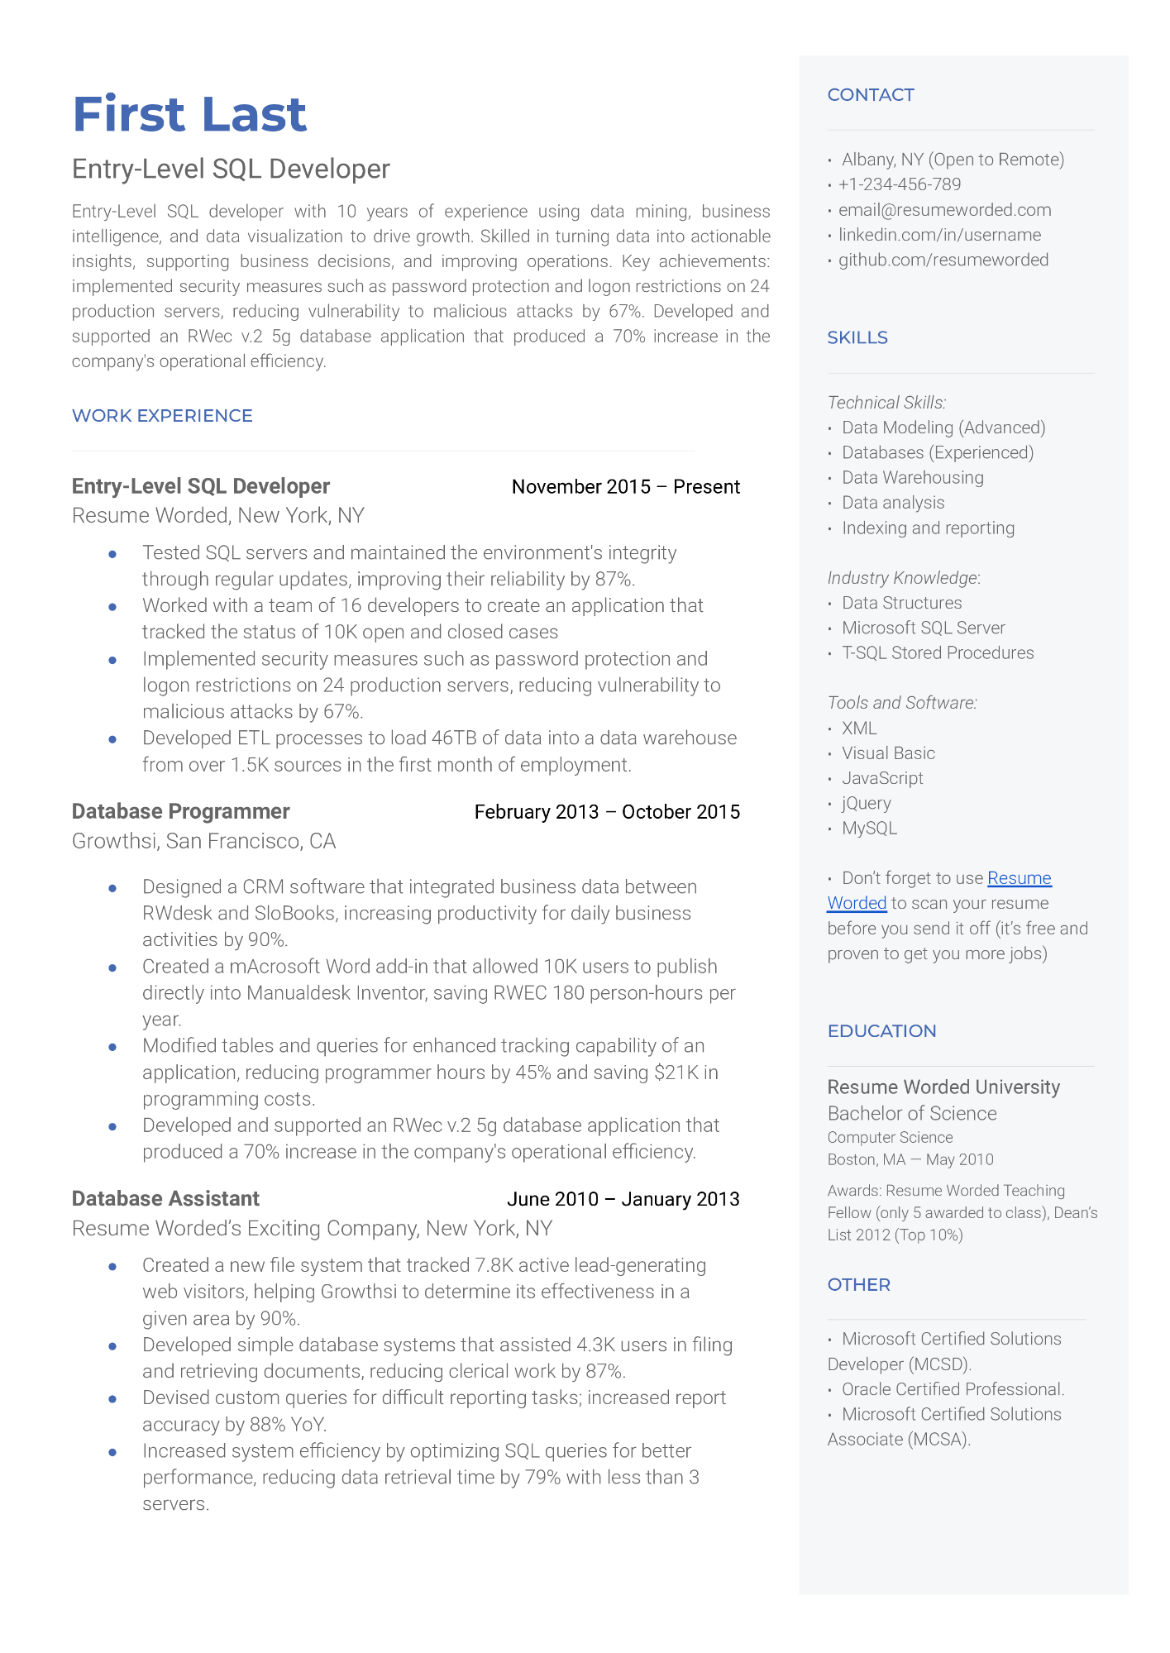

**First Last**

Entry-Level SQL Developer

Entry-Level SQL developer with 10 years of experience using data mining, business intelligence, and data visualization to drive growth. Skilled in turning data into actionable insights, supporting business decisions, and improving operations. Key achievements: implemented security measures such as password protection and logon restrictions on 24 production servers, reducing vulnerability to malicious attacks by 67%. Developed and supported an RWec v.2 5g database application that produced a 70% increase in the company's operational efficiency.

CONTACT

• Albany, NY (Open to Remote) +1-234-456-789

• email@resumeworded.com • linkedin.com/in/username

.github.com/resumeworded

SKILLS

WORK EXPERIENCE

**Entry-Level SQL Developer**

Resume Worded, New York, NY

November 2015 - Present

Tested SQL servers and maintained the environment's integrity through regular updates, improving their reliability by 87%. Worked with a team of 16 developers to create an application that tracked the status of 10K open and closed cases

Implemented security measures such as password protection and logon restrictions on 24 production servers, reducing vulnerability to malicious attacks by 67%.

Developed ETL processes to load 46TB of data into a data warehouse from over 1.5K sources in the first month of employment.

Database Programmer Growthsi, San Francisco, CA

•

February 2013 October 2015

Designed a CRM software that integrated business data between RWdesk and SloBooks, increasing productivity for daily business activities by 90%.

Created a mAcrosoft Word add-in that allowed 10K users to publish directly into Manualdesk Inventor, saving RWEC 180 person-hours per year.

Modified tables and queries for enhanced tracking capability of an application, reducing programmer hours by 45% and saving $21K in programming costs.

• Developed and supported an RWec v.2 5g database application that produced a 70% increase in the company's operational efficiency.

**Database Assistant**

June 2010 January 2013

Resume Worded's Exciting Company, New York, NY

•

Created a new file system that tracked 7.8K active lead-generating web visitors, helping Growthsi to determine its effectiveness in a given area by 90%.

Developed simple database systems that assisted 4.3K users in filing and retrieving documents, reducing clerical work by 87%.

Devised custom queries for difficult reporting tasks; increased report accuracy by 88% YoY.

Increased system efficiency by optimizing SQL queries for better performance, reducing data retrieval time by 79% with less than 3

servers.

*Technical Skills:*

• Data Modeling (Advanced) Databases (Experienced)

• Data Warehousing • Data analysis

• Indexing and reporting

*Industry Knowledge:*

Data Structures

Microsoft SQL Server T-SQL Stored Procedures

*Tools and Software:*

XML

Visual Basic

JavaScript

• jQuery

MySQL

Don't forget to use Resume

Worded to scan your resume before you send it off (it's free and proven to get you more jobs)

·

EDUCATION

Resume Worded University Bachelor of Science Computer Science

Boston, MA – May 2010

Awards: Resume Worded Teaching

Fellow (only 5 awarded to class), Dean's List 2012 (Top 10%)

OTHER

Microsoft Certified Solutions Developer (MCSD).

· Oracle Certified Professional.

Microsoft Certified Solutions Associate (MCSA).