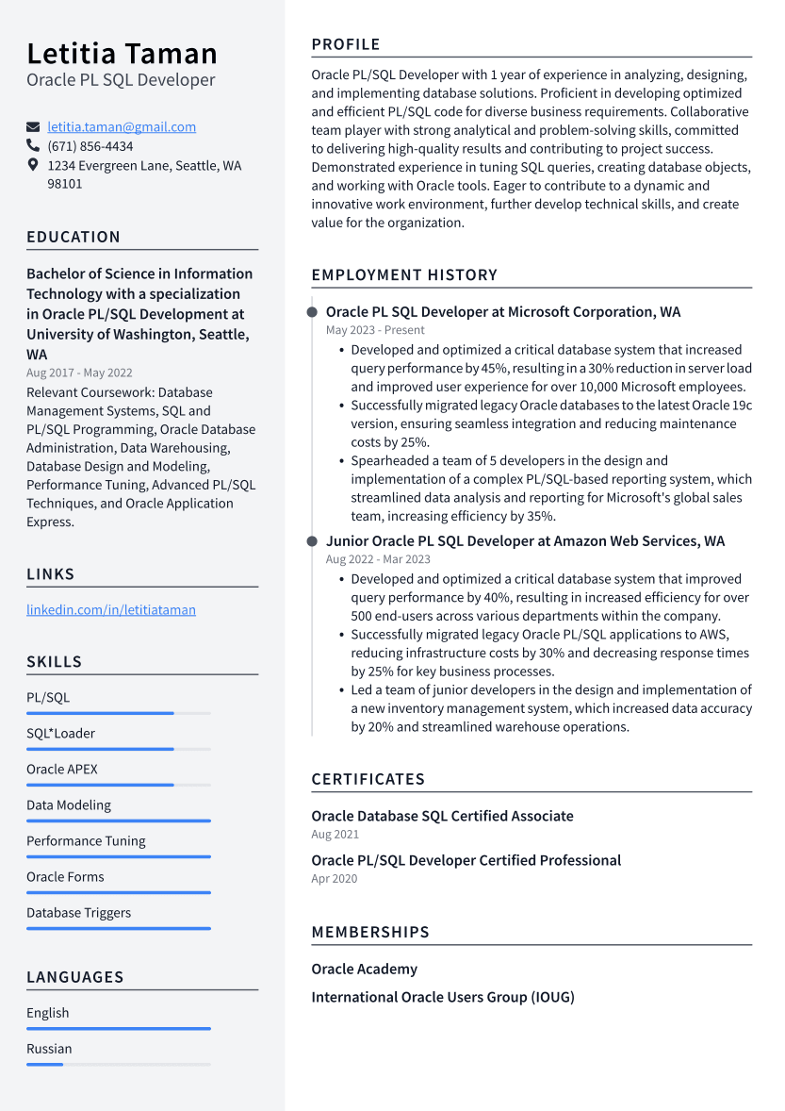

Letitia Taman Oracle PL SQL Developer

letitia.taman@gmail.com (671) 856-4434

1234 Evergreen Lane, Seattle, WA 98101

EDUCATION

Bachelor of Science in Information Technology with a specialization in Oracle PL/SQL Development at University of Washington, Seattle, WA

Aug 2017 - May 2022

Relevant Coursework: Database Management Systems, SQL and PL/SQL Programming, Oracle Database Administration, Data Warehousing, Database Design and Modeling, Performance Tuning, Advanced PL/SQL Techniques, and Oracle Application Express.

LINKS

linkedin.com/in/letitiataman

SKILLS

PL/SQL

SQL\*Loader

Oracle APEX

Data Modeling

Performance Tuning

Oracle Forms

Database Triggers

LANGUAGES

PROFILE

Oracle PL/SQL Developer with 1 year of experience in analyzing, designing, and implementing database solutions. Proficient in developing optimized and efficient PL/SQL code for diverse business requirements. Collaborative team player with strong analytical and problem-solving skills, committed to delivering high-quality results and contributing to project success. Demonstrated experience in tuning SQL queries, creating database objects, and working with Oracle tools. Eager to contribute to a dynamic and innovative work environment, further develop technical skills, and create value for the organization.

EMPLOYMENT HISTORY

Oracle PL SQL Developer at Microsoft Corporation, WA May 2023 - Present

• Developed and optimized a critical database system that increased query performance by 45%, resulting in a 30% reduction in server load and improved user experience for over 10,000 Microsoft employees. • Successfully migrated legacy Oracle databases to the latest Oracle 19c version, ensuring seamless integration and reducing maintenance costs by 25%.

• Spearheaded a team of 5 developers in the design and implementation of a complex PL/SQL-based reporting system, which streamlined data analysis and reporting for Microsoft's global sales team, increasing efficiency by 35%.

Junior Oracle PL SQL Developer at Amazon Web Services, WA Aug 2022 - Mar 2023

• Developed and optimized a critical database system that improved query performance by 40%, resulting in increased efficiency for over 500 end-users across various departments within the company. • Successfully migrated legacy Oracle PL/SQL applications to AWS, reducing infrastructure costs by 30% and decreasing response times by 25% for key business processes.

• Led a team of junior developers in the design and implementation of a new inventory management system, which increased data accuracy by 20% and streamlined warehouse operations.

CERTIFICATES

Oracle Database SQL Certified Associate Aug 2021

Oracle PL/SQL Developer Certified Professional Apr 2020

MEMBERSHIPS

Oracle Academy

International Oracle Users Group (IOUG)

English

Russian