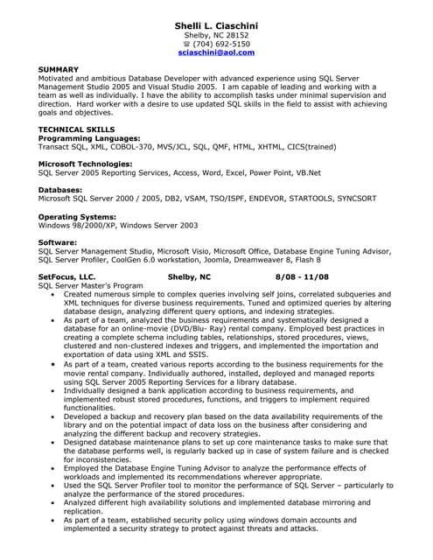

SUMMARY

Shelli L. Ciaschini Shelby, NC 28152 (704) 692-5150 sciaschini@aol.com

Motivated and ambitious Database Developer with advanced experience using SQL Server Management Studio 2005 and Visual Studio 2005. I am capable of leading and working with a team as well as individually. I have the ability to accomplish tasks under minimal supervision and direction. Hard worker with a desire to use updated SQL skills in the field to assist with achieving goals and objectives.

**TECHNICAL SKILLS**

**Programming Languages:**

Transact SQL, XML, COBOL-370, MVS/JCL, SQL, QMF, HTML, XHTML, CICS(trained)

Microsoft Technologies:

SQL Server 2005 Reporting Services, Access, Word, Excel, Power Point, VB.Net

Databases:

Microsoft SQL Server 2000/2005, DB2, VSAM, TSO/ISPF, ENDEVOR, STARTOOLS, SYNCSORT

**Operating Systems:**

Windows 98/2000/XP, Windows Server 2003

**Software:**

SQL Server Management Studio, Microsoft Visio, Microsoft Office, Database Engine Tuning Advisor, SQL Server Profiler, CoolGen 6,0 workstation, Joomla, Dreamweaver 8, Flash 8

**SetFocus, LLC.**

SQL Server Master's Program

Shelby, NC

8/08-11/08

Created numerous simple to complex queries involving self joins, correlated subqueries and XML techniques for diverse business requirements. Tuned and optimized queries by altering database design, analyzing different query options, and indexing strategies. ⚫As part of a team, analyzed the business requirements and systematically designed a database for an online-movie (DVD/Blu-Ray) rental company. Employed best practices in creating a complete schema including tables, relationships, stored procedures, views, clustered and non-clustered indexes and triggers, and implemented the importation and exportation of data using XML and SSIS.

As part of a team, created various reports according to the business requirements for the movie rental company. Individually authored, installed, deployed and managed reports using SQL Server 2005 Reporting Services for a library database.

Individually designed a bank application according to business requirements, and. implemented robust stored procedures, functions, and triggers to implement required functionalities.

•Developed a backup and recovery plan based on the data availability requirements of the library and on the potential impact of data loss on the business after considering and analyzing the different backup and recovery strategies.

Designed database maintenance plans to set up core maintenance tasks to make sure that the database performs well, is regularly backed up in case of system failure and is checked for inconsistencies.

Employed the Database Engine Tuning Advisor to analyze the performance effects of workloads and implemented its recommendations wherever appropriate.

• Used the SQL Server Profiler tool to monitor the performance of SQL Server - particularly to analyze the performance of the stored procedures.

• Analyzed different high availability solutions and implemented database mirroring and replication.

As part of a team, established security policy using windows domain accounts and implemented a security strategy to protect against threats and attacks.