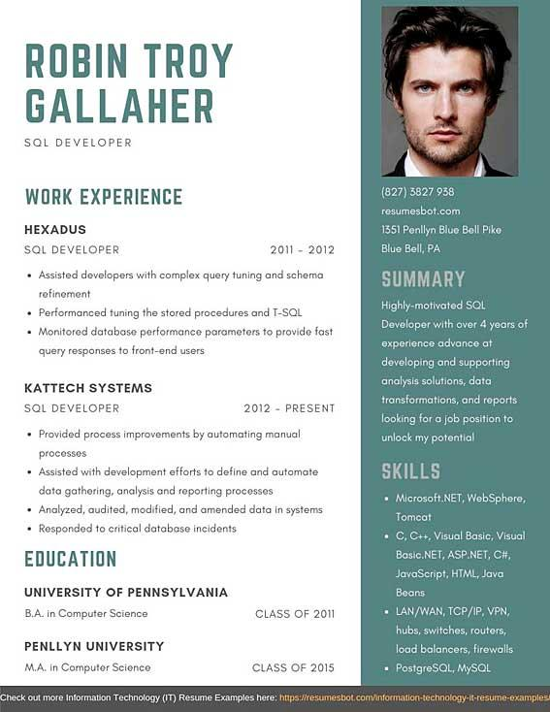

**ROBIN TROY GALLAHER**

SQL DEVELOPER

WORK EXPERIENCE

HEXADUS

SQL DEVELOPER

2011-2012

• Assisted developers with complex query tuning and schema refinement

• Performanced tuning the stored procedures and T-SQL

• Monitored database performance parameters to provide fast query responses to front-end users

KATTECH SYSTEMS

SQL DEVELOPER

2012 PRESENT

• Provided process improvements by automating manual processes

• Assisted with development efforts to define and automate data gathering, analysis and reporting processes

• Analyzed, audited, modified, and amended data in systems Responded to critical database incidents

EDUCATION

UNIVERSITY OF PENNSYLVANIA

(827) 3827 938 resumesbot.com

1351 Penllyn Blue Bell Pike

Blue Bell, PA

SUMMARY

Highly-motivated SQL

Developer with over 4 years of experience advance at developing and supporting analysis solutions, data transformations, and reports looking for a job position to unlock my potential

**SKILLS**

• Microsoft.NET, WebSphere, Tomcat

⚫ C, C++, Visual Basic, Visual Basic.NET, ASP.NET, C#, JavaScript, HTML, Java Beans

B.A. in Computer Science

PENLLYN UNIVERSITY

CLASS OF 2011

.

CLASS OF 2015

LAN/WAN, TCP/IP, VPN, hubs, switches, routers, load balancers, firewalls PostgreSQL, MySQL

M.A. in Computer Science

Check out more Information Technology (IT) Resume Examples here: https://resumesbot.com/nformation-technology-it-resume-examples