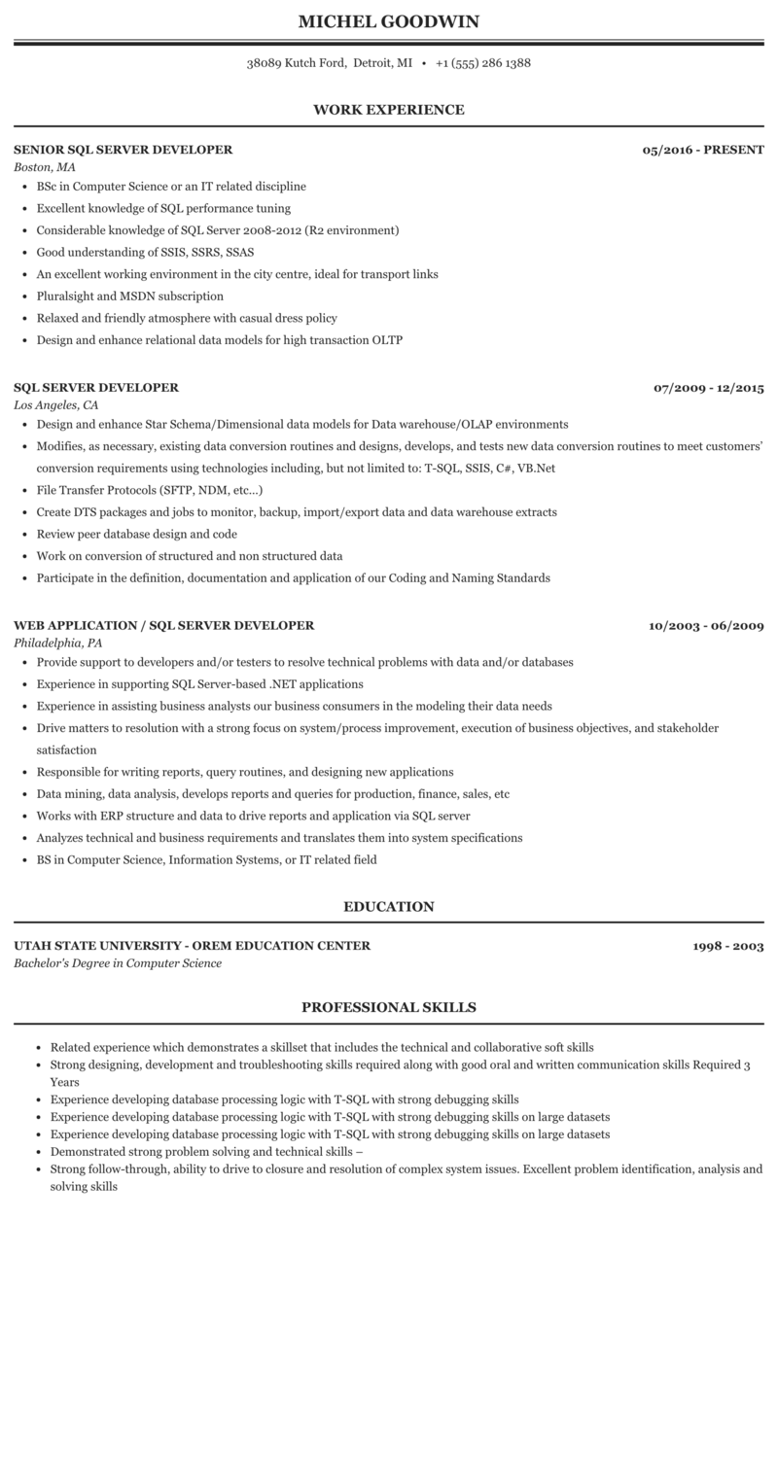

**MICHEL GOODWIN**

38089 Kutch Ford, Detroit, MI +1 (555) 286 1388

**WORK EXPERIENCE**

**SENIOR SQL SERVER DEVELOPER Boston, MA**

⚫ BSc in Computer Science or an IT related discipline

• Excellent knowledge of SQL performance tuning

⚫ Considerable knowledge of SQL Server 2008-2012 (R2 environment)

• Good understanding of SSIS, SSRS, SSAS

• An excellent working environment in the city centre, ideal for transport links

• Pluralsight and MSDN subscription

• Relaxed and friendly atmosphere with casual dress policy

• Design and enhance relational data models for high transaction OLTP

**05/2016 - PRESENT**

**SQL SERVER DEVELOPER**

*Los Angeles, CA*

• Design and enhance Star Schema/Dimensional data models for Data warehouse/OLAP environments

07/2009 - 12/2015

• Modifies, as necessary, existing data conversion routines and designs, develops, and tests new data conversion routines to meet customers'

conversion requirements using technologies including, but not limited to: T-SQL, SSIS, C#, VB.Net

⚫ File Transfer Protocols (SFTP, NDM, etc...)

• Create DTS packages and jobs to monitor, backup, import/export data and data warehouse extracts • Review peer database design and code

• Work on conversion of structured and non structured data

• Participate in the definition, documentation and application of our Coding and Naming Standards

*WEB APPLICATION/SQL SERVER DEVELOPER Philadelphia, PA*

• Provide support to developers and/or testers to resolve technical problems with data and/or databases

• Experience in supporting SQL Server-based .NET applications

• Experience in assisting business analysts our business consumers in the modeling their data needs

**10/2003 - 06/2009**

⚫ Drive matters to resolution with a strong focus on system/process improvement, execution of business objectives, and stakeholder satisfaction

• Responsible for writing reports, query routines, and designing new applications

⚫ Data mining, data analysis, develops reports and queries for production, finance, sales, etc

• Works with ERP structure and data to drive reports and application via SQL server

• Analyzes technical and business requirements and translates them into system specifications

⚫ BS in Computer Science, Information Systems, or IT related field

**EDUCATION**

*UTAH STATE UNIVERSITY-OREM EDUCATION CENTER Bachelor's Degree in Computer Science*

**PROFESSIONAL SKILLS**

**1998-2003**

• Related experience which demonstrates a skillset that includes the technical and collaborative soft skills

• Strong designing, development and troubleshooting skills required along with good oral and written communication skills Required 3 Years

• Experience developing database processing logic with T-SQL with strong debugging skills

• Experience developing database processing logic with T-SQL with strong debugging skills on large datasets

• Experience developing database processing logic with T-SQL with strong debugging skills on large datasets

• Demonstrated strong problem solving and technical skills -

• Strong follow-through, ability to drive to closure and resolution of complex system issues. Excellent problem identification, analysis and solving skills