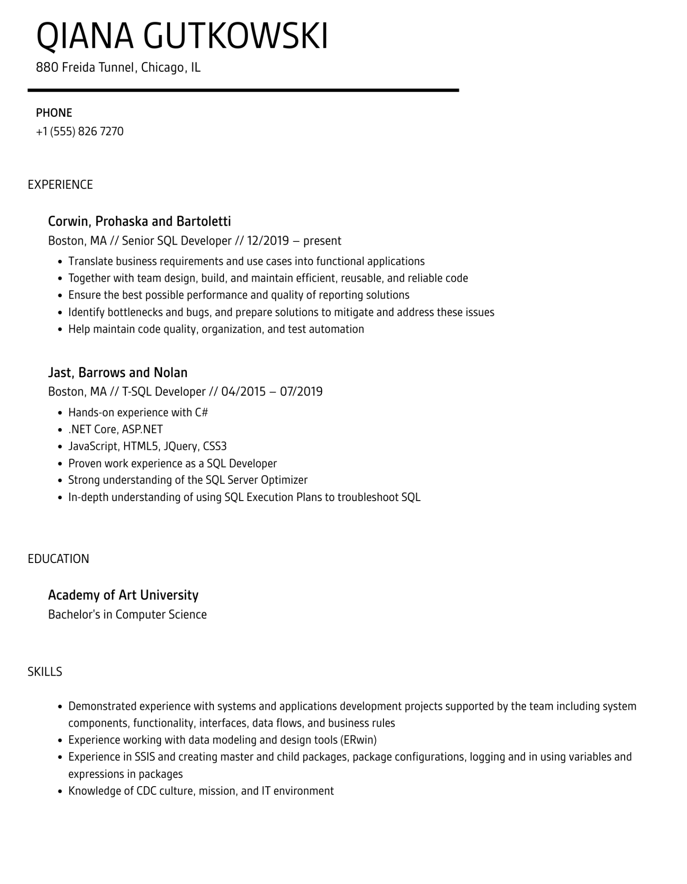

QIANA GUTKOWSKI

880 Freida Tunnel, Chicago, IL

PHONE

+1 (555) 826 7270

EXPERIENCE

Corwin, Prohaska and Bartoletti

Boston, MA // Senior SQL Developer // 12/2019 - present

• Translate business requirements and use cases into functional applications

•

Together with team design, build, and maintain efficient, reusable, and reliable code

•

Ensure the best possible performance and quality of reporting solutions

•

·

Identify bottlenecks and bugs, and prepare solutions to mitigate and address these issues

Help maintain code quality, organization, and test automation

Jast, Barrows and Nolan

Boston, MA // T-SQL Developer // 04/2015 - 07/2019

•

Hands-on experience with C#

⚫ .NET Core, ASP.NET

•

JavaScript, HTML5, JQuery, CSS3

• Proven work experience as a SQL Developer

·

Strong understanding of the SQL Server Optimizer

·

In-depth understanding of using SQL Execution Plans to troubleshoot SQL

EDUCATION

Academy of Art University

Bachelor's in Computer Science

SKILLS

·

•

•

Demonstrated experience with systems and applications development projects supported by the team including system components, functionality, interfaces, data flows, and business rules

Experience working with data modeling and design tools (ERwin)

Experience in SSIS and creating master and child packages, package configurations, logging and in using variables and expressions in packages

•

Knowledge of CDC culture, mission, and IT environment