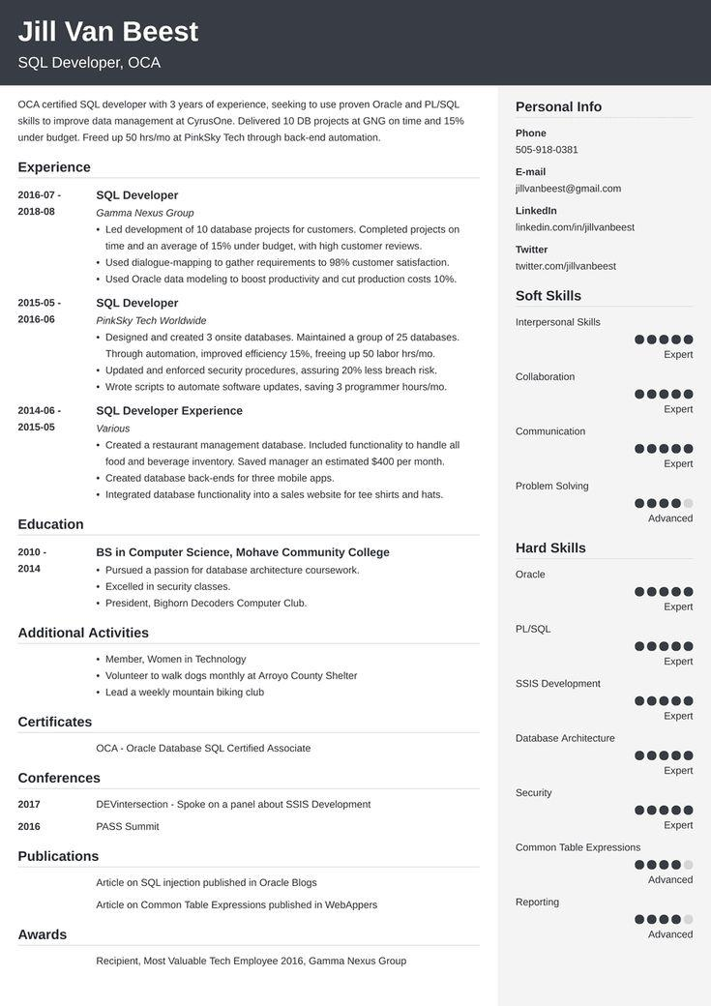

**Jill Van Beest**

SQL Developer, OCA

OCA certified SQL developer with 3 years of experience, seeking to use proven Oracle and PL/SQL skills to improve data management at CyrusOne. Delivered 10 DB projects at GNG on time and 15% under budget. Freed up 50 hrs/mo at PinkSky Tech through back-end automation.

Experience

2016-07-

**2018-08**

2015-05- 2016-06

SQL Developer

Gamma Nexus Group

• Led development of 10 database projects for customers. Completed projects on time and an average of 15% under budget, with high customer reviews.

• Used dialogue-mapping to gather requirements to 98% customer satisfaction.

• Used Oracle data modeling to boost productivity and cut production costs 10%. SQL Developer

PinkSky Tech Worldwide

.

• Designed and created 3 onsite databases. Maintained a group of 25 databases.

.

Through automation, improved efficiency 15%, freeing up 50 labor hrs/mo.

• Updated and enforced security procedures, assuring 20% less breach risk.

Personal Info

Phone 505-918-0381

E-mail

jillvanbeest@gmail.com

LinkedIn

linkedin.com/in/jillvanbeest

Twitter

twitter.com/jillvanbeest

Soft Skills

Interpersonal Skills

Expert

Collaboration

2014-06-

• Wrote scripts to automate software updates, saving 3 programmer hours/mo. SQL Developer Experience

Expert

2015-05

Various

Communication

• Created a restaurant management database. Included functionality to handle all food and beverage inventory. Saved manager an estimated $400 per month. • Created database back-ends for three mobile apps.

Expert

Problem Solving

Integrated database functionality into a sales website for tee shirts and hats.

**2014**

.

Education

**2010-**

• Pursued a passion for database architecture coursework.

• Excelled in security classes.

Advanced

BS in Computer Science, Mohave Community College

Hard Skills

Oracle

• President, Bighorn Decoders Computer Club.

Additional Activities

Expert

PL/SQL

• Member, Women in Technology

Expert

• Volunteer to walk dogs monthly at Arroyo County Shelter • Lead a weekly mountain biking club

SSIS Development

Certificates

OCA - Oracle Database SQL Certified Associate

Conferences

Expert

Database Architecture

Expert

Security

2017

**2016**

Publications

DEVintersection - Spoke on a panel about SSIS Development PASS Summit

Article on SQL injection published in Oracle Blogs

Article on Common Table Expressions published in WebAppers

Expert

Common Table Expressions

Advanced

Awards

Reporting

Advanced

Recipient, Most Valuable Tech Employee 2016, Gamma Nexus Group