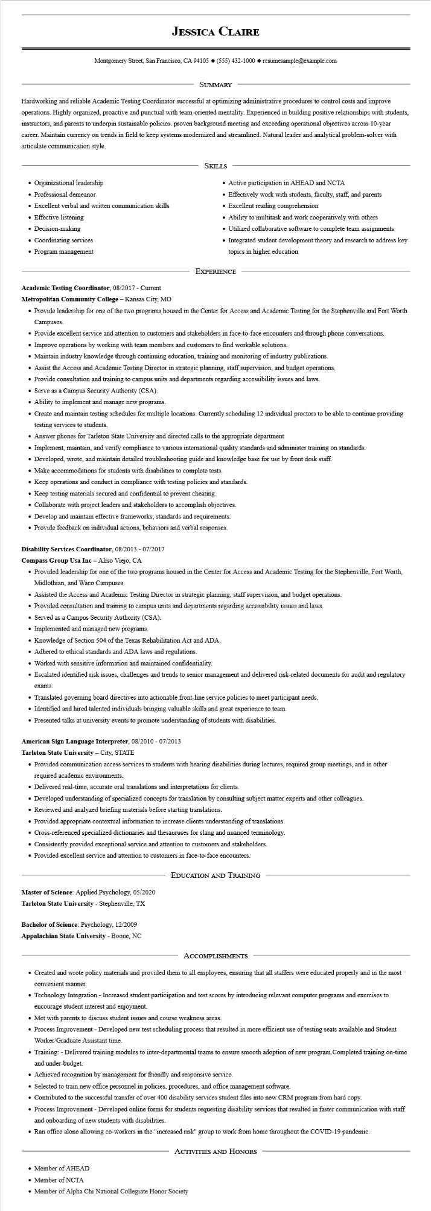

**JESSICA CLAIRE**

Montgomery Street, San Francisco, CA 94105 ♦ (555) 432-1000 resumesample@example.com

SUMMARY

Hardworking and reliable Academic Testing Coordinator successful at optimizing administrative procedures to control costs and improve operations. Highly organized, proactive and punctual with team-oriented mentality. Experienced in building positive relationships with students, instructors, and parents to underpin sustainable policies. proven background meeting and exceeding operational objectives across 10-year career. Maintain currency on trends in field to keep systems modernized and streamlined. Natural leader and analytical problem-solver with articulate communication style.

• Organizational leadership

• Professional demeanor

• Excellent verbal and written communication skills

• Effective listening

Decision-making

• Coordinating services

• Program management

SKILLS

• Active participation in AHEAD and NCTA

• Effectively work with students, faculty, staff, and parents

• Excellent reading comprehension

• Ability to multitask and work cooperatively with others

• Utilized collaborative software to complete team assignments

• Integrated student development theory and research to address key topics in higher education

EXPERIENCE

**Academic Testing Coordinator, 08/2017 - Current**

**Metropolitan Community College - Kansas City, MO**

• Provide leadership for one of the two programs housed in the Center for Access and Academic Testing for the Stephenville and Fort Worth Campuses.

• Provide excellent service and attention to customers and stakeholders in face-to-face encounters and through phone conversations.

• Improve operations by working with team members and customers to find workable solutions.

• Maintain industry knowledge through continuing education, training and monitoring of industry publications.

• Assist the Access and Academic Testing Director in strategic planning, staff supervision, and budget operations.

• Provide consultation and training to campus units and departments regarding accessibility issues and laws.

• Serve as a Campus Security Authority (CSA).

• Ability to implement and manage new programs.

• Create and maintain testing schedules for multiple locations. Currently scheduling 12 individual proctors to be able to continue providing testing services to students.

• Answer phones for Tarleton State University and directed calls to the appropriate department

• Implement, maintain, and verify compliance to various international quality standards and administer training on standards.

• Developed, wrote, and maintain detailed troubleshooting guide and knowledge base for use by front desk staff.

• Make accommodations for students with disabilities to complete tests.

• Keep operations and conduct in compliance with testing policies and standards.

• Keep testing materials secured and confidential to prevent cheating.

• Collaborate with project leaders and stakeholders to accomplish objectives.

• Develop and maintain effective frameworks, standards and requirements.

• Provide feedback on individual actions, behaviors and verbal responses.

**Disability Services Coordinator, 08/2013 - 07/2017**

**Compass Group Usa Inc - Aliso Viejo, CA**

• Provided leadership for one of the two programs housed in the Center for Access and Academic Testing for the Stephenville, Fort Worth, Midlothian, and Waco Campuses.

• Assisted the Access and Academic Testing Director in strategic planning, staff supervision, and budget operations.

• Provided consultation and training to campus units and departments regarding accessibility issues and laws.

• Served as a Campus Security Authority (CSA).

• Implemented and managed new programs.

• Knowledge of Section 504 of the Texas Rehabilitation Act and ADA.

• Adhered to ethical standards and ADA laws and regulations.

• Worked with sensitive information and maintained confidentiality.

• Escalated identified risk issues, challenges and trends to senior management and delivered risk-related documents for audit and regulatory

exams.

• Translated governing board directives into actionable front-line service policies to meet participant needs.

• Identified and hired talented individuals bringing valuable skills and great experience to team.

• Presented talks at university events to promote understanding of students with disabilities.

**American Sign Language Interpreter, 08/2010 - 07/2013**

**Tarleton State University - City, STATE**

• Provided communication access services to students with hearing disabilities during lectures, required group meetings, and in other required academic environments.

• Delivered real-time, accurate oral translations and interpretations for clients.

• Developed understanding of specialized concepts for translation by consulting subject matter experts and other colleagues.

• Reviewed and analyzed briefing materials before starting translations.

• Provided appropriate contextual information to increase clients understanding of translations.

• Cross-referenced specialized dictionaries and thesauruses for slang and nuanced terminology.

• Consistently provided exceptional service and attention to customers and stakeholders.

• Provided excellent service and attention to customers in face-to-face encounters.

Master of Science: Applied Psychology, 05/2020

**Tarleton State University - Stephenville, TX**

Bachelor of Science: Psychology, 12/2009

**Appalachian State University - Boone, NC**

EDUCATION AND TRAINING

ACCOMPLISHMENTS

• Created and wrote policy materials and provided them to all employees, ensuring that all staffers were educated properly and in the most convenient manner.

• Technology Integration - Increased student participation and test scores by introducing relevant computer programs and exercises to encourage student interest and enjoyment.

• Met with parents to discuss student issues and course weakness areas.

• Process Improvement - Developed new test scheduling process that resulted in more efficient use of testing seats available and Student Worker/Graduate Assistant time.

• Training: - Delivered training modules to inter-departmental teams to ensure smooth adoption of new program. Completed training on-time and under-budget.

• Achieved recognition by management for friendly and responsive service.

• Selected to train new office personnel in policies, procedures, and office management software.

• Contributed to the successful transfer of over 400 disability services student files into new CRM program from hard copy.

• Process Improvement - Developed online forms for students requesting disability services that resulted in faster communication with staff and onboarding of new students with disabilities.

• Ran office alone allowing co-workers in the "increased risk" group to work from home throughout the COVID-19 pandemic.

• Member of AHEAD

ACTIVITIES AND HONORS

• Member of NCTA

• Member of Alpha Chi National Collegiate Honor Society