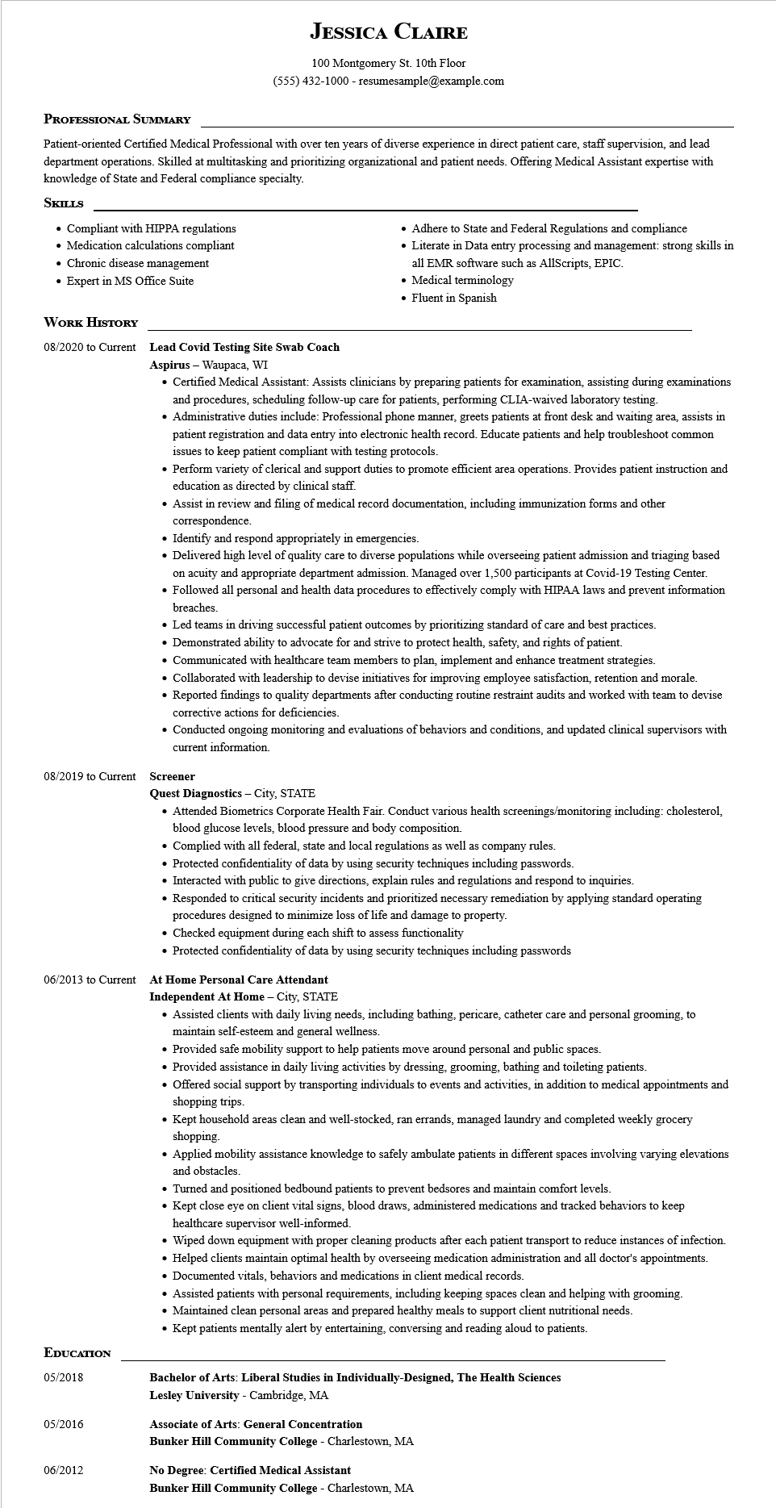

**JESSICA CLAIRE**

100 Montgomery St. 10th Floor

(555) 432-1000 - resumesample@example.com

**PROFESSIONAL SUMMARY**

Patient-oriented Certified Medical Professional with over ten years of diverse experience in direct patient care, staff supervision, and lead department operations. Skilled at multitasking and prioritizing organizational and patient needs. Offering Medical Assistant expertise with knowledge of State and Federal compliance specialty.

**SKILLS**

• Compliant with HIPPA regulations

Medication calculations compliant

• Chronic disease management

• Expert in MS Office Suite

**WORK HISTORY**

**08/2020 to Current Lead Covid Testing Site Swab Coach Aspirus - Waupaca, WI**

• Adhere to State and Federal Regulations and compliance

• Literate in Data entry processing and management: strong skills in all EMR software such as AllScripts, EPIC.

• Medical terminology

• Fluent in Spanish

• Certified Medical Assistant: Assists clinicians by preparing patients for examination, assisting during examinations and procedures, scheduling follow-up care for patients, performing CLIA-waived laboratory testing.

• Administrative duties include: Professional phone manner, greets patients at front desk and waiting area, assists in patient registration and data entry into electronic health record. Educate patients and help troubleshoot common issues to keep patient compliant with testing protocols.

• Perform variety of clerical and support duties to promote efficient area operations. Provides patient instruction and education as directed by clinical staff.

• Assist in review and filing of medical record documentation, including immunization forms and other correspondence.

• Identify and respond appropriately in emergencies.

• Delivered high level of quality care to diverse populations while overseeing patient admission and triaging based on acuity and appropriate department admission. Managed over 1,500 participants at Covid-19 Testing Center.

• Followed all personal and health data procedures to effectively comply with HIPAA laws and prevent information breaches.

• Led teams in driving successful patient outcomes by prioritizing standard of care and best practices.

• Demonstrated ability to advocate for and strive to protect health, safety, and rights of patient.

• Communicated with healthcare team members to plan, implement and enhance treatment strategies.

• Collaborated with leadership to devise initiatives for improving employee satisfaction, retention and morale.

• Reported findings to quality departments after conducting routine restraint audits and worked with team to devise corrective actions for deficiencies.

• Conducted ongoing monitoring and evaluations of behaviors and conditions, and updated clinical supervisors with current information.

08/2019 to Current Screener

06/2013 to Current

**EDUCATION**

**Quest Diagnostics - City, STATE**

• Attended Biometrics Corporate Health Fair. Conduct various health screenings/monitoring including: cholesterol, blood glucose levels, blood pressure and body composition.

• Complied with all federal, state and local regulations as well as company rules.

• Protected confidentiality of data by using security techniques including passwords.

• Interacted with public to give directions, explain rules and regulations and respond to inquiries.

• Responded to critical security incidents and prioritized necessary remediation by applying standard operating

procedures designed to minimize loss of life and damage to property.

• Checked equipment during each shift to assess functionality

• Protected confidentiality of data by using security techniques including passwords

At Home Personal Care Attendant

**Independent At Home - City, STATE**

• Assisted clients with daily living needs, including bathing, pericare, catheter care and personal grooming, to maintain self-esteem and general wellness.

• Provided safe mobility support to help patients move around personal and public spaces.

• Provided assistance in daily living activities by dressing, grooming, bathing and toileting patients.

• Offered social support by transporting individuals to events and activities, in addition to medical appointments and shopping trips.

• Kept household areas clean and well-stocked, ran errands, managed laundry and completed weekly grocery shopping.

• Applied mobility assistance knowledge to safely ambulate patients in different spaces involving varying elevations and obstacles.

• Turned and positioned bedbound patients to prevent bedsores and maintain comfort levels.

• Kept close eye on client vital signs, blood draws, administered medications and tracked behaviors to keep healthcare supervisor well-informed.

• Wiped down equipment with proper cleaning products after each patient transport to reduce instances of infection.

• Helped clients maintain optimal health by overseeing medication administration and all doctor's appointments.

• Documented vitals, behaviors and medications in client medical records.

• Assisted patients with personal requirements, including keeping spaces clean and helping with grooming.

• Maintained clean personal areas and prepared healthy meals to support client nutritional needs.

• Kept patients mentally alert by entertaining, conversing and reading aloud to patients.

05/2018

**Bachelor of Arts: Liberal Studies in Individually-Designed, The Health Sciences Lesley University - Cambridge, MA**

05/2016

**Associate of Arts: General Concentration Bunker Hill Community College - Charlestown, MA**

06/2012

**No Degree: Certified Medical Assistant**

Bunker Hill Community College - Charlestown, MA