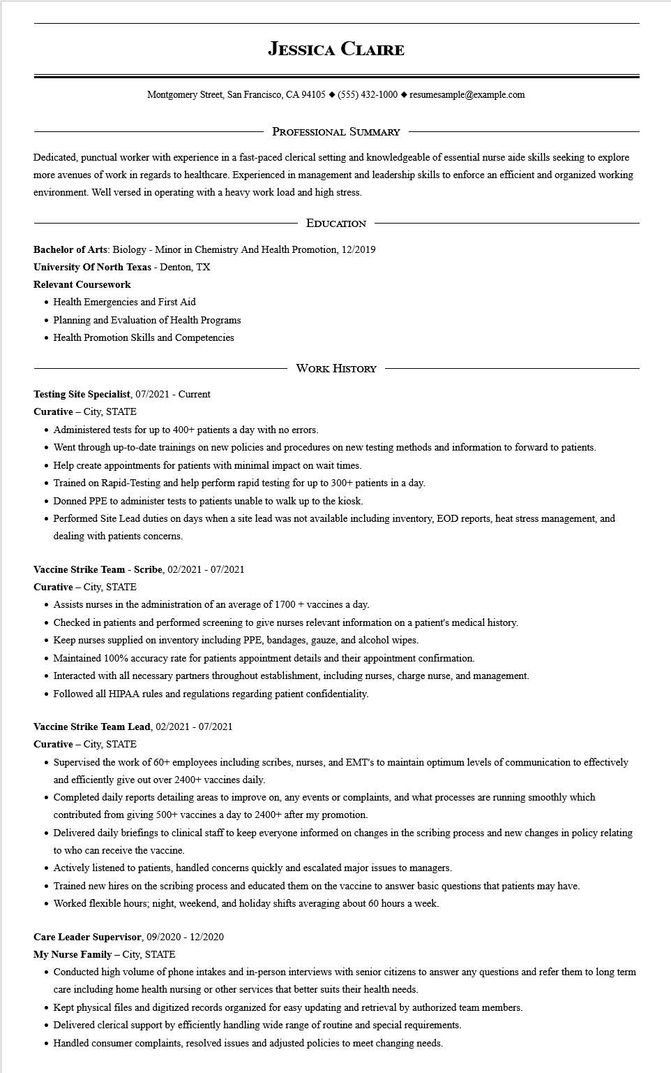

**JESSICA CLAIRE**

Montgomery Street, San Francisco, CA 94105 ♦ (555) 432-1000 resumesample@example.com

PROFESSIONAL SUMMARY

Dedicated, punctual worker with experience in a fast-paced clerical setting and knowledgeable of essential nurse aide skills seeking to explore more avenues of work in regards to healthcare. Experienced in management and leadership skills to enforce an efficient and organized working environment. Well versed in operating with a heavy work load and high stress.

EDUCATION

Bachelor of Arts: Biology - Minor in Chemistry And Health Promotion, 12/2019

**University of North Texas - Denton, TX**

**Relevant Coursework**

• Health Emergencies and First Aid

• Planning and Evaluation of Health Programs

• Health Promotion Skills and Competencies

WORK HISTORY

**Testing Site Specialist, 07/2021 - Current**

**Curative - City, STATE**

• Administered tests for up to 400+ patients a day with no errors.

• Went through up-to-date trainings on new policies and procedures on new testing methods and information to forward to patients.

• Help create appointments for patients with minimal impact on wait times.

• Trained on Rapid-Testing and help perform rapid testing for up to 300+ patients in a day.

• Donned PPE to administer tests to patients unable to walk up to the kiosk.

• Performed Site Lead duties on days when a site lead was not available including inventory, EOD reports, heat stress management, and dealing with patients concerns.

**Vaccine Strike Team - Scribe, 02/2021 - 07/2021**

**Curative - City, STATE**

• Assists nurses in the administration of an average of 1700 + vaccines a day.

• Checked in patients and performed screening to give nurses relevant information on a patient's medical history.

• Keep nurses supplied on inventory including PPE, bandages, gauze, and alcohol wipes.

• Maintained 100% accuracy rate for patients appointment details and their appointment confirmation.

• Interacted with all necessary partners throughout establishment, including nurses, charge nurse, and management.

• Followed all HIPAA rules and regulations regarding patient confidentiality.

**Vaccine Strike Team Lead, 02/2021 - 07/2021**

**Curative - City, STATE**

• Supervised the work of 60+ employees including scribes, nurses, and EMT's to maintain optimum levels of communication to effectively and efficiently give out over 2400+ vaccines daily.

• Completed daily reports detailing areas to improve on, any events or complaints, and what processes are running smoothly which contributed from giving 500+ vaccines a day to 2400+ after my promotion.

• Delivered daily briefings to clinical staff to keep everyone informed on changes in the scribing process and new changes in policy relating to who can receive the vaccine.

• Actively listened to patients, handled concerns quickly and escalated major issues to managers.

• Trained new hires on the scribing process and educated them on the vaccine to answer basic questions that patients may have.

• Worked flexible hours; night, weekend, and holiday shifts averaging about 60 hours a week.

**Care Leader Supervisor, 09/2020 - 12/2020**

**My Nurse Family - City, STATE**

• Conducted high volume of phone intakes and in-person interviews with senior citizens to answer any questions and refer them to long term

care including home health nursing or other services that better suits their health needs.

• Kept physical files and digitized records organized for easy updating and retrieval by authorized team members.

• Delivered clerical support by efficiently handling wide range of routine and special requirements.

• Handled consumer complaints, resolved issues and adjusted policies to meet changing needs.