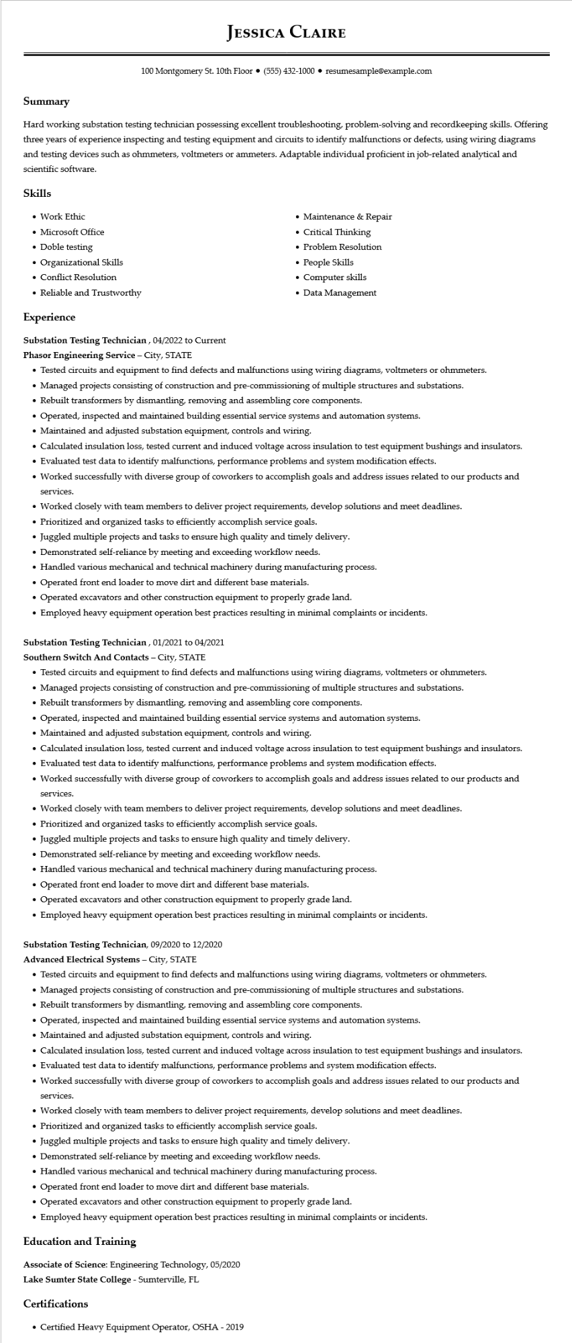

**JESSICA CLAIRE**

100 Montgomery St. 10th Floor⚫ (555) 432-1000⚫ resumesample@example.com

**Summary**

Hard working substation testing technician possessing excellent troubleshooting, problem-solving and recordkeeping skills. Offering three years of experience inspecting and testing equipment and circuits to identify malfunctions or defects, using wiring diagrams and testing devices such as ohmmeters, voltmeters or ammeters. Adaptable individual proficient in job-related analytical and scientific software.

**Skills**

• Work Ethic

• Microsoft Office

• Doble testing

• Organizational Skills

• Conflict Resolution

• Reliable and Trustworthy

**Experience**

**Substation Testing Technician, 04/2022 to Current**

Phasor Engineering Service - City, STATE

• Maintenance & Repair

• Critical Thinking

• Problem Resolution

• People Skills

• Computer skills

• Data Management

• Tested circuits and equipment to find defects and malfunctions using wiring diagrams, voltmeters or ohmmeters.

• Managed projects consisting of construction and pre-commissioning of multiple structures and substations.

• Rebuilt transformers by dismantling, removing and assembling core components.

• Operated, inspected and maintained building essential service systems and automation systems.

• Maintained and adjusted substation equipment, controls and wiring.

• Calculated insulation loss, tested current and induced voltage across insulation to test equipment bushings and insulators.

• Evaluated test data to identify malfunctions, performance problems and system modification effects.

• Worked successfully with diverse group of coworkers to accomplish goals and address issues related to our products and services.

• Worked closely with team members to deliver project requirements, develop solutions and meet deadlines.

• Prioritized and organized tasks to efficiently accomplish service goals.

• Juggled multiple projects and tasks to ensure high quality and timely delivery.

• Demonstrated self-reliance by meeting and exceeding workflow needs.

• Handled various mechanical and technical machinery during manufacturing process.

• Operated front end loader to move dirt and different base materials.

• Operated excavators and other construction equipment to properly grade land.

• Employed heavy equipment operation best practices resulting in minimal complaints or incidents.

**Substation Testing Technician, 01/2021 to 04/2021**

**Southern Switch And Contacts - City, STATE**

• Tested circuits and equipment to find defects and malfunctions using wiring diagrams, voltmeters or ohmmeters.

• Managed projects consisting of construction and pre-commissioning of multiple structures and substations.

• Rebuilt transformers by dismantling, removing and assembling core components.

• Operated, inspected and maintained building essential service systems and automation systems.

• Maintained and adjusted substation equipment, controls and wiring.

• Calculated insulation loss, tested current and induced voltage across insulation to test equipment bushings and insulators.

• Evaluated test data to identify malfunctions, performance problems and system modification effects.

• Worked successfully with diverse group of coworkers to accomplish goals and address issues related to our products and

services.

• Worked closely with team members to deliver project requirements, develop solutions and meet deadlines.

• Prioritized and organized tasks to efficiently accomplish service goals.

• Juggled multiple projects and tasks to ensure high quality and timely delivery.

• Demonstrated self-reliance by meeting and exceeding workflow needs.

• Handled various mechanical and technical machinery during manufacturing process.

• Operated front end loader to move dirt and different base materials.

• Operated excavators and other construction equipment to properly grade land.

• Employed heavy equipment operation best practices resulting in minimal complaints or incidents.

**Substation Testing Technician, 09/2020 to 12/2020**

Advanced Electrical Systems - City, STATE

• Tested circuits and equipment to find defects and malfunctions using wiring diagrams, voltmeters or ohmmeters.

• Managed projects consisting of construction and pre-commissioning of multiple structures and substations.

• Rebuilt transformers by dismantling, removing and assembling core components.

• Operated, inspected and maintained building essential service systems and automation systems.

• Maintained and adjusted substation equipment, controls and wiring.

• Calculated insulation loss, tested current and induced voltage across insulation to test equipment bushings and insulators.

• Evaluated test data to identify malfunctions, performance problems and system modification effects.

• Worked successfully with diverse group of coworkers to accomplish goals and address issues related to our products and

services.

• Worked closely with team members to deliver project requirements, develop solutions and meet deadlines.

• Prioritized and organized tasks to efficiently accomplish service goals.

• Juggled multiple projects and tasks to ensure high quality and timely delivery.

• Demonstrated self-reliance by meeting and exceeding workflow needs.

• Handled various mechanical and technical machinery during manufacturing process.

• Operated front end loader to move dirt and different base materials.

• Operated excavators and other construction equipment to properly grade land.

• Employed heavy equipment operation best practices resulting in minimal complaints or incidents.

**Education and Training**

Associate of Science: Engineering Technology, 05/2020

**Lake Sumter State College - Sumterville, FL**

Certifications

• Certified Heavy Equipment Operator, OSHA - 2019