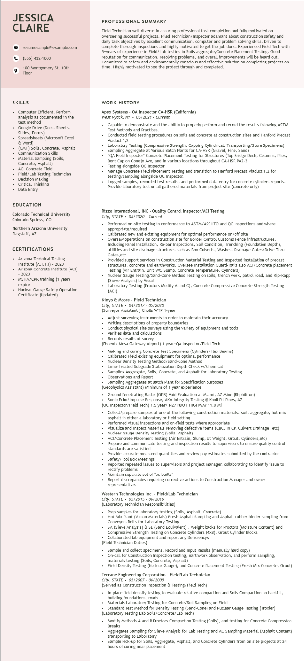

**JESSICA CLAIRE**

resumesample@example.com

(555) 432-1000

100 Montgomery St. 10th Floor

**PROFESSIONAL SUMMARY**

Field Technician well-diverse in assuring professional task completion and fully motivated on overseeing successful projects. Filed Technician/Inspector adamant about construction safety and daily task objectives by excellent communication, computer and problem solving skills. Driven to complete thorough inspections and highly motivated to get the job done. Experienced Field Tech with 5+years of experience in Field/Lab testing in Soils aggregate, Concrete Placement Testing. Good reputation for communication, resolving problems, and overall improvements will be heard out. Committed to safety and environmentally-conscious and effective solution on completing projects on time. Highly motivated to see the project through and completed.

SKILLS

Computer Efficient, Perform

analysis as documented in the test method

Google Drive (Docs, Sheets, Slides, Forms)

Spreadsheets (Microsoft Excel & Word)

Soils, Concrete, Asphalt

(CMT) Soils

• Communication Skills

·

Material Sampling (Soils, Concrete, Asphalt)

ACI Concrete Field

Field/Lab Testing Technician

Decision Making

Critical Thinking

Data Entry

EDUCATION

Colorado Technical University

Colorado Springs, CO

Northern Arizona University Flagstaff, AZ

CERTIFICATIONS

• Arizona Technical Testing Institute (A.T.T.I) - 2023 Arizona Concrete Institute (ACI) - 2023 MSHA/CPR training (1 year) expire

• Nuclear Gauge Safety Operation Certificate (Updated)

**WORK HISTORY**

Apex Systems - QA Inspector CA-HSR (California)

West Nyack, NY⚫ 05/2021 - Current

• Capable to demonstrate and the ability to properly perform and record the results following ASTM Test Methods and Practices.

Conducted field testing procedures on soils and concrete at construction sites and Hanford Precast Viaduct 1,2

Laboratory Testing (Compressive Strength, Capping Cylindrical, Transporting/Store Specimens) • Sampling Aggregate at Various Batch Plants for CA-HSR (Gravel, Fine, Sand)

"QA Field Inspector" Concrete Placement Testing for Structures (Top Bridge Deck, Columns, Piles, Bent Cap on Conejo Ave, and in various locations throughout CA-HSR PA2-3

• Testing alongside QC Inspector

• Manage Concrete Field Placement Testing and transition to Hanford Precast Viaduct 1,2 for testing/sampling alongside QC Inspector.

Logged samples, recorded test results, and performed data entry for concrete cylinders reports. Provide laboratory test on all gathered materials from project site (concrete only)

Rizzo International, INC Quality Control Inspector/ACI Testing

*City, STATE⚫ 05/2020 - Current*

Performed on-site testing in conformance to ASTM/ASSHTO and QC Inspections and where appropriate/required

Calibrated new and existing equipment for optimal performance on/off site

Oversaw operations on construction site for Border Control Customs Fence infrastructures. Including Panel Installation, Re-bar Inspections, Soil Condition, Trenching (Foundation Depth), utilities and site drainage structures such as Box Culverts, Washes, Drainage Gates/Drive Thru dunities Gates, etc

Provided support services in Construction Material Testing and Inspected installation of precast structures, concrete and earthworks. Oversee Installation Guard-Rails also ACI/Concrete placement Testing (Air Entrain, Unit Wt, Slump, Concrete Temperature, Cylinders)

Nuclear Gauge Testing/Sand-Cone Method Testing on soils, trench work, patrol road, and Rip-Rapp (Sieve Analysis) by Visual

Laboratory Testing (Proctors Modify A and C), Concrete Compressive Concrete Strength Testing (ACI)

Ninyo & Moore - Field Technician

City, STATE. 04/2017 - 05/2020

(Surveyor Assistant) Cholla WTP 1-year

• Adjust surveying instruments in order to maintain their accuracy.

• Writing descriptions of property boundaries

• Conduct physical site surveys using the variety of equipment and tools

• Verifies data and calculations

• Records results of survey

(Phoenix Mesa Gateway Airport) 1 year+QA Inspector/Field Tech

• Making and curing Concrete Test Specimens (Cylinders/Flex Beams)

Calibrated Field existing equipment for optimal performance

Nuclear Density Testing Method/Sand-Cone Method

Lime-Treated Subgrade Stabilization Depth Check w/Chemical

Sampling Aggregate, Soils, Concrete, and Asphalt for Laboratory Testing Observations and Report

Sampling Aggregates at Batch Plant for Specification purposes

(Geophysics Assistant) Minimum of 1 year experience

Ground Penetrating Radar (GPR) Void Evaluation at Miami, AZ Mine (Bhpbiliton)

• Sonic Echo/Impulse Response, AKA Integrity Testing @ Knoll Pit Pines, AZ

(QC Inspector/Field Tech) 1.5 year+ N27 NDOT HIGHWAY 11.0 Mi

.

Collect/prepare samples of one of the following construction materials: soil, aggregate, hot mix asphalt in either a laboratory or field setting

Performed visual inspections and on-field tests where appropriate

Visualize and Inspect Materials removing defective items (CBC. RFCP, Culvert Drainage, etc) Nuclear Gauge Density Testing (Soils, Asphalt)

ACI/Concrete Placement Testing (Air Entrain, Slump, Ut Weight, Grout, Cylinders, etc)

Prepare and communicate testing and inspection results to supervisors to ensure quality control standards are satisfied

Provide accurate measured quantities and review pay estimates submitted by the contractor Safety/Tool Box Meetings

Reported repeated issues to supervisors and project manager, collaborating to identify issue to rectify problems

Maintain separate set of "as builts"

Report discrepancies requiring corrective actions to Construction Manager and owner representative.

Western Technologies Inc. - Field/Lab Technician

*City, STATE 05/2015 06/2016*

(Laboratory Technician Responsibilities)

.

Prep samples for laboratory testing (Soils, Asphalt, Concrete)

Hot Mix Plant (Vulcan Materials) Fresh Asphalt Sampling and Asphalt-rubber binder sampling from Conveyors Belts for Laboratory Testing

SA (Sieve Analysis) & SE (Sand Equivalent), Weight backs for Proctors (Moisture Content) and Compressive Strength Testing on Concrete Cylinders (4x8), Grout Cylinder Blocks Collaborated lab equipment and report any Deficiency's

.

(Field Technician Duties)

• Sample and collect specimens, Record and Input Results (manually hard copy)

On-call for Construction Inspection testing, earthwork observation, and perform sampling,

materials testing (Soils, Concrete, Asphalt)

Field Density Testing (Nuclear Gauge), and Concrete Placement Testing (Fresh Mix Concrete, Grout)

Terrane Engineering Corporation - Field/Lab Technician

City, STATE 05/2007 - 06/2009

(Served as Construction Inspection & Testing/Field Tech)

• In-place field density testing to evaluate relative compaction and Soils Compaction on backfill, building foundations, roads

Materials Laboratory Testing for Concrete/Soil Sampling on Field

Standard Test Method for Density Testing (Sand-Cone) and Nuclear Gauge Testing (Troxler)

(Laboratory Testing Lab Soils/Concrete/Lab Tech)

• Modify Methods A and B Proctors Compaction Testing (Soils), and testing for Concrete Compression Breaks

Aggregates Sampling for Sieve Analysis for Lab Testing and AC Sampling Material (Asphalt Content) transporting to Laboratory

• Sample Pick-up for Soils, Aggregate, Asphalt, and Concrete Cylinders from on site projects at 24 hours of curing near placement