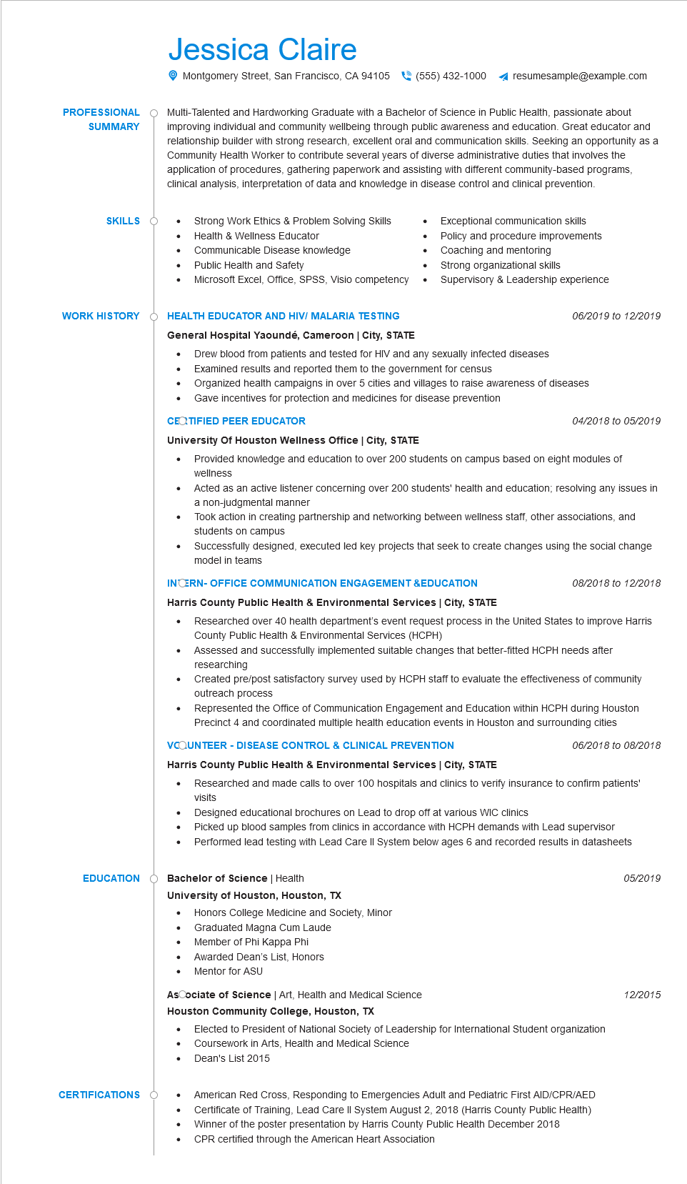

**PROFESSIONAL**

**SUMMARY**

**SKILLS O**

Jessica Claire

Montgomery Street, San Francisco, CA 94105(555) 432-1000 ◄ resumesample@example.com

Multi-Talented and Hardworking Graduate with a Bachelor of Science in Public Health, passionate about improving individual and community wellbeing through public awareness and education. Great educator and relationship builder with strong research, excellent oral and communication skills. Seeking an opportunity as a Community Health Worker to contribute several years of diverse administrative duties that involves the application of procedures, gathering paperwork and assisting with different community-based programs, clinical analysis, interpretation of data and knowledge in disease control and clinical prevention.

Strong Work Ethics & Problem Solving Skills

•

• Health & Wellness Educator

•

Communicable Disease knowledge

•

Public Health and Safety

•

Microsoft Excel, Office, SPSS, Visio competency

•

Exceptional communication skills

Policy and procedure improvements Coaching and mentoring

Strong organizational skills

Supervisory & Leadership experience

**WORK HISTORY**

**HEALTH EDUCATOR AND HIVI MALARIA TESTING**

06/2019 to 12/2019

**General Hospital Yaoundé, Cameroon | City, STATE**

Drew blood from patients and tested for HIV and any sexually infected diseases

Examined results and reported them to the government for census

Organized health campaigns in over 5 cities and villages to raise awareness of diseases

•

Gave incentives for protection and medicines for disease prevention

**CERTIFIED PEER EDUCATOR**

**University Of Houston Wellness Office | City, STATE**

04/2018 to 05/2019

· Provided knowledge and education to over 200 students on campus based on eight modules of wellness

• Acted as an active listener concerning over 200 students' health and education; resolving any issues in a non-judgmental manner

·

Took action in creating partnership and networking between wellness staff, other associations, and students on campus

Successfully designed, executed led key projects that seek to create changes using the social change model in teams

**INTERN-OFFICE COMMUNICATION ENGAGEMENT &EDUCATION**

**Harris County Public Health & Environmental Services | City, STATE**

•

*08/2018 to 12/2018*

Researched over 40 health department's event request process in the United States to improve Harris County Public Health & Environmental Services (HCPH)

Assessed and successfully implemented suitable changes that better-fitted HCPH needs after researching

Created pre/post satisfactory survey used by HCPH staff to evaluate the effectiveness of community outreach process

Represented the Office of Communication Engagement and Education within HCPH during Houston Precinct 4 and coordinated multiple health education events in Houston and surrounding cities VCOUNTEER - DISEASE CONTROL & CLINICAL PREVENTION

**Harris County Public Health & Environmental Services | City, STATE**

*06/2018 to 08/2018*

Researched and made calls to over 100 hospitals and clinics to verify insurance to confirm patients' visits

Designed educational brochures on Lead to drop off at various WIC clinics

*05/2019*

•

•

Picked up blood samples from clinics in accordance with HCPH demands with Lead supervisor Performed lead testing with Lead Care II System below ages 6 and recorded results in datasheets

**EDUCATION Bachelor of Science | Health**

**University of Houston, Houston, TX**

• Honors College Medicine and Society, Minor

Graduated Magna Cum Laude

Member of Phi Kappa Phi

Awarded Dean's List, Honors

Mentor for ASU

AsCociate of Science | Art, Health and Medical Science

**Houston Community College, Houston, TX**

Elected to President of National Society of Leadership for International Student organization Coursework in Arts, Health and Medical Science

Dean's List 2015

**CERTIFICATIONS**

•

American Red Cross, Responding to Emergencies Adult and Pediatric First AID/CPR/AED Certificate of Training, Lead Care II System August 2, 2018 (Harris County Public Health) Winner of the poster presentation by Harris County Public Health December 2018 CPR certified through the American Heart Association

12/2015