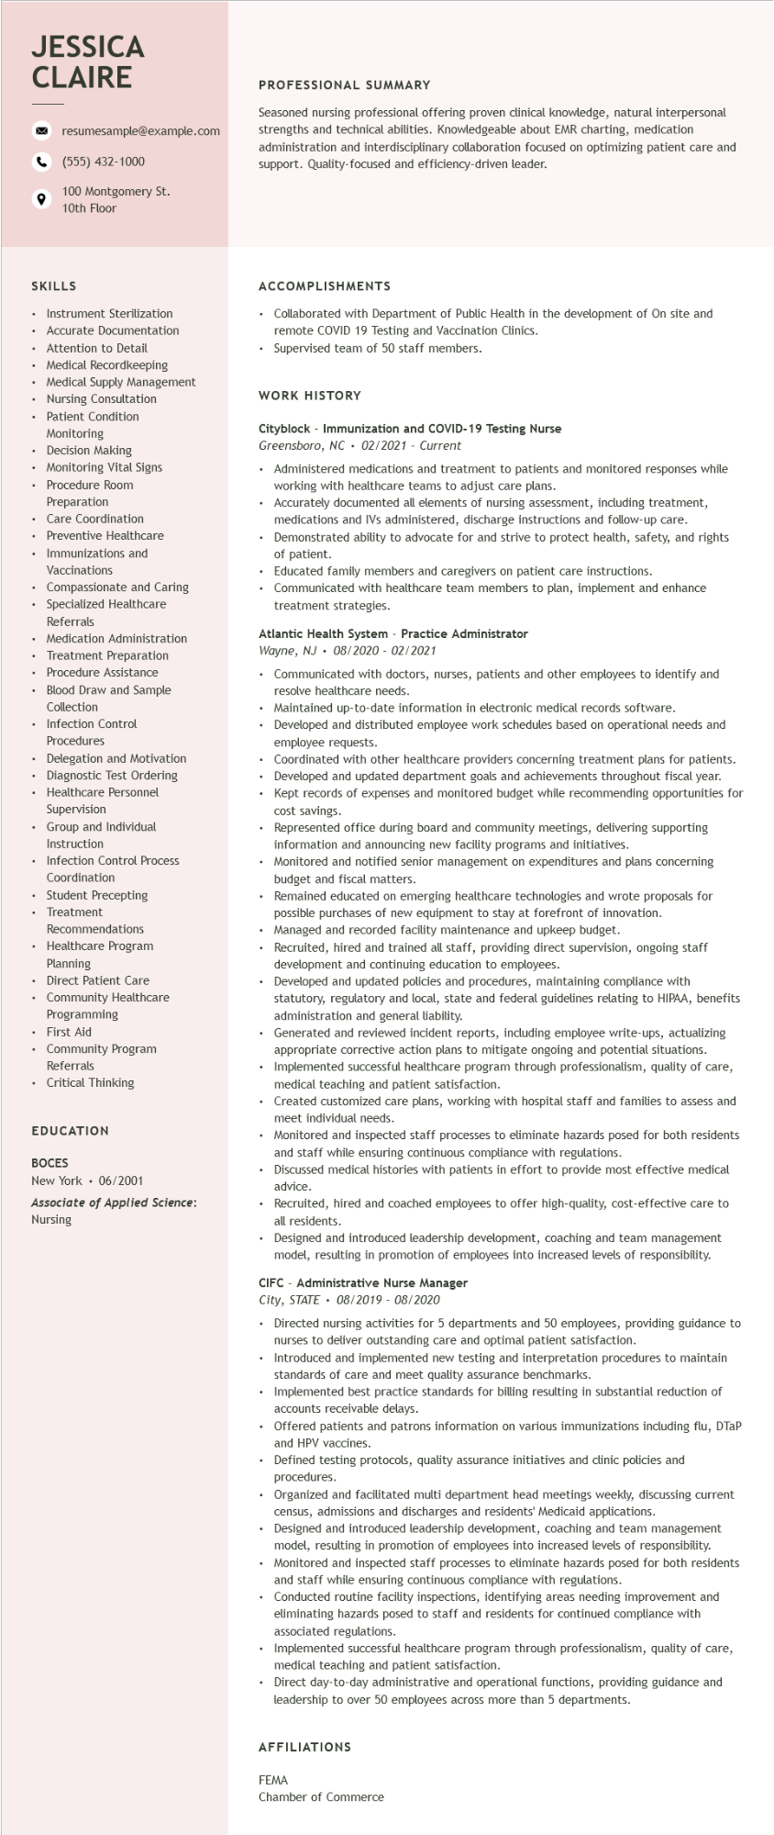

**JESSICA CLAIRE**

resumesample@example.com (555) 432-1000

100 Montgomery St.

10th Floor

**PROFESSIONAL SUMMARY**

Seasoned nursing professional offering proven clinical knowledge, natural interpersonal strengths and technical abilities. Knowledgeable about EMR charting, medication administration and interdisciplinary collaboration focused on optimizing patient care and support. Quality-focused and efficiency-driven leader.

**SKILLS**

ACCOMPLISHMENTS

Collaborated with Department of Public Health in the development of On site and remote COVID 19 Testing and Vaccination Clinics.

Supervised team of 50 staff members.

.

Instrument Sterilization

.

•

Accurate Documentation

Attention to Detail

• Medical Recordkeeping

• Medical Supply Management

• Nursing Consultation

• Patient Condition

Monitoring

Decision Making

• Monitoring Vital Signs

• Procedure Room

Preparation

Care Coordination

• Preventive Healthcare

• Immunizations and

Vaccinations

• Compassionate and Caring

• Specialized Healthcare

Referrals

• Medication Administration

•

Treatment Preparation

Procedure Assistance

Blood Draw and Sample Collection

• Infection Control

Procedures

Delegation and Motivation

• Diagnostic Test Ordering

• Healthcare Personnel

Supervision

Group and Individual Instruction

• Infection Control Process

Coordination

• Student Precepting

•

Treatment

Recommendations

Healthcare Program Planning

• Direct Patient Care

• Community Healthcare

Programming

• First Aid

• Community Program Referrals

• Critical Thinking

EDUCATION

**BOCES**

New York. 06/2001

Associate of Applied Science: Nursing

**WORK HISTORY**

**Cityblock - Immunization and COVID-19 Testing Nurse**

*Greensboro, NC 02/2021 - Current*

• Administered medications and treatment to patients and monitored responses while working with healthcare teams to adjust care plans.

Accurately documented all elements of nursing assessment, including treatment, medications and IVs administered, discharge instructions and follow-up care.

Demonstrated ability to advocate for and strive to protect health, safety, and rights of patient.

Educated family members and caregivers on patient care instructions.

Communicated with healthcare team members to plan, implement and enhance treatment strategies.

**Atlantic Health System - Practice Administrator**

*Wayne, NJ 08/2020- 02/2021*

• Communicated with doctors, nurses, patients and other employees to identify and resolve healthcare needs.

.

Maintained up-to-date information in electronic medical records software.

Developed and distributed employee work schedules based on operational needs and employee requests.

Coordinated with other healthcare providers concerning treatment plans for patients. Developed and updated department goals and achievements throughout fiscal year. Kept records of expenses and monitored budget while recommending opportunities for cost savings.

Represented office during board and community meetings, delivering supporting information and announcing new facility programs and initiatives.

Monitored and notified senior management on expenditures and plans concerning budget and fiscal matters.

Remained educated on emerging healthcare technologies and wrote proposals for possible purchases of new equipment to stay at forefront of innovation. Managed and recorded facility maintenance and upkeep budget.

Recruited, hired and trained all staff, providing direct supervision, ongoing staff development and continuing education to employees.

Developed and updated policies and procedures, maintaining compliance with statutory, regulatory and local, state and federal guidelines relating to HIPAA, benefits administration and general liability.

Generated and reviewed incident reports, including employee write-ups, actualizing appropriate corrective action plans to mitigate ongoing and potential situations. Implemented successful healthcare program through professionalism, quality of care, medical teaching and patient satisfaction.

• Created customized care plans, working with hospital staff and families to assess and meet individual needs.

Monitored and inspected staff processes to eliminate hazards posed for both residents and staff while ensuring continuous compliance with regulations.

Discussed medical histories with patients in effort to provide most effective medical advice.

Recruited, hired and coached employees to offer high-quality, cost-effective care to all residents.

Designed and introduced leadership development, coaching and team management model, resulting in promotion of employees into increased levels of responsibility.

CIFC - Administrative Nurse Manager

*City, STATE 08/2019 - 08/2020*

Directed nursing activities for 5 departments and 50 employees, providing guidance to nurses to deliver outstanding care and optimal patient satisfaction.

Introduced and implemented new testing and interpretation procedures to maintain standards of care and meet quality assurance benchmarks.

Implemented best practice standards for billing resulting in substantial reduction of accounts receivable delays.

Offered patients and patrons information on various immunizations including flu, DTaP and HPV vaccines.

Defined testing protocols, quality assurance initiatives and clinic policies and

procedures.

Organized and facilitated multi department head meetings weekly, discussing current census, admissions and discharges and residents' Medicaid applications.

Designed and introduced leadership development, coaching and team management model, resulting in promotion of employees into increased levels of responsibility.

• Monitored and inspected staff processes to eliminate hazards posed for both residents and staff while ensuring continuous compliance with regulations.

Conducted routine facility inspections, identifying areas needing improvement and eliminating hazards posed to staff and residents for continued compliance with associated regulations.

Implemented successful healthcare program through professionalism, quality of care, medical teaching and patient satisfaction.

• Direct day-to-day administrative and operational functions, providing guidance and leadership to over 50 employees across more than 5 departments.

AFFILIATIONS

FEMA

Chamber of Commerce