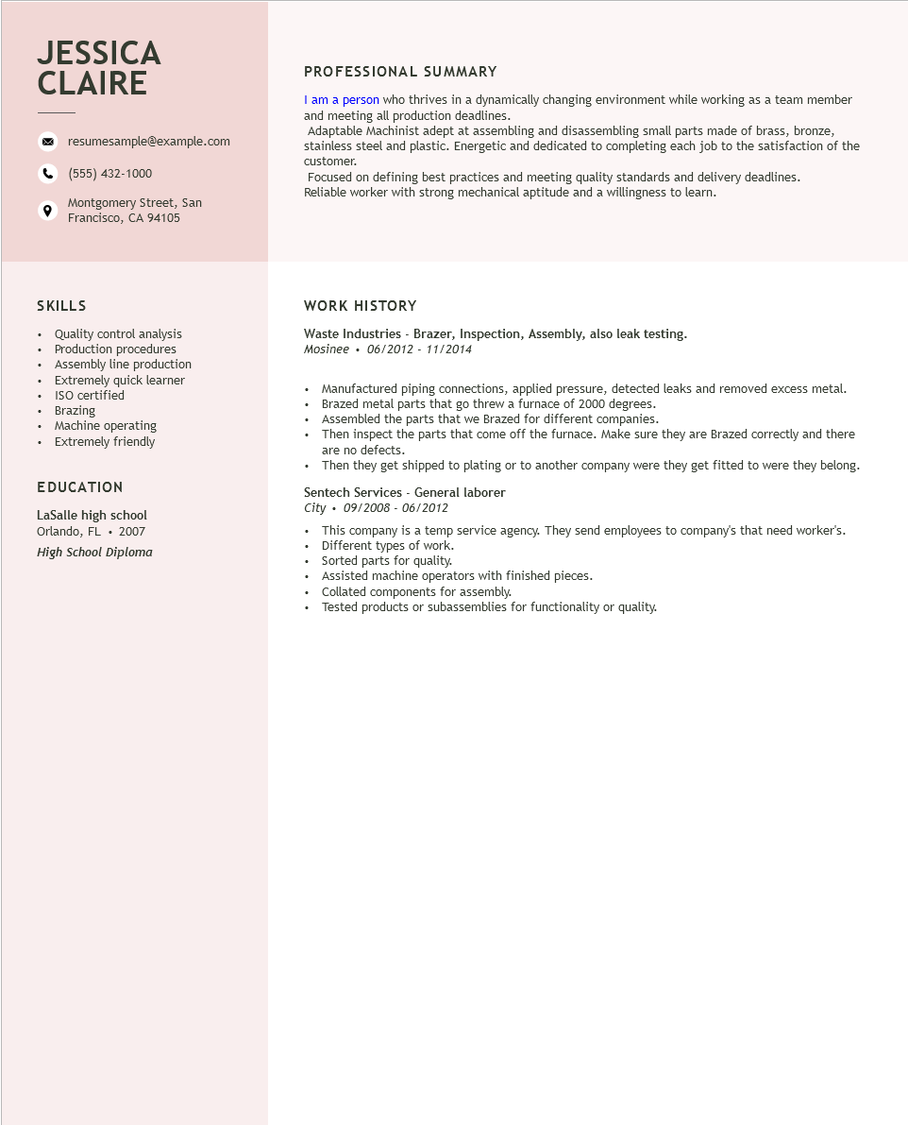

**JESSICA CLAIRE**

resumesample@example.com

(555) 432-1000

Montgomery Street, San Francisco, CA 94105

PROFESSIONAL SUMMARY

I am a person who thrives in a dynamically changing environment while working as a team member and meeting all production deadlines.

Adaptable Machinist adept at assembling and disassembling small parts made of brass, bronze, stainless steel and plastic. Energetic and dedicated to completing each job to the satisfaction of the customer.

Focused on defining best practices and meeting quality standards and delivery deadlines. Reliable worker with strong mechanical aptitude and a willingness to learn.

SKILLS

• Quality control analysis

•

•

•

•

•

Production procedures Assembly line production

Extremely quick learner

ISO certified

Brazing

• Machine operating

• Extremely friendly

**EDUCATION**

LaSalle high school Orlando, FL 2007

*High School Diploma*

**WORK HISTORY**

Waste Industries - Brazer, Inspection, Assembly, also leak testing. Mosinee⚫ 06/2012 - 11/2014

Manufactured piping connections, applied pressure, detected leaks and removed excess metal. Brazed metal parts that go threw a furnace of 2000 degrees.

Assembled the parts that we Brazed for different companies.

• Then inspect the parts that come off the furnace. Make sure they are Brazed correctly and there are no defects.

• Then they get shipped to plating or to another company were they get fitted to were they belong.

Sentech Services - General laborer

City

*09/2008 - 06/2012*

• This company is a temp service agency. They send employees to company's that need worker's. Different types of work.

•

• Sorted parts for quality.

• Assisted machine operators with finished pieces.

• Collated components for assembly.

Tested products or subassemblies for functionality or quality.