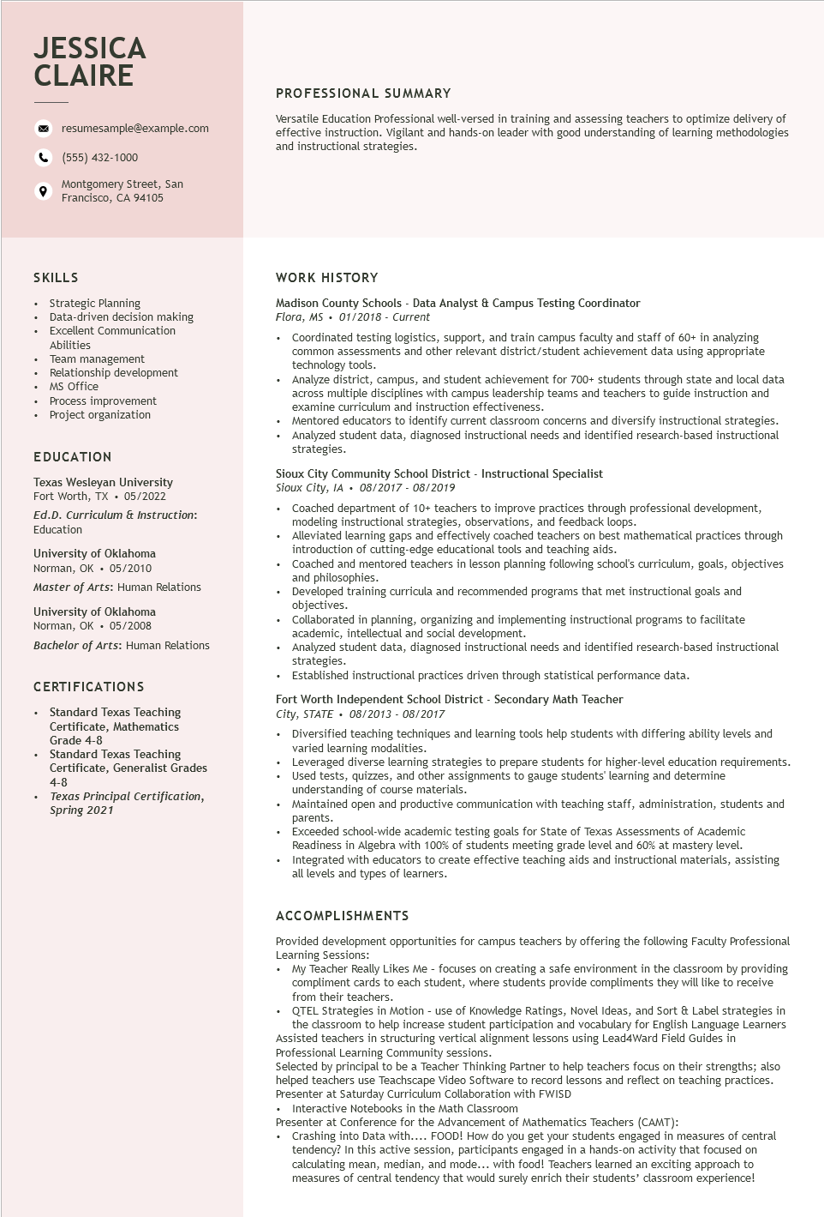

**JESSICA CLAIRE**

resumesample@example.com

(555) 432-1000

Montgomery Street, San Francisco, CA 94105

PROFESSIONAL SUMMARY

Versatile Education Professional well-versed in training and assessing teachers to optimize delivery of effective instruction. Vigilant and hands-on leader with good understanding of learning methodologies and instructional strategies.

SKILLS

•

Strategic Planning

·

•

Data-driven decision making

Excellent Communication

Abilities

•

Team management

•

•

MS Office

Relationship development

Process improvement Project organization

EDUCATION

Texas Wesleyan University Fort Worth, TX. 05/2022

Ed.D. Curriculum & Instruction: Education

University of Oklahoma Norman, OK 05/2010

Master of Arts: Human Relations

University of Oklahoma Norman, OK 05/2008

Bachelor of Arts: Human Relations

**CERTIFICATIONS**

•

Standard Texas Teaching

Certificate, Mathematics

Grade 4-8

Standard Texas Teaching

Certificate, Generalist Grades 4-8

*Texas Principal Certification, Spring 2021*

**WORK HISTORY**

Madison County Schools - Data Analyst & Campus Testing Coordinator Flora, MS. 01/2018 - Current

• Coordinated testing logistics, support, and train campus faculty and staff of 60+ in analyzing common assessments and other relevant district/student achievement data using appropriate technology tools.

• Analyze district, campus, and student achievement for 700+ students through state and local data across multiple disciplines with campus leadership teams and teachers to guide instruction and examine curriculum and instruction effectiveness.

• Mentored educators to identify current classroom concerns and diversify instructional strategies. Analyzed student data, diagnosed instructional needs and identified research-based instructional strategies.

Sioux City Community School District - Instructional Specialist

*Sioux City, IA. 08/2017 - 08/2019*

• Coached department of 10+ teachers to improve practices through professional development, modeling instructional strategies, observations, and feedback loops.

• Alleviated learning gaps and effectively coached teachers on best mathematical practices through introduction of cutting-edge educational tools and teaching aids.

• Coached and mentored teachers in lesson planning following school's curriculum, goals, objectives and philosophies.

• Developed training curricula and recommended programs that met instructional goals and objectives.

.

·

Collaborated in planning, organizing and implementing instructional programs to facilitate academic, intellectual and social development.

Analyzed student data, diagnosed instructional needs and identified research-based instructional strategies.

• Established instructional practices driven through statistical performance data.

Fort Worth Independent School District - Secondary Math Teacher

*City, STATE⚫ 08/2013 - 08/2017*

⚫ Diversified teaching techniques and learning tools help students with differing ability levels and varied learning modalities.

• Leveraged diverse learning strategies to prepare students for higher-level education requirements.

• Used tests, quizzes, and other assignments to gauge students' learning and determine understanding of course materials.

• Maintained open and productive communication with teaching staff, administration, students and parents.

Exceeded school-wide academic testing goals for State of Texas Assessments of Academic Readiness in Algebra with 100% of students meeting grade level and 60% at mastery level.

• Integrated with educators to create effective teaching aids and instructional materials, assisting all levels and types of learners.

**ACCOMPLISHMENTS**

Provided development opportunities for campus teachers by offering the following Faculty Professional Learning Sessions:

• My Teacher Really Likes Me - focuses on creating a safe environment in the classroom by providing compliment cards to each student, where students provide compliments they will like to receive from their teachers.

• QTEL Strategies in Motion - use of Knowledge Ratings, Novel Ideas, and Sort & Label strategies in the classroom to help increase student participation and vocabulary for English Language Learners Assisted teachers in structuring vertical alignment lessons using Lead4Ward Field Guides in Professional Learning Community sessions.

Selected by principal to be a Teacher Thinking Partner to help teachers focus on their strengths; also helped teachers use Teachscape Video Software to record lessons and reflect on teaching practices. Presenter at Saturday Curriculum Collaboration with FWISD

• Interactive Notebooks in the Math Classroom

Presenter at Conference for the Advancement of Mathematics Teachers (CAMT):

• Crashing into Data with.... FOOD! How do you get your students engaged in measures of central tendency? In this active session, participants engaged in a hands-on activity that focused on calculating mean, median, and mode... with food! Teachers learned an exciting approach to measures of central tendency that would surely enrich their students' classroom experience!