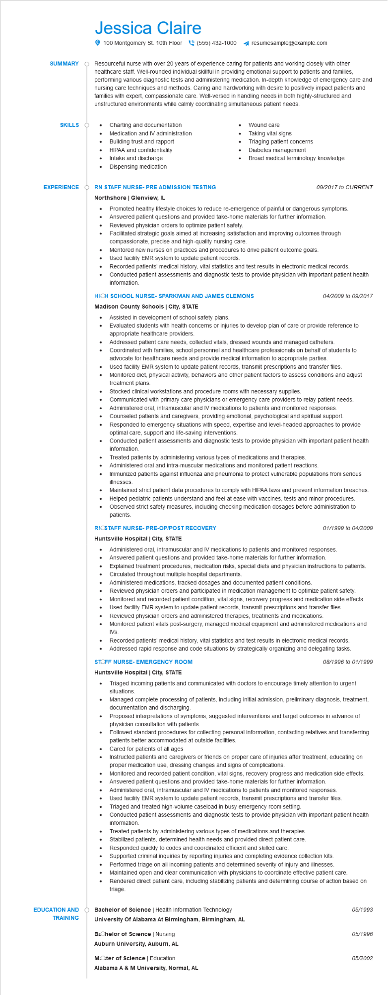

**SUMMARY**

**SKILLS O**

Jessica Claire

100 Montgomery St. 10th Floor (555) 432-1000 ◄ resumesample@example.com

Resourceful nurse with over 20 years of experience caring for patients and working closely with other healthcare staff. Well-rounded individual skillful in providing emotional support to patients and families, performing various diagnostic tests and administering medication. In-depth knowledge of emergency care and nursing care techniques and methods. Caring and hardworking with desire to positively impact patients and families with expert, compassionate care. Well-versed in handling needs in both highly-structured and unstructured environments while calmly coordinating simultaneous patient needs.

Charting and documentation

• Medication and IV administration

Wound care

•

Taking vital signs

**EXPERIENCE**

**EDUCATION AND TRAINING**

•

Building trust and rapport

HIPAA and confidentiality

•

Intake and discharge

Dispensing medication

Triaging patient concerns Diabetes management

Broad medical terminology knowledge

**RN STAFF NURSE- PRE ADMISSION TESTING Northshore | Glenview, IL**

•

•

•

*09/2017 to CURRENT*

Promoted healthy lifestyle choices to reduce re-emergence of painful or dangerous symptoms. Answered patient questions and provided take-home materials for further information.

Reviewed physician orders to optimize patient safety.

Facilitated strategic goals aimed at increasing satisfaction and improving outcomes through compassionate, precise and high-quality nursing care.

Mentored new nurses on practices and procedures to drive patient outcome goals.

Used facility EMR system to update patient records.

Recorded patients' medical history, vital statistics and test results in electronic medical records. Conducted patient assessments and diagnostic tests to provide physician with important patient health information.

**HICH SCHOOL NURSE- SPARKMAN AND JAMES CLEMONS**

**Madison County Schools | City, STATE**

• Assisted in development of school safety plans.

•

•

•

•

•

04/2009 to 09/2017

Evaluated students with health concerns or injuries to develop plan of care or provide reference to appropriate healthcare providers.

Addressed patient care needs, collected vitals, dressed wounds and managed catheters. Coordinated with families, school personnel and healthcare professionals on behalf of students to advocate for healthcare needs and provide medical information to appropriate parties.

Used facility EMR system to update patient records, transmit prescriptions and transfer files. Monitored diet, physical activity, behaviors and other patient factors to assess conditions and adjust treatment plans.

Stocked clinical workstations and procedure rooms with necessary supplies.

Communicated with primary care physicians or emergency care providers to relay patient needs. Administered oral, intramuscular and IV medications to patients and monitored responses. Counseled patients and caregivers, providing emotional, psychological and spiritual support. Responded to emergency situations with speed, expertise and level-headed approaches to provide optimal care, support and life-saving interventions.

Conducted patient assessments and diagnostic tests to provide physician with important patient health information.

•

Treated patients by administering various types of medications and therapies. Administered oral and intra-muscular medications and monitored patient reactions.

•

•

Immunized patients against influenza and pneumonia to protect vulnerable populations from serious illnesses.

Maintained strict patient data procedures to comply with HIPAA laws and prevent information breaches. Helped pediatric patients understand and feel at ease with vaccines, tests and minor procedures. Observed strict safety measures, including checking medication dosages before administration to patients.

**RNOSTAFF NURSE- PRE-OP/POST RECOVERY Huntsville Hospital | City, STATE**

•

01/1999 to 04/2009

Administered oral, intramuscular and IV medications to patients and monitored responses.

• Answered patient questions and provided take-home materials for further information.

•

Explained treatment procedures, medication risks, special diets and physician instructions to patients. Circulated throughout multiple hospital departments.

•

Administered medications, tracked dosages and documented patient conditions.

•

•

Reviewed physician orders and participated in medication management to optimize patient safety. Monitored and recorded patient condition, vital signs, recovery progress and medication side effects. Used facility EMR system to update patient records, transmit prescriptions and transfer files. Reviewed physician orders and administered therapies, treatments and medications.

Monitored patient vitals post-surgery, managed medical equipment and administered medications and IVs.

Recorded patients' medical history, vital statistics and test results in electronic medical records. Addressed rapid response and code situations by strategically organizing and delegating tasks. STOFF NURSE- EMERGENCY ROOM

**Huntsville Hospital | City, STATE**

•

•

08/1996 to 01/1999

Triaged incoming patients and communicated with doctors to encourage timely attention to urgent situations.

Managed complete processing of patients, including initial admission, preliminary diagnosis, treatment, documentation and discharging.

•

Proposed interpretations of symptoms, suggested interventions and target outcomes in advance of physician consultation with patients.

Followed standard procedures for collecting personal information, contacting relatives and transferring patients better accommodated at outside facilities.

Cared for patients of all ages

Instructed patients and caregivers or friends on proper care of injuries after treatment, educating on proper medication use, dressing changes and signs of complications.

•

•

Monitored and recorded patient condition, vital signs, recovery progress and medication side effects. Answered patient questions and provided take-home materials for further information. Administered oral, intramuscular and IV medications to patients and monitored responses.

•

Used facility EMR system to update patient records, transmit prescriptions and transfer files. Triaged and treated high-volume caseload in busy emergency room setting.

Conducted patient assessments and diagnostic tests to provide physician with important patient health information.

Treated patients by administering various types of medications and therapies.

Stabilized patients, determined health needs and provided direct patient care.

•

Responded quickly to codes and coordinated efficient and skilled care.

Supported criminal inquiries by reporting injuries and completing evidence collection kits.

•

Performed triage on all incoming patients and determined severity of injury and illnesses.

Maintained open and clear communication with physicians to coordinate effective patient care.

•

Rendered direct patient care, including stabilizing patients and determining course of action based on triage.

Bachelor of Science | Health Information Technology

**University Of Alabama At Birmingham, Birmingham, AL**

**Bachelor of Science | Nursing**

**Auburn University, Auburn, AL**

**Moter of Science | Education**

Alabama A & M University, Normal, AL

*05/1993*

05/1996

05/2002