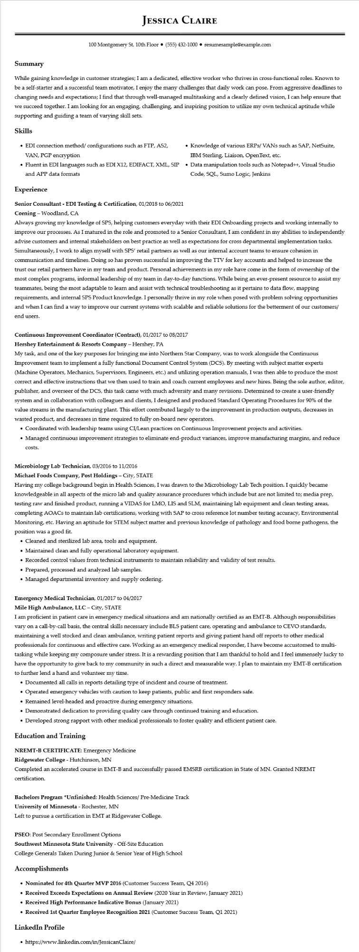

**JESSICA CLAIRE**

100 Montgomery St. 10th Floor⚫ (555) 432-1000⚫ resumesample@example.com

**Summary**

While gaining knowledge in customer strategies; I am a dedicated, effective worker who thrives in cross-functional roles. Known to be a self-starter and a successful team motivator, I enjoy the many challenges that daily work can pose. From aggressive deadlines to changing needs and expectations; I find that through well-managed multitasking and a clearly defined vision, I can help ensure that we succeed together. I am looking for an engaging, challenging, and inspiring position to utilize my own technical aptitude while supporting and guiding a team of varying skill sets.

**Skills**

• EDI connection method/ configurations such as FTP, AS2, VAN, PGP encryption

• Fluent in EDI languages such as EDI X12, EDIFACT, XML, SIP and APP data formats

**Experience**

**Senior Consultant - EDI Testing & Certification, 01/2018 to 06/2021**

Corning - Woodland, CA

Knowledge of various ERPs/ VANs such as SAP, NetSuite,

IBM Sterling, Liaison, OpenText, etc.

• Data manipulation tools such as Notepad++, Visual Studio Code, SQL, Sumo Logic, Jenkins

Always growing my knowledge of SPS, helping customers everyday with their EDI Onboarding projects and working internally to improve our processes. As I matured in the role and promoted to a Senior Consultant, I am confident in my abilities to independently advise customers and internal stakeholders on best practice as well as expectations for cross departmental implementation tasks. Simultaneously, I work to align myself with SPS' retail partners as well as our internal account teams to ensure cohesion in communication and timelines. Doing so has proven successful in improving the TTV for key accounts and helped to increase the trust our retail partners have in my team and product. Personal achievements in my role have come in the form of ownership of the most complex programs, informal leadership of my team in day-to-day functions. While being an ever-present resource to assist my teammates, being the most adaptable to learn and assist with technical troubleshooting as it pertains to data flow, mapping requirements, and internal SPS Product knowledge. I personally thrive in my role when posed with problem solving opportunities and when I can find a way to improve our current systems with scalable and reliable solutions for the betterment of our customers/ end users.

**Continuous Improvement Coordinator (Contract), 01/2017 to 08/2017**

**Hershey Entertainment & Resorts Company - Hershey, PA**

My task, and one of the key purposes for bringing me into Northern Star Company, was to work alongside the Continuous Improvement team to implement a fully functional Document Control System (DCS). By meeting with subject matter experts (Machine Operators, Mechanics, Supervisors, Engineers, etc.) and utilizing operation manuals, I was then able to produce the most correct and effective instructions that we then used to train and coach current employees and new hires. Being the sole author, editor, publisher, and overseer of the DCS, this task came with much adversity and many revisions. Determined to create a user-friendly system and in collaboration with colleagues and clients, I designed and produced Standard Operating Procedures for 90% of the value streams in the manufacturing plant. This effort contributed largely to the improvement in production outputs, decreases in wasted product, and decreases in time required to fully on-board new operators.

• Coordinated with leadership teams using CI/Lean practices on Continuous Improvement projects and activities.

• Managed continuous improvement strategies to eliminate end-product variances, improve manufacturing margins, and reduce

costs.

Microbiology Lab Technician, 03/2016 to 11/2016

**Michael Foods Company, Post Holdings - City, STATE**

Having my college background begin in Health Sciences, I was drawn to the Microbiology Lab Tech position. I quickly became knowledgeable in all aspects of the micro lab and quality assurance procedures which include but are not limited to; media prep, testing raw and finished product, running a VIDAS for LMO, LIS and SLM, maintaining lab equipment and clean testing areas, completing AOACs to maintain lab certifications, working with SAP to cross reference lot number testing accuracy, Environmental Monitoring, etc. Having an aptitude for STEM subject matter and previous knowledge of pathology and food borne pathogens, the position was a good fit.

• Cleaned and sterilized lab area, tools and equipment.

• Maintained clean and fully operational laboratory equipment.

• Recorded control values from technical instruments to maintain reliability and validity of test results.

• Prepared, processed and analyzed lab samples.

• Managed departmental inventory and supply ordering.

**Emergency Medical Technician, 01/2017 to 04/2017**

**Mile High Ambulance, LLC - City, STATE**

I am proficient in patient care in emergency medical situations and am nationally certified as an EMT-B. Although responsibilities vary on a call-by-call basis, the central skills necessary include BLS patient care, operating and ambulance to CEVO standards, maintaining a well stocked and clean ambulance, writing patient reports and giving patient hand off reports to other medical professionals for continuous and effective care. Working as an emergency medical responder, I have become accustomed to multi- tasking while keeping my composure under stress. It is a rewarding position that I am thankful to hold and I feel immensely lucky to have the opportunity to give back to my community in such a direct and measurable way. I plan to maintain my EMT-B certification to further lend a hand and volunteer my time.

• Documented all calls in reports detailing type of incident and course of treatment.

• Operated emergency vehicles with caution to keep patients, public and first responders safe.

• Remained level-headed and proactive during emergency situations.

• Demonstrated dedication to providing quality care through continued training and education.

• Developed strong rapport with other medical professionals to foster quality and efficient patient care.

**Education and Training**

**NREMT-B CERTIFICATE: Emergency Medicine**

**Ridgewater College - Hutchinson, MN**

Completed an accelerated course in EMT-B and successfully passed EMSRB certification in State of MN. Granted NREMT certification.

**Bachelors Program *Unfinished: Health Sciences/ Pre-Medicine Track**

**University of Minnesota - Rochester, MN**

Left to pursue a certification in EMT at Ridgewater College.

PSEO: Post Secondary Enrollment Options

**Southwest Minnesota State University - Off-Site Education**

College Generals Taken During Junior & Senior Year of High School

**Accomplishments**

**• Nominated for 4th Quarter MVP 2016 (Customer Success Team, Q4 2016)**

**• Received Exceeds Expectations on Annual Review (2020 Year in Review, January 2021)**

**• Received High Performance Indicative Bonus (January 2021)**

• Received 1st Quarter Employee Recognition 2021 (Customer Success Team, Q1 2021)

**LinkedIn Profile**

• https://www.linkedin.com/in/JessicanClaire/