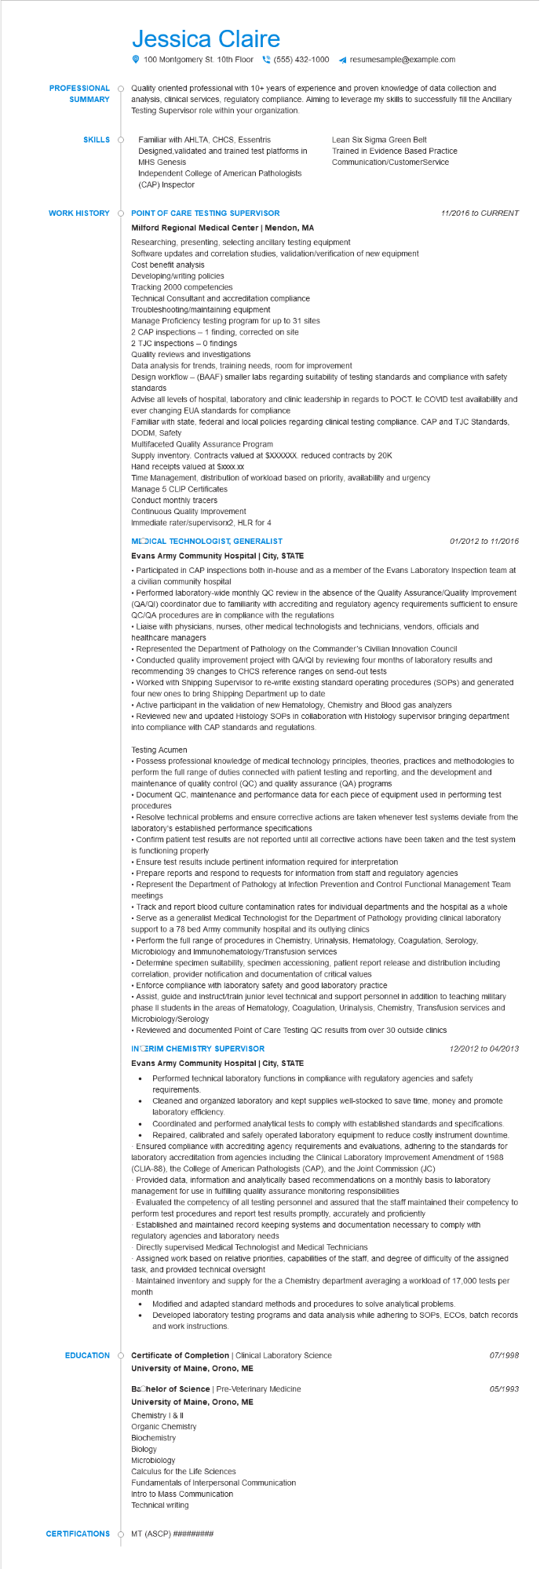

**PROFESSIONAL**

**SUMMARY**

Jessica Claire

100 Montgomery St. 10th Floor (555) 432-1000 ◄ resumesample@example.com

Quality oriented professional with 10+ years of experience and proven knowledge of data collection and analysis, clinical services, regulatory compliance. Aiming to leverage my skills to successfully fill the Ancillary Testing Supervisor role within your organization.

**SKILLS**

Familiar with AHLTA, CHCS, Essentris

Designed, validated and trained test platforms in MHS Genesis

Independent College of American Pathologists (CAP) Inspector

Lean Six Sigma Green Belt

Trained in Evidence Based Practice Communication/CustomerService

**WORK HISTORY**

**POINT OF CARE TESTING SUPERVISOR**

11/2016 to CURRENT

**Milford Regional Medical Center | Mendon, MA**

Researching, presenting, selecting ancillary testing equipment

Software updates and correlation studies, validation/verification of new equipment

Cost benefit analysis

Developing/writing policies

Tracking 2000 competencies

Technical Consultant and accreditation compliance

Troubleshooting/maintaining equipment

Manage Proficiency testing program for up to 31 sites

2 CAP inspections - 1 finding, corrected on site

2 TJC inspections - O findings

Quality reviews and investigations

Data analysis for trends, training needs, room for improvement

Design workflow - (BAAF) smaller labs regarding suitability of testing standards and compliance with safety standards

Advise all levels of hospital, laboratory and clinic leadership in regards to POCT. le COVID test availability and ever changing EUA standards for compliance

Familiar with state, federal and local policies regarding clinical testing compliance. CAP and TJC Standards, DODM, Safety

Multifaceted Quality Assurance Program

Supply inventory. Contracts valued at $XXXXXX. reduced contracts by 20K

Hand receipts valued at $xxxxx.xx

Time Management, distribution of workload based on priority, availability and urgency

Manage 5 CLIP Certificates

Conduct monthly tracers

Continuous Quality Improvement

Immediate rater/supervisorx2, HLR for 4

**MODICAL TECHNOLOGIST, GENERALIST**

**Evans Army Community Hospital | City, STATE**

*01/2012 to 11/2016*

• Participated in CAP inspections both in-house and as a member of the Evans Laboratory Inspection team at a civilian community hospital

• Performed laboratory-wide monthly QC review in the absence of the Quality Assurance/Quality Improvement (QA/QI) coordinator due to familiarity with accrediting and regulatory agency requirements sufficient to ensure QC/QA procedures are in compliance with the regulations

• Liaise with physicians, nurses, other medical technologists and technicians, vendors, officials and healthcare managers

• Represented the Department of Pathology on the Commander's Civilian Innovation Council

• Conducted quality improvement project with QA/QI by reviewing four months of laboratory results and recommending 39 changes to CHCS reference ranges on send-out tests

• Worked with Shipping Supervisor to re-write existing standard operating procedures (SOPs) and generated four new ones to bring Shipping Department up to date

• Active participant in the validation of new Hematology, Chemistry and Blood gas analyzers

• Reviewed new and updated Histology SOPS in collaboration with Histology supervisor bringing department into compliance with CAP standards and regulations.

Testing Acumen

• Possess professional knowledge of medical technology principles, theories, practices and methodologies to perform the full range of duties connected with patient testing and reporting, and the development and maintenance of quality control (QC) and quality assurance (QA) programs

• Document QC, maintenance and performance data for each piece of equipment used in performing test procedures

• Resolve technical problems and ensure corrective actions are taken whenever test systems deviate from the laboratory's established performance specifications

• Confirm patient test results are not reported until all corrective actions have been taken and the test system is functioning properly

• Ensure test results include pertinent information required for interpretation

• Prepare reports and respond to requests for information from staff and regulatory agencies

• Represent the Department of Pathology at Infection Prevention and Control Functional Management Team meetings

• Track and report blood culture contamination rates for individual departments and the hospital as a whole

• Serve as a generalist Medical Technologist for the Department of Pathology providing clinical laboratory support to a 78 bed Army community hospital and its outlying clinics

• Perform the full range of procedures in Chemistry, Urinalysis, Hematology, Coagulation, Serology, Microbiology and Immunohematology/Transfusion services

• Determine specimen suitability, specimen accessioning, patient report release and distribution including correlation, provider notification and documentation of critical values

• Enforce compliance with laboratory safety and good laboratory practice

• Assist, guide and instruct/train junior level technical and support personnel in addition to teaching military phase II students in the areas of Hematology, Coagulation, Urinalysis, Chemistry, Transfusion services and Microbiology/Serology

• Reviewed and documented Point of Care Testing QC results from over 30 outside clinics

**INTERIM CHEMISTRY SUPERVISOR**

**Evans Army Community Hospital | City, STATE**

12/2012 to 04/2013

• Performed technical laboratory functions in compliance with regulatory agencies and safety requirements.

Cleaned and organized laboratory and kept supplies well-stocked to save time, money and promote laboratory efficiency.

Coordinated and performed analytical tests to comply with established standards and specifications. Repaired, calibrated and safely operated laboratory equipment to reduce costly instrument downtime. Ensured compliance with accrediting agency requirements and evaluations, adhering to the standards for laboratory accreditation from agencies including the Clinical Laboratory Improvement Amendment of 1988 (CLIA-88), the College of American Pathologists (CAP), and the Joint Commission (JC)

Provided data, information and analytically based recommendations on a monthly basis to laboratory management for use in fulfilling quality assurance monitoring responsibilities

Evaluated the competency of all testing personnel and assured that the staff maintained their competency to perform test procedures and report test results promptly, accurately and proficiently

Established and maintained record keeping systems and documentation necessary to comply with regulatory agencies and laboratory needs

Directly supervised Medical Technologist and Medical Technicians

-Assigned work based on relative priorities, capabilities of the staff, and degree of difficulty of the assigned task, and provided technical oversight

Maintained inventory and supply for the a Chemistry department averaging a workload of 17,000 tests per month

•

· Modified and adapted standard methods and procedures to solve analytical problems. Developed laboratory testing programs and data analysis while adhering to SOPS, ECOS, batch records and work instructions.

**EDUCATION**

**Certificate of Completion | Clinical Laboratory Science**

**University of Maine, Orono, ME**

**Bachelor of Science | Pre-Veterinary Medicine**

**University of Maine, Orono, ME**

Chemistry I & II

Organic Chemistry

Biochemistry

Biology

Microbiology

Calculus for the Life Sciences

Fundamentals of Interpersonal Communication

Intro to Mass Communication

Technical writing

**CERTIFICATIONS MT (ASCP) ##########**

07/1998

05/1993