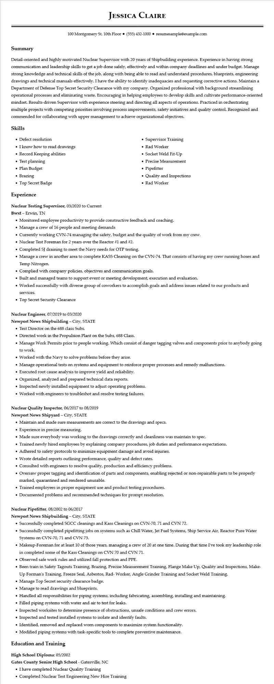

**JESSICA CLAIRE**

100 Montgomery St. 10th Floor⚫ (555) 432-1000⚫ resumesample@example.com

**Summary**

Detail-oriented and highly motivated Nuclear Supervisor with 20 years of Shipbuilding experience. Experience in having strong communication and leadership skills to get a job done safely, effectively and within company deadlines and under budget. Manage strong knowledge and technical skills of the job, along with being able to read and understand procedures, blueprints, engineering drawings and technical manuals effectively. I have the ability to identify inadequacies and requesting corrective actions. Maintain a Department of Defense Top Secret Security Clearance with my company. Organized professional with background streamlining operational processes and eliminating waste. Encouraging in helping employees to develop skills and cultivate performance-oriented mindset. Results-driven Supervisor with experience steering and directing all aspects of operations. Practiced in orchestrating multiple projects with competing priorities involving process improvements, safety initiatives and quality control. Recognized and commended for collaborating with upper management to achieve organizational objectives.

Skills

• Defect resolution

• I know how to read drawings

• Record Keeping abilities

• Test planning

• Plan Budget

• Brazing

• Top Secret Badge

**Experience**

**Nuclear Testing Supervisor, 03/2020 to Current**

Bwxt - Erwin, TN

• Supervisor Training

• Rad Worker

• Socket Weld Fit-Up

• Precise Measurement

• Pipefitter

• Quality and Inspections

• Rad Worker

• Monitored employee productivity to provide constructive feedback and coaching.

• Manage a crew of 16 people and meeting demands

• Currently working CVN-74 managing the safety, budget and the quality of work from my crew.

• Nuclear Test Foreman for 2 years over the Reactor #1 and #2.

• Completed SJ draining to meet the Navy needs for OTP testing.

• Manage a crew in another area to complete KASS Cleaning on the CVN-74. That consists of having my crew running hoses and Temp Nitrogen.

• Complied with company policies, objectives and communication goals.

• Built and managed teams to support event or meeting development, execution and evaluation.

• Worked successfully with diverse group of coworkers to accomplish goals and address issues related to our products and services.

• Top Secret Security Clearance

**Nuclear Engineer, 07/2019 to 03/2020**

**Newport News Shipbuilding - City, STATE**

• Test Director on the 688 class Subs.

• Directed work in the Propulsion Plant on the Subs, 688 Class.

• Manage Work Permits prior to people working. Which consist of danger tagging valves and components prior to anybody going to work.

• Worked with the Navy to solve problems before they arise.

• Manage operational tests on systems and equipment to reinforce proper processes and remedy malfunctions.

• Executed root cause analysis to improve yield and reliability.

• Organized, analyzed and prepared technical data reports.

• Inspected newly installed equipment to adjust operating problems.

• Worked with engineers to troubleshot and resolve testing failures.

**Nuclear Quality Inspector, 06/2017 to 08/2019**

**Newport News Shipyard - City, STATE**

• Maintain and made sure measurements are correct to the drawings and specs.

• Experience in precise measuring.

• Made sure everybody was working to the drawings correctly and cleanliness was maintain to spec.

• Trained newly hired employees by explaining company procedures, job duties and performance expectations.

• Adhered to safety protocols to minimize equipment damage and avoid injuries.

• Wrote detailed reports outlining performance, quality and defect rates.

• Consulted with engineers to resolve quality, production and efficiency problems.

• Oversaw proper tagging and identification of parts and components, enabling rejected or non-repairable parts to be properly marked, quarantined and rendered unusable.

• Trained employees in proper equipment use and product testing procedures.

• Documented problems and recommended techniques for prompt resolution.

**Nuclear Pipefitter, 08/2002 to 06/2017**

**Newport News Shipbuilding - City, STATE**

• Successfully completed SGCC cleanings and Kass Cleanings on CVN-70, 71 and CVN 72.

• Successfully completed pipefitting jobs on systems such as Chill Water, Jet Fuel Systems, Ship Service Air, Reactor Pure Water Systems on CVN-70, 71 and CVN 73.

• Makeup-Foreman for at least 10 of those years, managing a crew of 20 at one time. During that time I've took my leadership role in completed some of the Kass Cleanings on CVN 70 and CVN 71.

• Observed safe work rules and utilized fall protection and PPE.

• Been train in Safety Tagouts Training, Brazing, Precise Measurement Training, Flange Make Up, Quality and Inspections, Make- Up Forman's Training, Freeze Seal, Asbestos, Rad- Worker, Angle Grinder Training and Socket Weld Training.

• Manage Top Secret security clearance badge.

• Manage to read drawings and blueprints.

• Handled all responsibilities for piping systems, including fabricating, assembling, installing and maintaining.

• Filled piping systems with water and air to test for leaks.

• Inspected worksites to determine presence of obstructions, unsafe conditions and crew errors.

Inspected and tested installed systems to isolate and identify faults.

• Identified, removed and replaced worn components to maximize system functionality.

• Modified piping systems with task-specific tools to complete preventive maintenance.

**Education and Training**

**High School Diploma: 05/2002**

Gates County Senior High School - Gatesville, NC

• I have completed Nuclear Quality Training

• Completed Nuclear Test Engineering New Hire Training