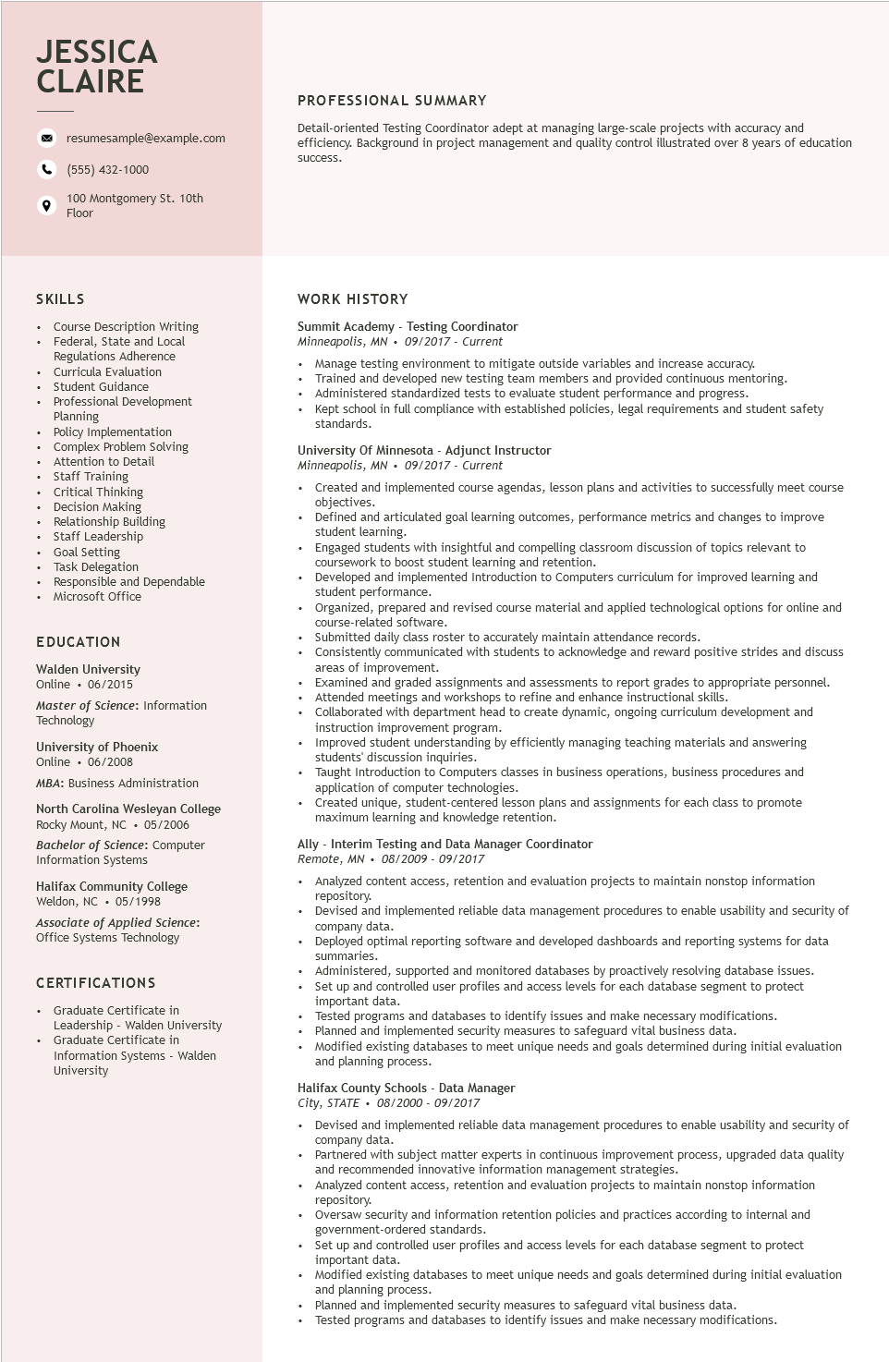

**JESSICA CLAIRE**

9

resumesample@example.com

(555) 432-1000

100 Montgomery St. 10th Floor

PROFESSIONAL SUMMARY

Detail-oriented Testing Coordinator adept at managing large-scale projects with accuracy and

efficiency. Background in project management and quality control illustrated over 8 years of education

success.

**SKILLS**

Course Description Writing

Federal, State and Local Regulations Adherence

Curricula Evaluation

Student Guidance

Professional Development Planning

Policy Implementation

Complex Problem Solving

comp

Attention to Detail

Staff Training

Critical Thinking

Decision Making

Relationship Building

• Staff Leadership

Goal Setting

Task Delegation

• Responsible and Dependable

• Microsoft Office

**EDUCATION**

Walden University Online 06/2015

Master of Science: Information

Technology

University of Phoenix Online⚫ 06/2008

MBA: Business Administration

North Carolina Wesleyan College Rocky Mount, NC 05/2006 Bachelor of Science: Computer Information Systems

Halifax Community College Weldon, NC 05/1998

Associate of Applied Science: Office Systems Technology

CERTIFICATIONS

• Graduate Certificate in

Leadership - Walden University Graduate Certificate in

Information Systems - Walden University

WORK HISTORY

Summit Academy - Testing Coordinator

Minneapolis, MN 09/2017 - Current

• Manage testing environment to mitigate outside variables and increase accuracy. Trained and developed new testing team members and provided continuous mentoring. Administered standardized tests to evaluate student performance and progress.

• Kept school in full compliance with established policies, legal requirements and student safety standards.

**University of Minnesota - Adjunct Instructor**

*Minneapolis, MN 09/2017 - Current*

Created and implemented course agendas, lesson plans and activities to successfully meet course objectives.

Defined and articulated goal learning outcomes, performance metrics and changes to improve student learning.

Engaged students with insightful and compelling classroom discussion of topics relevant to coursework to boost student learning and retention.

Developed and implemented Introduction to Computers curriculum for improved learning and student performance.

Organized, prepared and revised course material and applied technological options for online and course-related software.

Submitted daily class roster to accurately maintain attendance records.

Consistently communicated with students to acknowledge and reward positive strides and discuss areas of improvement.

Examined and graded assignments and assessments to report grades to appropriate personnel. I meetings and workshops to refine and enhance instructional skills.

Collaborated with department head to create dynamic, ongoing curriculum development and instruction improvement program.

mistruct

Improved student understanding by efficiently managing teaching materials and answering students' discussion inquiries.

Taught Introduction to Computers classes in business operations, business procedures and application of computer technologies.

Created unique, student-centered lesson plans and assignments for each class to promote maximum learning and knowledge retention.

Ally Interim Testing and Data Manager Coordinator

Remote, MN. 08/2009 - 09/2017

.

Analyzed content access, retention and evaluation projects to maintain nonstop information repository.

Devised and implemented reliable data management procedures to enable usability and security of company data.

Deployed optimal reporting software and developed dashboards and reporting systems for data summaries.

Administered, supported and monitored databases by proactively resolving database issues.

Sot un and

Set up and controlled user profiles and access levels for each database segment to protect important data.

Tested programs and databases to identify issues and make necessary modifications.

Planned and implemented security measures to safeguard vital business data.

Modified existing databases to meet unique needs and goals determined during initial evaluation and planning process.

Halifax County Schools Data Manager

City, STATE 08/2000-09/2017

•

Devised and implemented reliable data management procedures to enable usability and security of company data.

Partnered with subject matter experts in continuous improvement process, upgraded data quality and recommended innovative information management strategies.

Analyzed content access, retention and evaluation projects to maintain nonstop information repository.

Oversaw security and information retention policies and practices according to internal and government-ordered standards.

Set up and controlled user profiles and access levels for each database segment to protect important data.

Modified existing databases to meet unique needs and goals determined during initial evaluation and planning process.

Planned and implemented security measures to safeguard vital business data.

Tested programs and databases to identify issues and make necessary modifications.