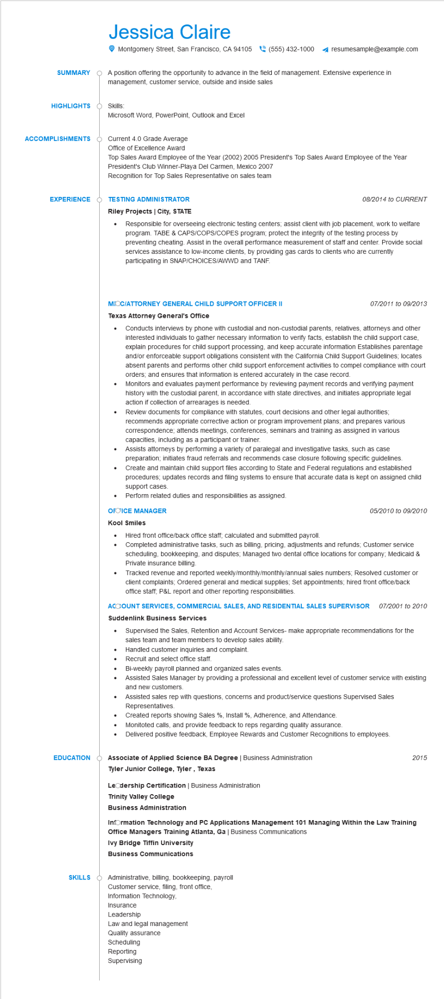

**SUMMARY**

Jessica Claire

Montgomery Street, San Francisco, CA 94105(555) 432-1000

resumesample@example.com

A position offering the opportunity to advance in the field of management. Extensive experience in management, customer service, outside and inside sales

**HIGHLIGHTS**

Skills:

Microsoft Word, PowerPoint, Outlook and Excel

**ACCOMPLISHMENTS**

Current 4.0 Grade Average

Office of Excellence Award

Top Sales Award Employee of the Year (2002) 2005 President's Top Sales Award Employee of the Year President's Club Winner-Playa Del Carmen, Mexico 2007 Recognition for Top Sales Representative on sales team

**EXPERIENCE**

**TESTING ADMINISTRATOR Riley Projects | City, STATE**

•

*08/2014 to CURRENT*

Responsible for overseeing electronic testing centers; assist client with job placement, work to welfare program. TABE & CAPS/COPS/COPES program; protect the integrity of the testing process by preventing cheating. Assist in the overall performance measurement of staff and center. Provide social services assistance to low-income clients, by providing gas cards to clients who are currently participating in SNAP/CHOICES/AWWD and TANF.

**EDUCATION**

**MIOC/ATTORNEY GENERAL CHILD SUPPORT OFFICER II**

**Texas Attorney General's Office**

*07/2011 to 09/2013*

Conducts interviews by phone with custodial and non-custodial parents, relatives, attorneys and other interested individuals to gather necessary information to verify facts, establish the child support case, explain procedures for child support processing, and keep accurate information Establishes parentage and/or enforceable support obligations consistent with the California Child Support Guidelines; locates absent parents and performs other child support enforcement activities to compel compliance with court orders; and ensures that information is entered accurately in the case record.

Monitors and evaluates payment performance by reviewing payment records and verifying payment history with the custodial parent, in accordance with state directives, and initiates appropriate legal action if collection of arrearages is needed.

• Review documents for compliance with statutes, court decisions and other legal authorities; recommends appropriate corrective action or program improvement plans; and prepares various correspondence; attends meetings, conferences, seminars and training as assigned in various capacities, including as a participant or trainer.

•

Assists attorneys by performing a variety of paralegal and investigative tasks, such as case preparation; initiates fraud referrals and recommends case closure following specific guidelines. Create and maintain child support files according to State and Federal regulations and established procedures; updates records and filing systems to ensure that accurate data is kept on assigned child support cases.

• Perform related duties and responsibilities as assigned.

**OFOICE MANAGER**

**Kool Smiles**

Hired front office/back office staff; calculated and submitted payroll.

*05/2010 to 09/2010*

Completed administrative tasks, such as billing, pricing, adjustments and refunds; Customer service scheduling, bookkeeping, and disputes; Managed two dental office locations for company; Medicaid & Private insurance billing.

Tracked revenue and reported weekly/monthly/monthly/annual sales numbers; Resolved customer or client complaints; Ordered general and medical supplies; Set appointments; hired front office/back office staff; P&L report and other reporting responsibilities.

**ACCOUNT SERVICES, COMMERCIAL SALES, AND RESIDENTIAL SALES SUPERVISOR 07/2001 to 2010 Suddenlink Business Services**

• Supervised the Sales, Retention and Account Services- make appropriate recommendations for the sales team and team members to develop sales ability.

• Handled customer inquiries and complaint.

•

Recruit and select office staff.

Bi-weekly payroll planned and organized sales events.

Assisted Sales Manager by providing a professional and excellent level of customer service with existing and new customers.

Assisted sales rep with questions, concerns and product/service questions Supervised Sales Representatives.

Created reports showing Sales %, Install %, Adherence, and Attendance.

Monitoted calls, and provide feedback to reps regarding quality assurance.

•

Delivered positive feedback, Employee Rewards and Customer Recognitions to employees.

Associate of Applied Science BA Degree | Business Administration

**Tyler Junior College, Tyler, Texas**

**LeOdership Certification | Business Administration**

**Trinity Valley College**

2015

**Business Administration**

**Information Technology and PC Applications Management 101 Managing Within the Law Training Office Managers Training Atlanta, Ga | Business Communications**

**Ivy Bridge Tiffin University**

Business Communications

SKILLS Administrative, billing, bookkeeping, payroll

Customer service, filing, front office,

Information Technology,

Insurance

Leadership

Law and legal management

Quality assurance

Scheduling

Reporting

Supervising