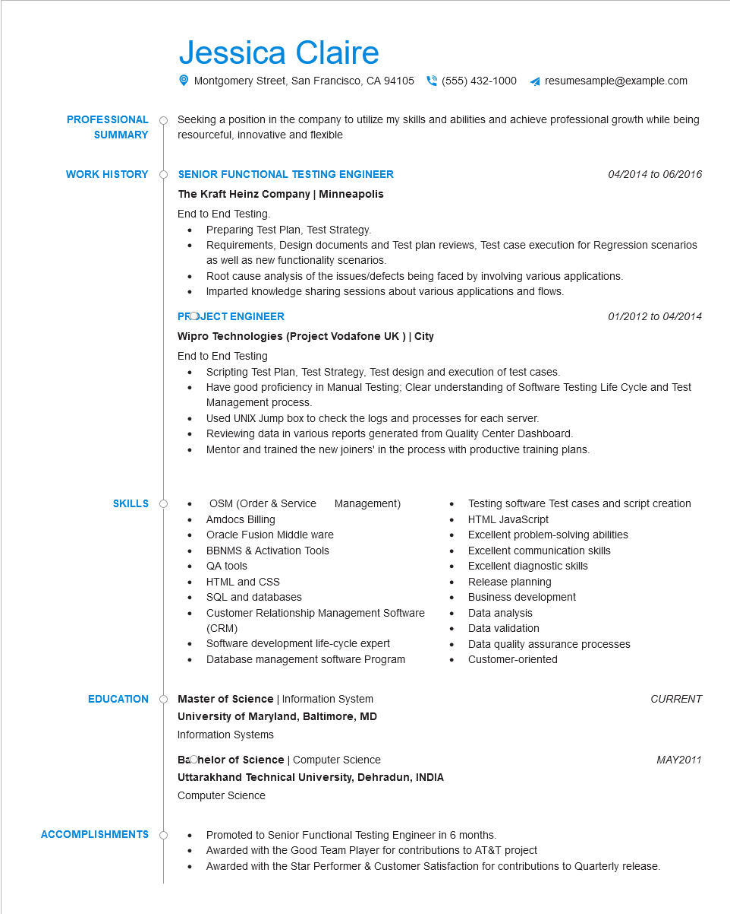

**PROFESSIONAL**

**SUMMARY**

Jessica Claire

Montgomery Street, San Francisco, CA 94105 (555) 432-1000

resumesample@example.com

Seeking a position in the company to utilize my skills and abilities and achieve professional growth while being resourceful, innovative and flexible

**WORK HISTORY**

**SKILLS**

**EDUCATION**

**SENIOR FUNCTIONAL TESTING ENGINEER**

*04/2014 to 06/2016*

**The Kraft Heinz Company | Minneapolis**

End to End Testing.

• •

Preparing Test Plan, Test Strategy.

Requirements, Design documents and Test plan reviews, Test case execution for Regression scenarios as well as new functionality scenarios.

• Root cause analysis of the issues/defects being faced by involving various applications.

Imparted knowledge sharing sessions about various applications and flows.

**PROJECT ENGINEER**

**Wipro Technologies (Project Vodafone UK ) | City**

End to End Testing

⚫

•

•

Scripting Test Plan, Test Strategy, Test design and execution of test cases.

01/2012 to 04/2014

Have good proficiency in Manual Testing; Clear understanding of Software Testing Life Cycle and Test Management process.

Used UNIX Jump box to check the logs and processes for each server.

Reviewing data in various reports generated from Quality Center Dashboard.

Mentor and trained the new joiners' in the process with productive training plans.

OSM (Order & Service

Management)

Amdocs Billing

Testing software Test cases and script creation HTML JavaScript

•

Oracle Fusion Middle ware

BBNMS & Activation Tools

•

QA tools

•

HTML and CSS

•

SQL and databases

•

•

• Data analysis

Excellent problem-solving abilities

Excellent communication skills

Excellent diagnostic skills

Release planning

Business development

Customer Relationship Management Software (CRM)

Software development life-cycle expert Database management software Program

Master of Science | Information System

**University of Maryland, Baltimore, MD**

Information Systems

•

Data validation

Data quality assurance processes Customer-oriented

*CURRENT*

**ACCOMPLISHMENTS**

**Bachelor of Science | Computer Science**

**Uttarakhand Technical University, Dehradun, INDIA Computer Science**

Promoted to Senior Functional Testing Engineer in 6 months.

• Awarded with the Good Team Player for contributions to AT&T project

• Awarded with the Star Performer & Customer Satisfaction for contributions to Quarterly release.

*MAY2011*