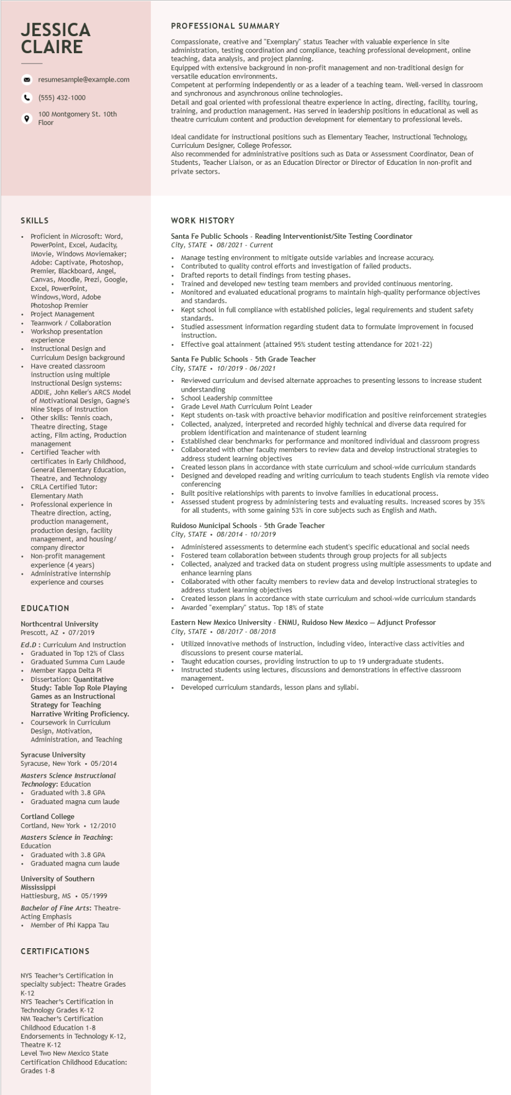

**JESSICA CLAIRE**

resumesample@example.com

(555) 432-1000

100 Montgomery St. 10th Floor

PROFESSIONAL SUMMARY

Compassionate, creative and "Exemplary" status Teacher with valuable experience in site administration, testing coordination and compliance, teaching professional development, online teaching, data analysis, and project planning.

Equipped with extensive background in non-profit management and non-traditional design for versatile education environments.

Competent at performing independently or as a leader of a teaching team. Well-versed in classroom and synchronous and asynchronous online technologies.

Detail and goal oriented with professional theatre experience in acting, directing, facility, touring, training, and production management. Has served in leadership positions in educational as well as theatre curriculum content and production development for elementary to professional levels.

Ideal candidate for instructional positions such as Elementary Teacher, Instructional Technology, Curriculum Designer, College Professor.

Also recommended for administrative positions such as Data or Assessment Coordinator, Dean of Students, Teacher Liaison, or as an Education Director or Director of Education in non-profit and private sectors.

SKILLS

Proficient in Microsoft: Word, PowerPoint, Excel, Audacity, IMovie, Windows Moviemaker; Adobe: Captivate, Photoshop, Premier, Blackboard, Angel,

Canvas, Moodle, Prezi, Google,

Excel, PowerPoint, Windows, Word, Adobe Photoshop Premier Project Management

Teamwork / Collaboration Workshop presentation experience

Instructional Design and

Curriculum Design background Have created classroom instruction using multiple Instructional Design systems: ADDIE, John Keller's ARCS Model of Motivational Design, Gagne's Nine Steps of Instruction Other skills: Tennis coach, Theatre directing, Stage acting, Film acting, Production management Certified Teacher with

certificates in Early Childhood, certifica General Elementary Education, Theatre, and Technology CRLA Certified Tutor: Elementary Math

Professional experience in Theatre direction, acting, production management, production design, facility management, and housing/ company director

• Non-profit management experience (4 years)

• Administrative internship experience and courses

**EDUCATION**

Northcentral University Prescott, AZ⚫ 07/2019

Ed.D: Curriculum And Instruction

• Graduated in Top 12% of Class

• Graduated Summa Cum Laude

• Member Kappa Delta Pi

Dissertation: Quantitative

Disser

Study: Table Top Role Playing

**Games as an Instructional**

Strategy for Teaching

Narrative Writing Proficiency. Coursework in Curriculum Design, Motivation,

Administration, and Teaching

Syracuse University

WORK HISTORY

Santa Fe Public Schools - Reading Interventionist/Site Testing Coordinator City, STATE⚫ 08/2021 - Current

Manage testing environment to mitigate outside variables and increase accuracy. Contributed to quality control efforts and investigation of failed products.

Drafted reports to detail findings from testing phases.

Trained and developed new testing team members and provided continuous mentoring. Monitored and evaluated educational programs to maintain high-quality performance objectives and standards.

Kept school in full compliance with established policies, legal requirements and student safety standards.

• Studied assessment information regarding student data to formulate improvement in focused instruction.

• Effective goal attainment (attained 95% student testing attendance for 2021-22)

Santa Fe Public Schools - 5th Grade Teacher

*City, STATE 10/2019 - 06/2021*

•

Reviewed curriculum and devised alternate approaches to presenting lessons to increase student understanding

School Leadership committee

Grade Level Math Curriculum Point Leader

Kept students on-task with proactive behavior modification and positive reinforcement strategies Collected, analyzed, interpreted and recorded highly technical and diverse data required for identification and maintenance of student learning

problem i

Established clear benchmarks for performance and monitored individual and classroom progress Collaborated with other faculty members to review data and develop instructional strategies to address student learning objectives

Created lesson plans in accordance with state curriculum and school-wide curriculum standards Designed and developed reading and writing curriculum to teach students English via remote video conferencing

Built positive relationships with parents to involve families in educational process.

Assessed student progress by administering tests and evaluating results. Increased scores by 35% for all students, with some gaining 53% in core subjects such as English and Math.

Ruidoso Municipal Schools - 5th Grade Teacher

*City, STATE⚫ 08/2014 - 10/2019*

Administered assessments to determine each student's specific educational and social needs Fostered team collaboration between students through group projects for all subjects

Collected, analyzed and tracked data on student progress using multiple assessments to update and enhance learning plans

Collaborated with other faculty members to review data and develop instructional strategies to address student learning objectives

Created lesson plans in accordance with state curriculum and school-wide curriculum standards Awarded "exemplary" status. Top 18% of state

Eastern New Mexico University - ENMU, Ruidoso New Mexico - Adjunct Professor City, STATE 08/2017 - 08/2018

• Utilized innovative methods of instruction, including video, interactive class activities and discussions to present course material.

Taught education courses, providing instruction to up to 19 undergraduate students.

• Instructed students using lectures, discussions and demonstrations in effective classroom management.

Developed curriculum standards, lesson plans and syllabi.

Syracuse, New York⚫ 05/2014

Masters Science Instructional

*Technology: Education*

•

Graduated with 3.8 GPA

• Graduated magna cum laude

Cortland College

Cortland, New York • 12/2010

Masters Science in Teaching: Education

• Graduated with 3.8 GPA

• Graduated magna cum laude

University of Southern

Mississippi

Hattiesburg, MS ⚫ 05/1999

Bachelor of Fine Arts: Theatre-

Acting Emphasis

• Member of Phi Kappa Tau

CERTIFICATIONS

NYS Teacher's Certification in specialty subject: Theatre Grades K-12

NYS Teacher's Certification in

Technology Grades K-12

NM Teacher's Certification

Childhood Education 1-8

Endorsements in Technology K-12, Theatre K-12

Level Two New Mexico State

Certification Childhood Education: Grades 1-8